**Хирургическое лечение почечно-клеточного рака почки с опухолевым тромбозом нижней полой вены: клинический случай**

АО «Национальный научный центр хирургии им. А.Н.Сызганова»

**Авторы:**

Б.Б. Баймаханов – профессор, трансплантолог, председатель правления АО «Национального научного центра хирургии им. А.Н. Сызганова» ([info@baimakhanov.kz](mailto:info@baimakhanov.kz), 87017223381).

И.К. Мададов - уролог-трансплантолог, заведующий отделением трансплантации почек, урологии и нефрологии, ([dominic89@mail.ru](mailto:dominic89@mail.ru) 87478397110) ORCID 0000-0003-2241-8603

Е.С.Набиев - уролог, отделение трансплантации почек, урологии и нефрологии ([esa-25@mail.ru](mailto:esa-25@mail.ru), 87013888344). ORCID **0000-0002-6167-1962**

Е.Б.Белгибаев - уролог - трансплантолог, отделение трансплантации почек, урологии и нефрологии ([dr_beb@mail.ru](mailto:dr_beb@mail.ru), 87759776773). ORCID **0000-0002-9439-2628**

Н.Т.Садуакас - уролог, отделение трансплантации почек, урологии и нефрологии ([nursultan2020.doc@bk.ru](mailto:nursultan2020.doc@bk.ru), 87473424642). ORCID **0000-0002-5249-1783**

Д. Ахметов – уролог, отделение трансплантации почек, урологии и нефрологии ([dilmurat96@gmail.com](mailto:dilmurat96@gmail.com), 87764120896). ORCID 0009-0004-4598-0652

**Authors:**

B.B. Baimakhanov – professor, transplant-surgeon, chairman of Board of JSC «National Scientific Center of Surgery named after A.N. Syzganov» ([info@baimakhanov.kz](mailto:info@baimakhanov.kz), 87017223381).

I.K. Madadov– urologist, transplant surgeon, head of kidney transplantation, urology and nephrology department. ([dominic89@mail.ru](mailto:dominic89@mail.ru), 87478397110) ORCID 0000-0003-2241-8603

E.B. Belgibaev - urologist, kidney transplantation, urology and nephrology department ([dr_beb@mail.ru](mailto:dr_beb@mail.ru), 87759776773). ORCID **0000-0002-9439-2628**

E.S. Nabiev - urologist, kidney transplantation, urology and nephrology department

([esa-25@mail.ru](mailto:esa-25@mail.ru), 87013888344). ORCID **0000-0002-6167-1962**

N.T. Saduakas- urologist, kidney transplantation, urology and nephrology department ([nursultan2020.doc@bk.ru](mailto:nursultan2020.doc@bk.ru), 87473424642). ORCID **0000-0002-5249-1783**

D. Akhmetov - urologist, kidney transplantation, urology and nephrology department (dilmurat96@gmail.com, 87764120896). ORCID **0009-0004-4598-0652**

**Авторлары:**

Б.Б. Баймаханов – профессор, трансплантолог дәрігері, «Ұлттық Ғылыми Хирургия орталығы» АҚ-ның басқарма төарағасы ([info@baimakhanov.kz](mailto:info@baimakhanov.kz),, 87017223381).

И.К. Мададов - уролог-трансплантолог дәрігері, бүйрек трансплантациясы, урология және нефрология бөлімшесінің жетекшісі ([dominic89@mail.ru](mailto:dominic89@mail.ru) 87478397110)

Е.Б.Белгібаев - уролог- трансплантолог дәрігері, бүйрек трансплантациясы, урология және нефрология бөлімшесі ([dr_beb@mail.ru](mailto:dr_beb@mail.ru), 87759776773).

Е.С.Набиев – уролог дәрігері, бүйрек трансплантациясы, урология және нефрология бөлімшесі ([esa-25@mail.ru](mailto:esa-25@mail.ru), 87013888344).

Н.Т.Садуақас - уролог дәрігері, бүйрек трансплантациясы, урология және нефрология бөлімшесі ([nursultan2020.doc@bk.ru](mailto:nursultan2020.doc@bk.ru), 87473424642).

Д. Ахметов – уролог дәрігері, бүйрек трансплантациясы, урология және нефрология бөлімшесі ([dilmurat96@gmail.com](mailto:dilmurat96@gmail.com), 87764120896).

**Абстракт**

Төменгі қуыс вена (ТҚВ) тромбозы бар бүйрек ісігі – мұқият хирургиялық емдеуді қажет ететін күрделі жағдай. Ересектердегі ең көп таралған қатерлі бүйрек ісігі - бүйрек жасушалық карциномасы (БЖК). Бейнелеу әдістерін жақсаруының нәтижесінде БЖК анықталу жиілігі өсіп келе жатыр. Көптеген жағдайда обыр кездейсоқ анықталады. Бүйрек ісігінің метастаздарсыз тамыр жүйесіне таралу қабілеті маңызды болып табылады. Венаның тартылуы оң жақ атриумға немесе төменгі қуыс венаға созылуы мүмкін. Диагноз қою кезінде пациенттердің шамамен 2-10% бүйрек венасында немесе ТҚВ-да ісік тромбының пайда болу қаупіне ұшырайды, оң жақ жиірек зардап шегеді [1]. Бұл жағдай ТҚВ тромбозы бар бүйрек ісігін емдеудегі мультидисциплинарлық тәсілдің және дәл хирургиялық әдісті талдаудың маңыздылығын көрсетеді, мұндай қиын жағдайларда қолайлы нәтижелерге қол жеткізу стратегияларына назар аударады.

*Түйінді сөздер: бүйрек жасушалы карциномасы; төменгі қуыс вена; тромб; нефрэктомия*

**Абстракт**

Рак почки с тромбозом нижней полой вены (НПВ) представляет собой сложное и требующее тщательного хирургического лечения состояние. Наиболее распространенной злокачественной опухолью почки у взрослых является почечно-клеточный рак почки (ПКР). Частота возникновения ПКР увеличилась в последнее время в результате повышения разрешающей способности методов визуализации. Большинство случаев обнаруживаются случайно. Способность ПКР распространяться на сосудистые системы без развития метастазов является важной особенностью. Венозное вовлечение может проявляться в виде опухолевого тромба в почечной вене на пораженной стороне с возможным распространением в правое предсердие или нижнюю полую вену (НПВ). Риск наличия опухолевого тромба в почечной вене или НПВ составляет 2-10%, при этом правая сторона поражается чаще [1]. Уровень распространения опухолевого тромба может достичь печеночных вен и даже правого предсердия. В связи с этим данное состояние требует междисциплинарный подход и рациональный хирургический подход, акцентируя внимание на стратегиях достижения благоприятных результатов в таких сложных случаях.

*Ключевые слова: почечно-клеточный рак; нижняя полая вена; тромб; нефрэктомия*

**Abstract**

Kidney cancer with inferior vena cava (IVC) thrombosis represents a complex condition that requires meticulous surgical treatment. The most common malignant kidney tumor in adults is renal cell carcinoma (RCC). The incidence of RCC has increased recently due to the enhanced resolution of imaging techniques. Most cases are discovered incidentally. RCC's ability to spread to vascular systems without developing metastases is a significant feature. Venous involvement can manifest as a tumor thrombus in the renal vein on the affected side, potentially extending to the right atrium or the inferior vena cava (IVC). The risk of having a tumor thrombus in the renal vein or IVC ranges from 2-10%, with the right side being more frequently affected [1]. The level of tumor thrombus extension can reach the hepatic veins and even the right atrium. This condition thus requires a multidisciplinary approach and a rational surgical strategy, focusing on achieving favorable outcomes in such complex cases.

*Keywords: renal cell carcinoma; inferior vena cava; thrombus; nephrectomy*

**Surgical Management of Renal Cell Carcinoma with Inferior Vena Cava Thrombosis: A Clinical Case Study**

**Introduction**

Renal cell carcinoma (RCC) represents 85% of all renal malignancies and is the most prevalent kind of kidney cancer [2]. RCC frequently shows no symptoms until it progresses, at which point it may manifest as hematuria, flank discomfort, and a palpable lump. It correlates with worse prognosis, aggressive histology, and advanced illness [3-5]. Tumor thrombus extension into the renal vein and, in certain situations, into the inferior vena cava (IVC) is one of the more serious side effects of advanced RCC [6-10]. This condition's intricate anatomy and the IVC's vital function in venous return make surgical therapy extremely difficult.

About 4–10% of RCC instances result in inferior vena cava thrombosis, which is linked to an increased risk of morbidity and death [11-14]. When IVC thrombus is present, careful surgical technique is required, frequently requiring multidisciplinary cooperation. Depending on the degree of thrombus involvement, several techniques are used, from a simple nephrectomy to more involved treatments such as thrombectomy and, in certain situations, cardiac bypass [15].

RCC with IVC thrombus poses a significant surgical challenge due to the complexities of achieving complete tumor resection while minimizing complications. The presence of IVC thrombus impacts survival outcomes negatively; however, aggressive surgical intervention has shown to improve survival rates significantly. Survival rates decrease with higher levels of thrombus extension. For localized stages (like Level I), the 5-year survival rate can be around 93%. For regional involvement (Levels II and III), the survival rate drops to approximately 74%. Distant stages, which include Level IV, have a significantly lower 5-year survival rate of about 17% [16-17].

This report describes a case that demonstrates the clinical presentation, diagnostic process, and surgical treatment of a patient who has both severe IVC thrombosis and RCC. We go over the preoperative planning, intraoperative difficulties, and postoperative results, offering an understanding of the interdisciplinary approach needed in such complicated situations. We hope that this case report will add to the body of knowledge on RCC with IVC involvement and highlight the significance of specialized surgical techniques for successful treatment.

**Case presentation**

Mr. X, a 60-year-old male, presented to our center with a chief complaint of hematuria persisting for one week. He was referred to our urology department after a renal ultrasound revealed a mass in the right kidney. Upon admission, patient underwent further evaluation, including a CT scan with contrast. The imaging revealed a large mass in the right kidney, extending into the inferior vena cava (IVC) (pic 1). Laboratory investigations indicated thrombocytopenia, elevated liver enzymes (ALT and AST), while coagulation parameters remained within normal limits. A chest CT scan showed no evidence of metastasis. The renal CT scan depicted a heterogeneous mass measuring 12x8.5x9.6 cm, with clear, irregular contours, located in the upper and middle thirds of the right kidney. The mass deformed the renal contour and extended into the renal vein, reaching the lumen of the renal tubular vein (4.8 cm in length). Collateral vessels, up to 1.1 cm in diameter, were observed. Intense contrast agent accumulation within the mass was noted post-injection. In order to determine the complexity of the surgery required and the likelihood of complications we used The Mayo Clinic classification (fig 1).

It is based on the level of the tumor thrombus extension into the inferior vena cava (IVC). This classification helps in planning the surgical approach and predicting the prognosis. The classification is divided into four levels:

1. **Level I**: The tumor thrombus extends into the renal vein but does not reach the IVC or extends slightly into the IVC but remains below the diaphragm.
2. **Level II**: The tumor thrombus extends into the IVC but remains below the liver (subhepatic).
3. **Level III**: The tumor thrombus extends into the IVC up to the liver but does not involve the heart (intrahepatic).
4. **Level IV**: The tumor thrombus extends above the diaphragm and may involve the heart or right atrium.

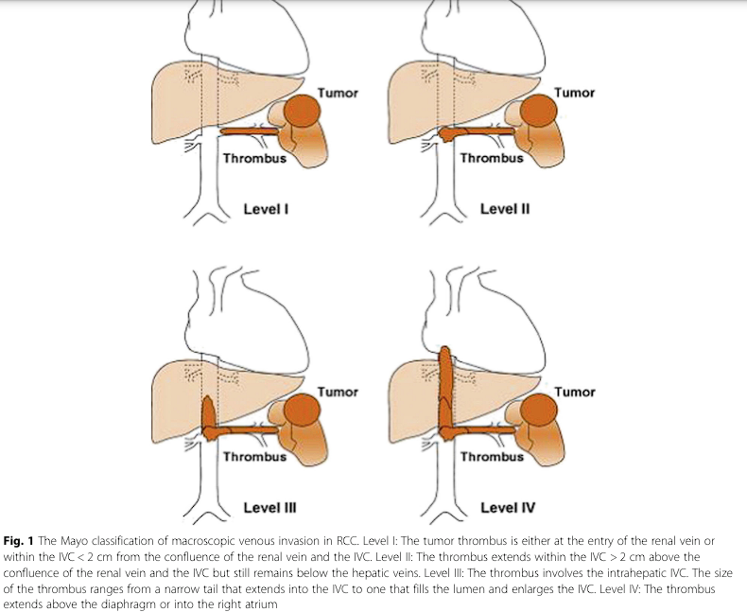

Fig.1. The Mayo classification of macroscopic venous invasion in RCC. [18]

**Diagnosis:** Right kidney mass with inferior vena cava thrombosis. Staging: T3bN1M0. Level III. **Comorbidities:** Mr. X had a history of ischemic heart disease, aneurysm of the interatrial septum, stage 1 arterial hypertension (high risk), and liver cirrhosis (Child-Turcotte-Pugh class B, MELD-9) secondary to chronic viral hepatitis C.  
After thorough consultations with a cardiologist and hepatologist, Mr. X provided informed consent for surgical intervention. The proposed surgical approach included laparotomy, nephrectomy, and thrombectomy with reconstruction of the inferior vena cava.

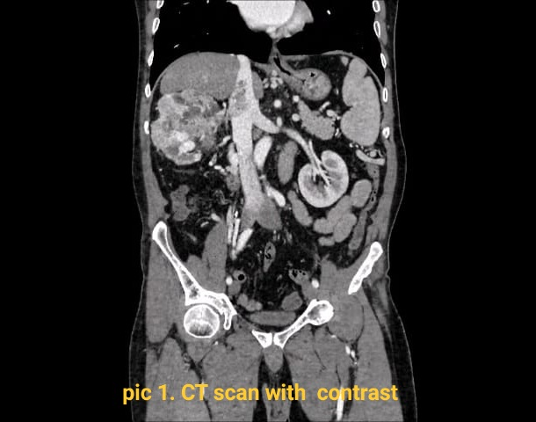

**Surgical Procedure**

Patient was positioned supine on the operating table under general anesthesia. Preoperative antibiotics were administered, and standard monitoring devices were applied. A right laparotomy was performed to access the retroperitoneal space and gain exposure to the right kidney and inferior vena cava (IVC). The incision provided adequate access to the affected structures while minimizing intraoperative complications. The right kidney was carefully dissected from the surrounding tissues, ensuring preservation of adjacent structures. Additional vessels and collaterals were isolated, ligated, and divided. The ureter in the lower third was isolated, ligated, and divided. The renal vein, along with its entry into the inferior vena cava (IVC), was isolated and secured with a vessel loop. Three renal arteries were isolated, clamped, divided, and ligated. A Satinsky clamp was applied to the IVC at the entry of the renal vein. The renal vein was divided, and an incision was made in the IVC. The entire kidney, including the tumor mass, was excised en bloc. Attention was then turned to the inferior vena cava, where the thrombus was located. Special care was taken to avoid dislodging the thrombus during manipulation. Using meticulous dissection techniques, the 5cm thrombus was carefully removed from the lumen of the vena cava (pic 2), ensuring complete clearance of the vessel. Following thrombus removal, the integrity of the inferior vena cava was assessed. reconstruction of the vena cava was performed using primary closure (pic 3). Hemostasis was ensured, and meticulous attention was paid to controlling any bleeding points. The surgical field was thoroughly irrigated with saline to remove any debris or residual thrombus. The surgical procedure was successful, with complete removal of the renal tumor and thrombus from the inferior vena cava. Patient's postoperative recovery was uneventful, and he was discharged home with appropriate follow-up instructions. This surgical approach highlights the importance of meticulous dissection techniques and careful vascular management in achieving favorable outcomes in patients with renal cell carcinoma and inferior vena cava thrombosis.

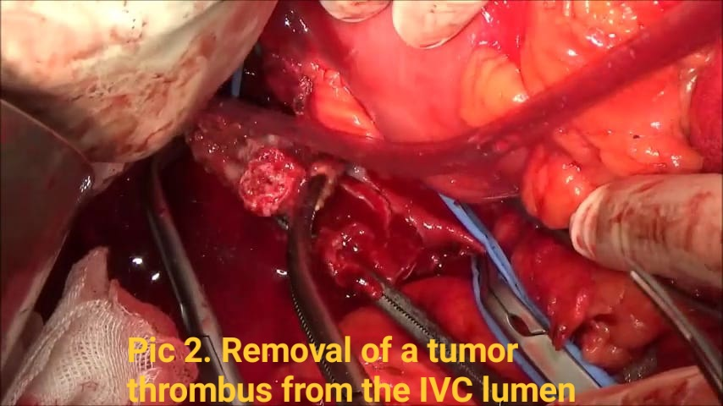

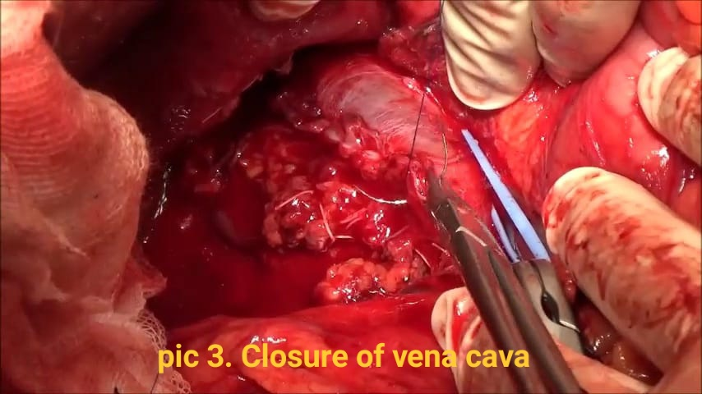

**Pic 4. Gross specimen of a kidney with a tumor thrombus.**

**Discussion**

Renal cell carcinoma (RCC) with inferior vena cava (IVC) thrombus presents a significant surgical and clinical challenge, necessitating a multidisciplinary approach for effective management. This case highlights several critical aspects of surgical and perioperative management, contributing to the broader understanding of advanced RCC treatment.

RCC often remains asymptomatic until it reaches an advanced stage, as illustrated by our patient's presentation with hematuria—a common symptom of advanced renal tumors. The diagnostic journey began with a renal ultrasound, a standard initial imaging modality, which identified a mass in the right kidney. Further evaluation with contrast-enhanced computed tomography (CT) was crucial for detailed anatomical assessment. Contrast-enhanced CT scans are indispensable in RCC cases for visualizing tumor extension, vascular involvement, and potential metastases [19].

The CT scan in this case revealed a large, heterogeneous mass in the right kidney with clear, irregular contours extending into the IVC. The ability of CT imaging to provide detailed visualization of the tumor thrombus was instrumental in surgical planning. This aligns with findings in the literature that underscore the importance of high-resolution imaging for accurate staging and preoperative assessment [20].

The surgical management of RCC with IVC thrombus is complex and requires a highly specialized approach. The choice of a cherry right laparotomy provided optimal exposure to the kidney and IVC, facilitating meticulous dissection and thrombus removal. Nephrectomy, combined with thrombectomy and IVC reconstruction, was necessary due to the extent of the thrombus. This approach is consistent with current surgical guidelines that recommend aggressive resection to achieve complete tumor removal and minimize recurrence [21].

The intricacies of performing thrombectomy from the IVC involve preventing thrombus dislodgement, which could lead to potentially fatal pulmonary embolism. In this case, careful surgical technique and intraoperative management were critical to avoiding such complications. Literature reviews support that experienced surgical teams and meticulous technique are essential for successful outcomes in such high-risk surgeries [22].

This case presented several intraoperative challenges, including the patient’s thrombocytopenia and elevated liver enzymes, indicating an increased risk of bleeding. Careful intraoperative hemostasis was paramount to manage this risk effectively. The presence of significant comorbidities—ischemic heart disease, arterial hypertension, and cirrhosis—required comprehensive preoperative optimization and interdisciplinary collaboration. Preoperative consultations with cardiology and hepatology were essential for risk stratification and management, highlighting the importance of a holistic approach to patient care [23].

Postoperative care involved intensive monitoring to detect and address early complications, such as bleeding or thromboembolic events. The successful outcome in this case, marked by the uneventful recovery and confirmed patency of the IVC on postoperative imaging, underscores the effectiveness of the surgical approach and the importance of comprehensive perioperative care [24].

The patient’s recovery was facilitated by a multidisciplinary team that included surgeons, anesthesiologists, intensivists, and nursing staff, ensuring that all aspects of the patient’s care were addressed. The literature supports the role of multidisciplinary teams in improving surgical outcomes for complex cases such as RCC with IVC thrombus [25].

The management of RCC with IVC thrombus has evolved significantly, with advances in imaging, surgical techniques, and perioperative care contributing to improved outcomes. Studies have shown that aggressive surgical intervention, even in advanced cases, can lead to prolonged survival and improved quality of life [26]. However, the inherent risks of such extensive surgeries, including morbidity and mortality, must be carefully weighed against the potential benefits.

Emerging surgical techniques, such as minimally invasive approaches and robotic-assisted surgeries, offer the potential for reduced morbidity and faster recovery times. Initial studies on these techniques have shown promising results, although further research and long-term data are needed to establish their efficacy and safety in managing RCC with IVC thrombus [27].

**Conclusion:**

The management of RCC with IVC thrombosis requires a tailored and multidisciplinary approach, incorporating meticulous surgical technique, comprehensive preoperative assessment, and close postoperative monitoring. This case study highlights the importance of collaboration between different specialties and the challenges encountered in the surgical management of complex renal tumors. Further research and clinical studies are warranted to refine treatment strategies and improve outcomes in this challenging patient population.

No financial interest

No conflict of interest

References

1. Kirkali Z, Van Poppel H. A critical analysis of surgery for kidney cancer with vena cava invasion. Eur Urol. 2007 Sep;52(3):658-62. doi: 10.1016/j.eururo.2007.05.009. Epub 2007 May 24. PMID: 17548146.
2. <https://www.cancer.gov/types/kidney/hp/kidney-treatment-pdq>
3. Patard, J.J., et al. Correlation between symptom graduation, tumor characteristics and survival in renal cell carcinoma. Eur Urol, 2003. 44: 226
4. Lee, C.T., et al. Mode of presentation of renal cell carcinoma provides prognostic information. Urol Oncol, 2002. 7: 135.
5. Vasudev, N.S., et al. Challenges of early renal cancer detection: symptom patterns and incidental diagnosis rate in a multicentre prospective UK cohort of patients presenting with suspected renal cancer. BMJ Open, 2020. 10: e035938.
6. Haidar GM, Hicks TD, El-Sayed HF, Davies MG. Treatment options and outcomes for cavalthrombectomy and resection for renal cell carcinoma. J Vasc Surg Venous LymphatDisord May. 2017;5(3):430–6.
7. Gonzalez J. Update on surgical management of renal cell carcinoma with venous extension. CurrUrol Rep Feb. 2012;13(1):8–15.
8. Calero A, Armstrong PA. Renal cell carcinoma accompanied by venous invasion and inferior vena cava thrombus: classification and operative strategies for the vascular surgeon. SeminVasc Surg Dec. 2013;26(4):219–25.
9. Marshall FF, Reitz BA, Diamond DA. A new technique for management of renal cell carcinoma involving the right atrium: hypothermia and cardiac arrest. J Urol. 1984;131(1):103–7.
10. Belis JA, Levinson ME, Pae WE Jr. Complete radical nephrectomy and vena cavalthrombectomy during circulatory arrest. J Urol. 2000;163(2):434–6.
11. Blute ML, Leibovich BC, Lohse CM, Cheville JC, Zincke H. The Mayo Clinic experience with surgical management, complications and outcome for patients with renal cell carcinoma and venous tumour thrombus. BJU Int. 2004 Jul;94(1):33-41. doi: 10.1111/j.1464-410X.2004.04897.x. PMID: 15217427.
12. Zisman A, Wieder JA, Pantuck AJ, et al. Renal cell carcinoma with tumor thrombus extension: biology, role of nephrectomy and response to immunotherapy. *J Urol* 2003;169:909-16. 10.1097/01.ju.0000045706.35470.1e
13. Lam JS, Klatte T, Breda A. Staging of renal cell carcinoma: Current concepts. *Indian J Urol* 2009;25:446-54. 10.4103/0970-1591.57906
14. Dall'Oglio MF, Ribeiro-Filho LA, Antunes AA, et al. Microvascular tumor invasion, tumor size and Fuhrman grade: a pathological triad for prognostic evaluation of renal cell carcinoma. *J Urol* 2007;178:425-8; discussion 428. 10.1016/j.juro.2007.03.128
15. Ghoreifi, A., Djaladat, H. Surgical Tips for Inferior Vena Cava Thrombectomy. Curr Urol Rep 21, 51 (2020). <https://doi.org/10.1007/s11934-020-01007-9>
16. Xie, W., Regan, M. M., Buyse, M., et al. (2008). Metastasis-free survival is a strong surrogate of overall survival in localized renal cell carcinoma. Journal of Clinical Oncology, 26(22), 3749-3755.
17. Abel, E. J., Thompson, R. H., Margulis, V., et al. (2014). Perioperative outcomes following surgical resection of renal cell carcinoma with inferior vena cava thrombus extending above the hepatic veins: A contemporary multicenter experience. European Urology, 66(3), 584-592.
18. Zhu P, Du S, Chen S, Zheng S, Hu Y, Liu L, Zheng S. The role of deep hypothermic circulatory arrest in surgery for renal or adrenal tumor with vena cava thrombus: a single-institution experience. J Cardiothorac Surg. 2018 Jul 5;13(1):85. doi: 10.1186/s13019-018-0772-z. PMID: 29976214; PMCID: PMC6034231.
19. Ferda, J., et al. Assessment of the kidney tumor vascular supply by two-phase MDCT-angiography. Eur J Radiol, 2007. 62: 295.
20. Shao, P., et al. Precise segmental renal artery clamping under the guidance of dual-source computed tomography angiography during laparoscopic partial nephrectomy. Eur Urol, 2012. 62: 1001.
21. Abel, E. J., Thompson, R. H., Margulis, V., et al. (2014). Perioperative outcomes following surgical resection of renal cell carcinoma with inferior vena cava thrombus extending above the hepatic veins: A contemporary multicenter experience. *European Urology*, 66(3), 584-592.
22. Haferkamp, A., Hafez, K., Schmidt, S., et al. (2007). Renal cell carcinoma with tumor thrombus extension into the vena cava: prospective long-term followup. *The Journal of Urology*, 177(5), 1703-1708.
23. Blute, M. L., Leibovich, B. C., Lohse, C. M., et al. (2004). The Mayo Clinic experience with surgical management, complications and outcome for patients with renal cell carcinoma and venous tumor thrombus. *The Journal of Urology*, 171(5), 1803-1807.
24. Bex, A., Albiges, L., Ljungberg, B., et al. (2018). Updated European Association of Urology guidelines for renal cell carcinoma: Immune checkpoint inhibition is the new backbone in first-line treatment of metastatic clear-cell renal cell carcinoma. *European Urology*, 74(4), 455-463.
25. Staehler, M., Koch, A. F., Haseke, N., et al. (2011). Perioperative risk of patients with renal cell carcinoma and inferior vena cava thrombus extension treated without cardiopulmonary bypass. *European Urology*, 59(4), 589-597.
26. Delahunt, B., Eble, J. N. (1997). History of the development of the classification of renal cell neoplasia. *Clinical Laboratory Medicine*, 17(4), 605-622.
27. Shuch, B., Hofmann, F., Gill, I. S., et al. (2011). The expanding role of partial nephrectomy: a critical analysis of indications, outcomes, and complications. *European Urology*, 59(5), 744-752.