УДК 617.559-07-089
Бадыров Руслан Муратович - заведующий хирургическим блоком клиники НАО «Медицнский университет Караганды», PhD, ассоциированный профессор кафедры хирургических болезней. badyrov_ruslan@bk.ru
ORDIC ID 0000-0002-3578-7144
Ruslan Badyrov - Head of the surgical unit of the NсJSC "Medical University Karaganda" clinic in Karaganda, PhD, Associate Professor of the Department of Surgical Diseases. badyrov_ruslan@bk.ru
ORDIC ID 0000-0002-3578-7144
Бадыров Руслан Мұратұлы - «Қарағанды қаласының медициналық университеті» КеАҚ клиникасының хирургиялық бөлімшесінің меңгерушісі, м.ғ.д., хирургиялық аурулар кафедрасының доценті. badyrov_ruslan@bk.ru ORDIC ID 0000-0002-3578-7144

Абзалов Денис Фаритович резидент общий хирург, первого года обучения. Медицинский университет Караганды. a-d-f@mail.ru
ORDIC ID 0009-0003-9354-9130
Abzalov Denis Faritovich resident surgeon of the first year of study, Department of Surgical Diseases of NсJSC "Medical University Karaganda. a-d-f@mail.ru
ORDIC ID 0009-0003-9354-9130
Абзалов Денис Фаритович «Қарағанды қаласының Медицина университеті» КеАҚ хирургиялық аурулар кафедрасының 1 курстың хирург-ординаторы. a-d-f@mail.ru
ORDIC ID 0009-0003-9354-9130

ЭПИТЕЛИАЛДЫ ҚҰЙЫМШАҚ БАРЫСЫН ХИРУРГИЯЛЫҚ ЕМДЕУ ТАКТИКАСЫ
SURGICAL TREATMENT OF EPITHELIAL COCCYGEAL PASSAGE
ХИРУРГИЧЕСКАЯ ТАКТИКА ЛЕЧЕНИЯ ЭПИТЕЛИАЛЬНОГО КОПЧИКОВОГО ХОДА.

Абзалов Денис Фаритович 8-7774171477. a-d-f@mail.ru

ЭПИТЕЛИАЛДЫ ҚҰЙЫМШАҚ БАРЫСЫН ХИРУРГИЯЛЫҚ ЕМДЕУ ТАКТИКАСЫ
Аннотация: Эпителиалды құйымшақ барысы (ЭҚБ) проктологияның пікірталасқа толы тақырыптарының бірі болып табылады. Алайда қазіргі заманауи хирургия көптеген модификацияланған реконструктивті операциялар ұсынғанымен, хирургтардың бір бөлігі құйымшақ барысын пластикалық отаға жүгінбей, бастапқы жабылуымен жою тактикасын ұстанады. Бұл жұмыс Лимбергтің классикалық стиліндегі қайта жаңарту кесіндісімен салыстырғанда ЭҚБ жою нәтижесін көрсетуге бағытталған. Зерттеуге барлығы 10 науқас қатысқан, оның 8-і ер адам -80% және 2 әйел адам -20%. Орташа жасы - 37 жас. Жұмыс қорытындысы бойынша бір пациентте рецидив болды.
Түйін сөздер: Эпителиалды құйымшақ барысы, хирургиялық емдеу, қайта жаңарту.
ХИРУРГИЧЕСКАЯ ТАКТИКА ЛЕЧЕНИЯ ЭПИТЕЛИАЛЬНОГО КОПЧИКОВОГО ХОДА.
Аннотация: Эпителиальный копчиковый ход (ЭКХ)является одной из самых дискутируемых тем проктологии. Не смотря на то что современная, хирургия представляет многочисленные модификации реконструктивных операций, часть хирургов придерживается тактики иссечения хода с его первичным закрытием, не прибегая к пластике. Данная работа нацелена на демонстрацию результатов иссечения ЭКХ с первичным закрытием в сравнении с иссечением с классической реконструкцией в стиле лоскута Лимберга. В исследование было включено 10 пациентов 8 из которых были мужчины-80% и 2 женщины-20 % Средний возраст 37 лет. По окончанию работы был получен один рецидив.
Ключевые слова: Эпителиальный копчиковый ход, хирургическое лечение, реконструкция.
SURGICAL TREATMENT OF EPITHELIAL COCCYGEAL PASSAGE
Annotation: Epithelial coccygeal passage (ECP) is one of the most discussed topics in proctology. Despite the fact that modern surgery presents numerous modifications of reconstructive operations, some surgeons adhere to the tactics of the excision of the passage with its primary closure, without plastic surgery.This work is aimed to demonstrate the results of the excision of ECP with primary closure in comparison with excision with the classical Limberg flap wound closure reconstruction. The research included 10 patients, 8 of which were men - 80% and 2 women - 20%. The average age of the patients is 37 years old. At the end of the work, one recurrence was received.
Key words: Epithelial coccygeal passage, surgical treatment, reconstruction.

Introduction: The epithelial coccygeal passage is a narrow channel lined with cutaneous epithelium containing hair follicles, sebaceous glands, the waste products of which are excreted through one or more point funnel–shaped holes localized strictly along the line of the interdigital fold, the so-called primary holes, infection can penetrate through the same holes into the tissue, which can cause violations of the emptying of the passage and as a result, the inflammatory process[1,3].
Materials and methods:
From December 2021 to December 2022, a prospective study was conducted at the Karaganda Railway Hospital in which 10 surgical interventions were performed in patients with epithelial coccygeal course in the form of excision and primary closure (group I, n=5 patients) and excision with reconstruction of the Limberg flap (group II, n=5). The tactics of the surgical technique were explained to the patients, and informed consent was obtained.
Preoperative preparation: First of all, hair removal in the gluteal and sacral areas and cleansing enema, antibiotic prophylaxis 30 minutes before surgery.
Group 1 included patients with a chronic form of epithelial coccygeal course during the period of remission of the inflammatory process. The position of the patient intraoperatively on the abdomen. After treatment of the surgical field, under spinal anesthesia, contrast (Diamond green) was introduced into the coccygeal cavity, there were no reports with the rectum in any of the treated cases. The patients underwent excision of the coccygeal passage with primary closure of the wound without plastic surgery. With the installation of a control drainage on active aspiration. The average duration of the operation is 30 minutes.
Group 2 included patients with acute epithelial coccygeal course (infiltrative stage or abscess formation). The first stage was the autopsy and drainage of the abscess with the intake of the opened discharge for bacteriological examination to determine the pathogen and its sensitivity to antibiotics. The wound was abundantly washed with solutions of hydrogen peroxide and chlorhexidine. Loosely tamponed with cloths with chlorhexidine. Healing by secondary tension. After 2-3 weeks, patients from the 2nd group came for a follow-up examination, according to the results of which one of the patients required a second opening of the abscess. After making sure that there were no signs of inflammation, the patients were offered the second stage of surgical treatment, excision of the coccygeal passage with classical reconstruction of the defect with a Limberg flap.
The diamond-shaped Limberg flap has a certain structure, the basis lies in the fact that the defect has equal sides and angles of 60 and 120 °[2,5,7]. After the surgeon diamond-shaped excision of the ECC (Fig. 1-excision of the skin flap), a line is drawn with a scalpel along the short axis of the defect, the line has a length equal to the side of the defect. (a=в fig2- mobilization of the skin flap) The second incision is made at an angle of 60° relative to the first, has the same length [5,7].
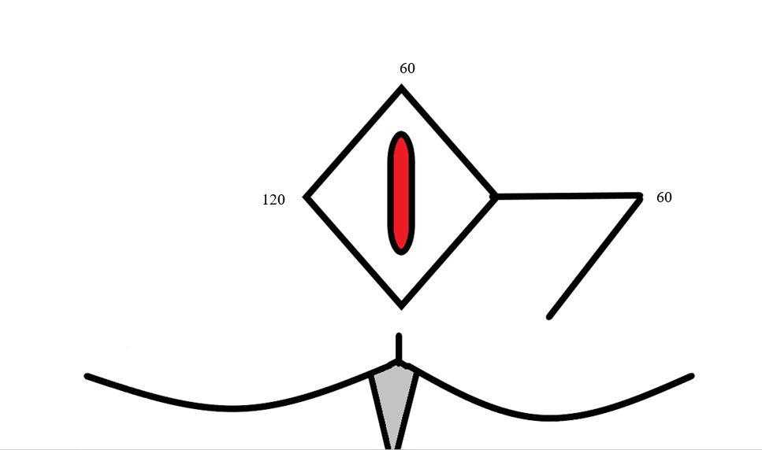
(Fig. 1-excision of the skin flap)
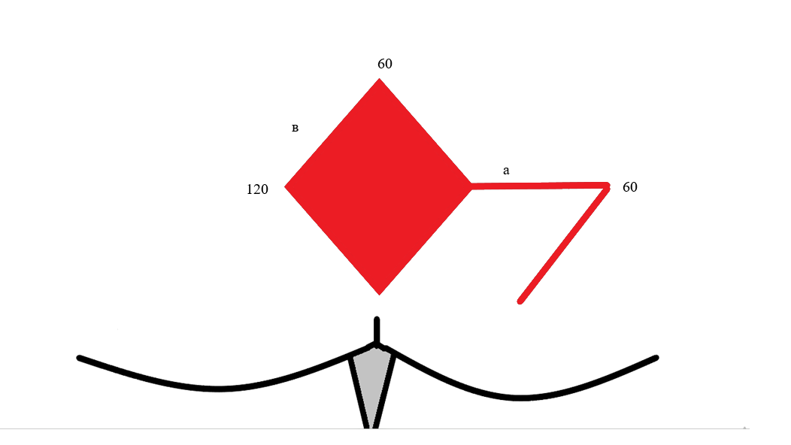
(fig2- mobilization of the skin flap)
The mobilization of the skin flap occurs counterclockwise so that the angle 60⁰ coincides with the angle 60⁰ and a corresponds to в [5,7]. The operation was completed by installing a control drainage and applying nodular sutures.
The average duration of the operation is 40 minutes.

Results: Postoperative activation was resolved after 8 hours in group I and in group II after 6 hours. Drainage systems were removed when the aspiration volume per day was less than 10 ml, on average, drainage was removed for 5 days.
Upon discharge, they were informed of the need to refrain from sitting (except for the toilet), up to 6 weeks after surgery, to prevent wound rupture; improvement of local hygiene. Dieting, in particular, the intake of plant-based protein foods that provide soft and regular stools. Patients were re-examined 2 weeks, 1, 3 and 12 months after surgery. The groups were compared in terms of hospital stay, postoperative activation, wound healing, postoperative infection, time of disability and relapses
To assess the result of satisfaction and comfort, patients were asked to fill out a questionnaire with registration of such data as the time of painless toilet sitting and painless walking.
Table.1- The results obtained.

Clinical results: | 1 группа | 2 группа
Activation time after surgery | after 12 hours | after 6 hours
Time for painless toilet sitting | 3 minutes | 5-7 minutes
Time for a painless walk | 10 minutes | 17 minutes
Number of days of hospital stay | 6 days | 4 days
Time to complete wound healing | 23 days | 18 days
Time of disability | 37 days | 25 days
Wound infection | 1 | -
Divergence of the wound edges | 2 | -
Relapse | 1 | -
The technique of excision and primary closure without plastic surgery causes limitation of the patient's mobility due to tissue tension. Most of the patients' complaints after surgery were caused by the soreness of the wound, which in turn delayed the early activation of patients.

Discussion: It is known that the simplest way to treat this disease is incision and drainage of the cavity, but numerous studies report a high recurrence rate, so a radical treatment method is wide excision of the fistula, with its primary closure, which will shorten the healing time of the wound avoiding tamponing [4,6,8]. Nevertheless, the tactics of reconstruction of the excised area is an open question

Conclusions: Based on the results of the work carried out, it can be said with certainty that each treated case is absolutely individual, it is necessary to take into account the stage of the patient's disease, in order to select the appropriate tactics for surgical treatment, also the size of the skin defect that needs to be eliminated, excluding tissue tension, which in turn may lead to a divergence of the edges of the postoperative wound with the addition of a secondary infection. All these factors were taken into account by the surgeon and, of course, the patient's interest in his own health is necessary in this particular situation — this is compliance with a protective regime and personal hygiene. It is impossible to ignore the fact that the reconstruction of a skin defect with a flap has a number of advantages, namely, the absence of tension of the skin flap reduces the risk of divergence and infection of postoperative wounds, respectively, creates favorable conditions for wound healing by primary tension, reducing cases of recurrence. Together, these parameters increase the comfort and satisfaction of patients after surgical treatment.
There was no conflict of interest in the conducted research.
There was no funding

List of used literature
1. Arnous M, Elgendy H, Thabet W, Emile SH, Elbaz SA, and Khafagy W. Excision with primary midline closure compared with Limberg flap in the treatment of sacrococcygeal pilonidal disease: a randomised clinical trial. The Annals of The Royal College of Surgeons of England. The Bulletin -2019.№9. - p.17-23. doi: 10.1308/rcsann.2018.0144

2. N Rashidian 1, J Vahedian-Ardakani, M Baghai-Wadji, M R Keramati, A Saraee, K Ansari, A A Adman. How to repair the surgical defect after excision of sacrococcygeal pilonidal sinus: a dilemma.// Colorectal Disease Resident of General Surgery, Iran University of Medical Sciences, Tehran, Iran. 2010. № 17.-p.37-41. DOI:10.12968/jowc.2014.23.12.630
3. J Horwood 1, D Hanratty, P Chandran, P Billings. Primary closure or rhomboid excision and Limberg flap for the management of primary sacrococcygeal pilonidal disease? A meta-analysis of randomized controlled trials.// of Wound Care. Department of General Surgery, Wrexham Maelor Hospital, Wrexham, UK. 2012. №5- p.89-96. DOI: 10.1111/j.1463-1318.2010.02473.x
4. Klinikum Graz, Klinische Abteilung für Plastische, Ästhetische und Rekonstruktive Chirurgie, Universitätsklinik für Chirurgie, Graz, Austria. S Dahmann 1, P B Lebo 2, M V Meyer-Marcotty 1. Comparison of Treatments for an Infected Pilonidal Sinus: Differences in Scar Quality and Outcome Between Secondary Wound Healing and Limberg Flap in a Prospective Study.// Thieme Connect .LKH-Univ. 2015. № 11.- p.45-53 DOI: 10.1055/s-0041-111322
5. P B Lebo 1, S Dahmann 2, E Sinkovits 3, M Meyer-Marcotty 2. Pilonidal sinus: Secondary wound closure vs. Limberg flap : Cost and satisfaction analysis.// International Journal of Surgery. Universität Wien, Universitätsring 1, 1010, Wien, Österreich. 2017. №19.- p.72-78. DOI: 10.1007/s00104-016-0289-8
8. V I Pomazkin. Modified Limberg plasty in treatment of epithelial coccygeal passage. // Khirurgiya Zhurnal im N I Pirogova. Sverdlovsk Regional Clinical Hospital for war veterans, Yekaterinburg. 2015.№.14.- p.52-69. DOI: 10.17116/hirurgia2015551-55

Table.1- The results obtained. Evaluation of the result and patient satisfaction in the postoperative period.

Clinical results: | 1 группа | 2 группа
Activation time after surgery | after 12 hours | after 6 hours
Time for painless toilet sitting | 3 minutes | 5-7 minutes
Time for a painless walk | 10 minutes | 17 minutes
Number of days of hospital stay | 6 days | 4 days
Time to complete wound healing | 23 days | 18 days
Time of disability | 37 days | 25 days
Wound infection | 1 | -
Divergence of the wound edges | 2 | -
Relapse | 1 | -

Drawings and illustrations.

Fig. 1-excision of the skin flap.

fig2- mobilization of the skin flap

