SURVIVAL ANALYSIS AND CHARACTERISTICS OF PANCREATIC ADENOCARCINOMA BASED ON MSCT DATA OF 216 CASES

Baiguissova D.,1 Akhmetov Ye.,2Duisenbayeva B.,3Mukhamejanova A.,4Battalova G.,4Kalshabay Ye., 4Kabidenov A.,4Sadykova A. 4

Baiguissova D. <https://orcid.org/0000-0003-4261-3537>

Akhmetov Ye. <https://orcid.org/0000-0002-6042-4935>

Duisenbayeva B. https://orcid.org/0009-0003-3380-0100

Mukhamejanova A. https://orcid.org/0000-0002-4487-1604

Battalova G. <https://orcid.org/0000-0003-4261-3537>

Kalshabay Y. <https://orcid.org/0000-0003-0493-6685>

Kabidenov A. https://orcid.org/0000-0001-5038-2033

Sadykova A. <https://orcid.org/0000-0003-4768-4799>

1. Kazakhstan Medical University “KSPH” Almaty, Kazakhstan **University**
2. Kazakh-Russian Medical University Almaty, Kazakhstan

3. Corporate Fund “University Medical School” Almaty, Kazakhstan

4. National Scientific Center of Surgery named After A.N. Syzganov

**Abstract**

Pancreatic adenocarcinoma is a highly aggressive malignancy characterized by poor prognosis and a continuing increase in morbidity and mortality worldwide. Diagnosis of pancreatic cancer, especially in its early stages, remains challenging as the disease is often detected at an advanced stage. Imaging, especially computed tomography, plays a key role in diagnosis, resectability assessment, and treatment response monitoring. The aim of this study was to analyze the characteristics of PAC, including its location, metastasis extent, resectability, and postoperative follow-up, using contrast-enhanced Multispiral Computed Tomography. These data will help improve the diagnosis, prognosis, and treatment planning of patients with PAC, which is important for improving survival and quality of life.

**Introduction**

Pancreatic adenocarcinoma (PAC) is a highly aggressive malignancy with poor prognosis [1].

Currently, the incidence and mortality of pancreatic cancer continue to increase annually throughout the world, including the United States, Europe, Japan and China. By 2050, the global incidence of pancreatic cancer is projected to reach 18.6 cases per 100,000 people, with an average annual increase of 1.1%, which will create a significant burden on healthcare systems. Despite the rapid development of modern medical technologies and significant improvement in survival in many oncological diseases, pancreatic cancer remains one of the most lethal malignant neoplasms of the gastrointestinal tract [2]. The five-year survival rate of pancreatic adenocarcinoma is only 10% [3].

In the diagnosis of pancreatic cancer, imaging methods play a key role in screening, disease detection, resectability assessment and monitoring of treatment effectiveness. Determination of resectability and tumor diagnosis are decisive factors in choosing treatment tactics, while computed tomography (CT) remains the first-line diagnostic method [4].

Approximately three quarters of pancreatic cancer cases occur in the head of the pancreas, 17-26% in the body and tail, and the remaining 5-8% in multiple sites of the pancreas [5,6]. Due to the anatomical location of the pancreas, the disease is usually diagnosed at a late stage, when pronounced clinical symptoms are already present [7]. Tumors located in the body and tail of the pancreas are usually diagnosed at a later stage compared to tumors of the head, since the latter cause symptoms associated with obstruction of the common bile duct and/or pancreatic duct [8].

The main problem in treatment remains the late stage of the disease at the time of diagnosis [9]. Most patients are already at the stage of locally advanced or metastatic process at the time of diagnosis [10].

Currently, the only potentially radical method of treatment remains surgical intervention, but it is associated with a high risk of complications [11]. However, even with radical surgery, the prognosis remains unfavorable, since surgical treatment is accompanied by a high risk of complications, including postoperative pancreatic fistula, as well as a high risk of recurrence and metastasis [12].

Early diagnosis and accurate treatment of pancreatic cancer largely depend on medical imaging, so accurate analysis of medical images is of great importance for patients with this disease [13].

The aim of this study is to analyze the characteristics of pancreatic adenocarcinoma, including its location, prevalence of metastases, resectability and postoperative follow-up according to contrast-enhanced multispiral computed tomography (MSCT).

**Materials and methods**

A retrospective analysis of 216 cases of APJ registered at the A.N. Syzganov National Scientific Surgical Center (NSSC) from 2022 to 2024 was performed. All patients underwent bolus contrast-enhanced MSCT. The diagnosis was established by histological examination of patients. The inclusion criteria were patients diagnosed with pancreatic adenocarcinoma who underwent contrast-enhanced MSCT and underwent surgery at the NSSC. The exclusion criteria were patients with other pancreatic diseases and those who did not have MSCT data. The following patient parameters were analyzed: age, gender, tumor location, presence of metastases, and surgical treatment results.

**Results**

The mean age of patients was 65 years (range 33–90 years). The study group included 110 women (50.9%) and 106 men (49.1%).Regarding tumor localization, the highest number of cases was observed in the head of the pancreas – 156 cases (72.2%), in the body – 30 cases (13.9%), in the tail – 8 cases (3.7%), and widespread forms (affecting multiple areas) were observed in 22 cases (10.2%) (p< 0.05).The highest, albeit low, survival rate was observed among patients with tumors located in the body and tail of the pancreas compared to those with tumors in the head. The survival rates were 50% and 62.5%, respectively (p = 0.08) (Table 1).

**Table 1. Survival and life expectancy depending on tumor localization**

| **Tumor Localization** | **Number of Cases, n (%)** | **Alive, n (%)** | **Mean Follow-up Duration, Days** | **Deceased, n (%)** | **Mean Life Expectancy, Days** |
| --- | --- | --- | --- | --- | --- |
| Head | 156 (72.2%) | 60 (38.5%) | 247 | 96 (61.5%) | 142 |
| Body | 30 (13.9%) | 15 (50%) | 353 | 15 (50%) | 135 |
| Tail | 8 (3.7%) | 5 (62.5%) | 294 | 3 (37.5%) | 85 |
| WidespreadForms | 22 (10.2%) | 4 (18.2%) | 502 | 18 (81.8%) | 65 |

Metastases were detected in 50% of patients (108 cases), with the liver being the most common site (p < 0.05) (Table 2).

**Table 2. Distribution of metastasis localization in patients**

| **Metastasis Localization** | **Number of Cases, n (%)** |
| --- | --- |
| Liveronly | 37 (34.3%) |
| Liver + regionallymphnodes | 13 (12.0%) |
| Carcinomatosis | 7 (6.5%) |
| Isolated involvement of other organs | <5% |
| Multiplemetastases | 19 (17.6%) |

Among patients with pancreatic adenocarcinoma (PAC) without metastases, 52 (48.1%) were alive, with a mean follow-up duration of 299 days, while 56 (51.9%) had died, with a mean life expectancy of 160 days.

Among patients with metastases, 32 (29.6%) were alive, with a mean follow-up duration of 253 days, while 76 (70.4%) had died, with a mean life expectancy of 107 days.Theresectability of patients with pancreatic adenocarcinoma (PAC) largely depends on the involvement of major blood vessels, such as the celiac trunk, mesenteric artery and vein, and splenic artery and vein (Figure 1 a, b, c).

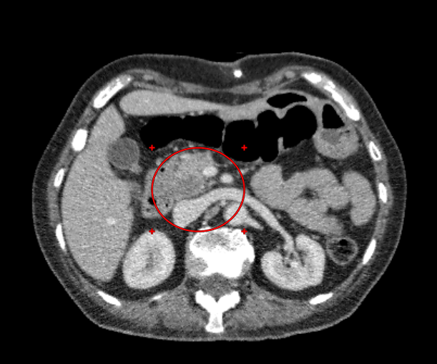

**Figure 1a.** Axial CT scan of pancreatic head adenocarcinoma.  
**Status:** Resectable – does not involve the celiac trunk (CT) and superior mesenteric artery (SMA); does not involve the superior mesenteric vein (SMV) and portal vein (PV).

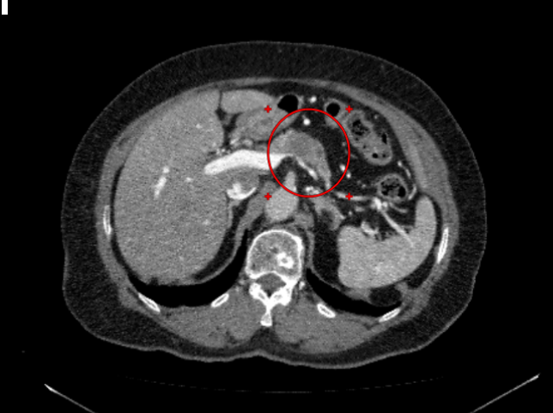

**Figure 1b.** Axial CT scan of pancreatic body adenocarcinoma.  
**Status:** Resectable – does not involve CT and SMA; involves SMV <180°.

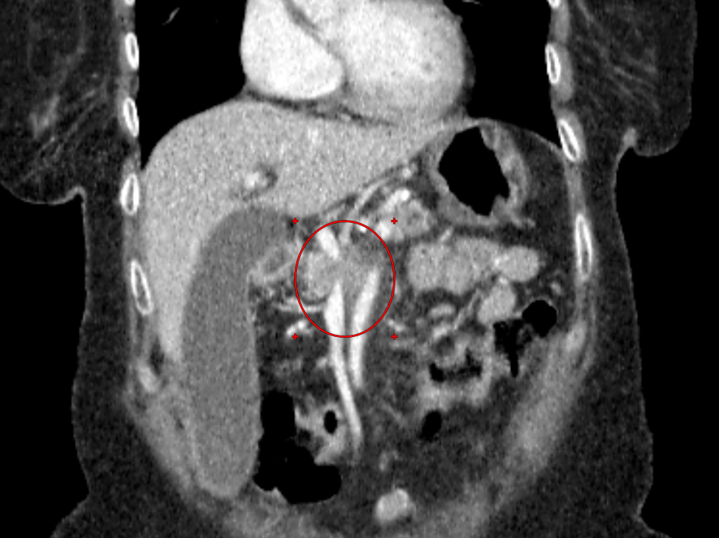

**Figure 1c.** Coronal CT scan of pancreatic head adenocarcinoma.  
**Status:**Unresectable – involves SMA >180°; tumor occlusion of SMV.

Radical surgery (subtotal pancreatectomy, partial resection, pancreaticoduodenectomy) was performed on 41 patients (19%), while 66 patients (30.5%) underwent palliative surgeries.

Among patients who underwent radical resections, 25 (61%) survived, with a mean follow-up duration of 258 days.

Among those who underwent palliative procedures (66 patients), 22 (33.3%) survived, with a mean follow-up duration of 262 days.

The mean life expectancy among deceased patients was without surgery 110 days, after radical resections 247 days, after palliative interventions 118 days (Table 3).

### Table 3. Survival and life expectancy depending on treatment type

| **Treatment Type** | **Number of Patients, n (%)** | **Alive,**  **n (%)** | **Mean Follow-up Duration, Days** | **Deceased,**  **n (%)** | **Mean Life Expectancy,**  **Days** |
| --- | --- | --- | --- | --- | --- |
| No Surgery | 109 (50.5%) | 37 (33.9%) | 308 | 72 (66.1%) | 110 |
| Radical Surgery | 41 (19.0%) | 25 (61%) | 258 | 16 (39.0%) | 247 |
| Palliative Surgery | 66 (30.5%) | 22 (33.3%) | 262 | 44 (66.7%) | 118 |

**Discussion**

Our study results confirm global literature data, indicating that PAC is most commonly localized in the pancreatic head, which is explained by its proximity to blood vessels and bile ducts.

Half of the patients had metastases at the time of diagnosis. Tumor localization influences prognosis: patients with tumors in the tail and body of the pancreas had the highest survival rates (62.5% and 50%, respectively), while widespread tumor forms were associated with the worst outcomes (survival rate – 18.2%).

Radical surgeries improve survival: the survival rate after resections was 61%, compared to 33.9% without surgery and 33.3% after palliative interventions. Additionally, the mean life expectancy among deceased patients increased to 247 days.

The low resectability rate due to tumor spread and major vessel involvement, along with the presence of metastases, underscores the need for effective strategies for early diagnosis and prevention.

Multislice CT (MSCT) with contrast enhancement has proven to be a highly informative diagnostic method; however, further studies are needed to optimize early detection and differential diagnosis of pancreatic tumors.

*Limitations; t*his study does not include data on patients who underwent chemotherapy for pancreatic adenocarcinoma.

*What’s Known?*Computed tomography with intravenous contrast is the method of choice for diagnosing, staging, and assessing tumor resectability.

*What’s New?*Key diagnostic patterns of pancreatic adenocarcinoma have been identified.

**Conclusion**

PAС remains a disease with extremely low survival rates, especially in the advanced stages. The presence of metastases significantly worsens the prognosis, reducing both the proportion of survivors and life expectancy. Surgery, especially tumor resection, has a positive effect on survival. Tumor localization affects the prognosis: tumors in the body and tail have a better outcome, while disseminated forms are associated with worse results. Efforts are needed to improve early diagnosis and improve the availability of high-tech imaging methods. Contrast-enhanced CT plays a key role in the evaluation of pancreatic tumors, but requires complementation with other diagnostic tools to improve efficiency.

**Keywords: pancreatic adenocarcinoma, metastases, survival, surgical treatment, CT.**

**References**

1. SuYY, ChiangNJ, ChiuTJ, HuangCJ, HsuSJ, LinHC, YangSH, YangY, ChouWC, ChenYY, BaiLY, LiCP, ChenJS. Systemic treatments in pancreatic cancer: Taiwan pancreas society recommendation. Biomed J. 2024 Jun;47(3):100696. doi: 10.1016/j.bj.2023.100696.
2. 2.Hu JX, Zhao CF, Chen WB, Liu QC, Li QW, Lin YY, Gao F. Pancreatic cancer: A review of epidemiology, trend, and risk factors. World J Gastroenterol. 2021 Jul 21;27(27):4298-4321. doi: 10.3748/wjg.v27.i27.4298.
3. Kenner B, Chari ST, Kelsen D, Klimstra DS, Pandol SJ, Rosenthal M, Rustgi AK, Taylor JA, Yala A, Abul-Husn N, Andersen DK, Bernstein D, Brunak S, Canto MI, Eldar YC, Fishman EK, Fleshman J, Go VLW, Holt JM, Field B, Goldberg A, Hoos W, Iacobuzio-Donahue C, Li D, Lidgard G, Maitra A, Matrisian LM, Poblete S, Rothschild L, Sander C, Schwartz LH, Shalit U, Srivastava S, Wolpin B. Artificial Intelligence and Early Detection of Pancreatic Cancer: 2020 Summative Review.Pancreas. 2021 Mar 1;50(3):251-279. doi: 10.1097/MPA.0000000000001762.
4. Rhee H, Park MS. The Role of Imaging in Current Treatment Strategies for Pancreatic Adenocarcinoma. Korean J Radiol. 2021 Jan;22(1):23-40. doi: 10.3348/kjr.2019.0862.
5. Latenstein AEJ, van der Geest LGM, Bonsing BA, et al. Nationwide trends in incidence, treatment and survival of pancreatic ductal adenocarcinoma. Eur J Cancer. 2020;125:83-93.
6. Kirkegard J, Bojesen AB, Nielsen MF, et al. Trends in pancreatic cancer incidence, characteristics, and outcomes in Denmark 1980-2019: a nationwide cohort study. Cancer Epidemiol. 2022;80:102230.
7. Hu JX, Zhao CF, Chen WB, Liu QC, Li QW, Lin YY, Gao F. Pancreatic cancer: A review of epidemiology, trend, and risk factors. World J Gastroenterol. 2021 Jul 21;27(27):4298-4321. doi: 10.3748/wjg.v27.i27.4298.
8. Conroy T, Pfeiffer P, Vilgrain V, Lamarca A, Seufferlein T, O'Reilly EM, Hackert T, Golan T, Prager G, Haustermans K, Vogel A, Ducreux M; ESMO Guidelines Committee. Electronic address: clinicalguidelines@esmo.org. Pancreatic cancer: ESMO Clinical Practice Guideline for diagnosis, treatment and follow-up. Ann Oncol. 2023 Nov;34(11):987-1002. doi: 10.1016/j.annonc.2023.08.009.
9. TemperoMA, MalafaMP, Al-HawaryM, BehrmanSW, BensonAB, CardinDB, ChioreanEG, ChungV, CzitoB, DelChiaroM, DillhoffM, DonahueTR, DotanE, FerroneCR, FountzilasC, HardacreJ, HawkinsWG, KluteK, KoAH, KunstmanJW, LoConteN, LowyAM, MoravekC, NakakuraEK, NarangAK, ObandoJ, PolancoPM, ReddyS, ReyngoldM, ScaifeC, ShenJ, VollmerC, WolffRA, WolpinBM, LynnB, GeorgeGV.Pancreatic Adenocarcinoma, Version 2.2021, NCCN Clinical Practice Guidelines in Oncology. J NatlComprCancNetw. 2021 Apr 1;19(4):439-457. doi: 10.6004/jnccn.2021.0017.

## Yang H, Li W, Ren L, Yang Y, Zhang Y, Ge B, Li S, Zheng X, Liu J, Zhang S, DU G, Tang BO, Wang H, Wang J. Progress on diagnostic and prognostic markers of pancreatic cancer. OncolRes. 2023 Apr 10;31(2):83-99. doi: 10.32604/or.2023.028905.

## Olakowski M, Grudzińska E. Pancreatic head cancer - Current surgery techniques. Asian J Surg. 2023 Jan;46(1):73-81. doi: 10.1016/j.asjsur.2022.05.117.

## Chen X, Liu F, Xue Q, Weng X, Xu F. Metastatic pancreatic cancer: Mechanisms and detection (Review). Oncol Rep. 2021 Nov;46(5):231. doi: 10.3892/or.2021.8182.

## Liu W, Zhang B, Liu T, Jiang J, Liu Y. Artificial Intelligence in Pancreatic Image Analysis: A Review. Sensors (Basel). 2024 Jul 22;24(14):4749. doi: 10.3390/s24144749.