**Title: Expanded criteria for lifetime donation in kidney transplantation.**

Saduakas N. T., Syzganov National Scientific Center of Surgery, Almaty, Kazakhstan, https://orcid.org/0000-0002-5249-1783

Baimakhanov B.B., Syzganov National Scientific Center of Surgery, Almaty, Kazakhstan,

Madadov I.K., Syzganov National Scientific Center of Surgery, Almaty, Kazakhstan, https://orcid.org/0000-0003-2241-8603

Belgibaev E.B., Syzganov National Scientific Center of Surgery, Almaty, Kazakhstan, https://orcid.org/0000-0002-9439-2628

Nabiev E. S., Syzganov National Scientific Center of Surgery, Almaty, Kazakhstan, https://orcid.org/0000-0002-6167-1962

Rgebayev B.G., Syzganov National Scientific Center of Surgery, Almaty, Kazakhstan, https://orcid.org/0000-0002-5201-3888

Akhmetov D., Syzganov National Scientific Center of Surgery, Almaty, Kazakhstan, <https://orcid.org/0009-0004-4598-0652>

**Author for correspondence:** Saduakas Nursultan T. - urologist, kidney transplantation, urology and nephrology department [nursultan2020.doc@bk.ru](mailto:nursultan2020.doc@bk.ru), +77473424642, ORCID **0000-0002-5249-1783**

**Declaration of conflicting interest.** The authors declared no potential conflicts of interest with respect to the research, authoship, and/or publication of this article.

**Expanded criteria for lifetime donation in kidney transplantation.**

Saduakas Nursultan T., Baimakhanov Bolatbek B., Madadov Islam K., Belgibaev Ernur B., Nabiev Elshad S, Rgebayev Berik G., Akhmetov Dilmurat

**Abstract**

An expanded criteria donor can be any donor over 60 years of age or a donor with a history of arterial hypertension. Selection of an expanded criteria donor can significantly reduce the waiting time for transplantation but requires written informed consent from the donor. Kidneys from an expanded criteria donor are known to have predictably poorer outcomes than donors with standard criteria. There is evidence that at 4-year follow-up, 90% of donor kidneys with expanded criteria are still functional. Donors with expanded criteria may be justified by careful selection of each donor for recipients as well as more sophisticated surgical techniques to maximize the kidney donor pool. The preparation of lifetime donors for kidney transplantation is a critical aspect of the transplantation process that significantly affects both donor and recipient outcomes. This literature review will examine current methods of living donor preparation, identify challenges faced by donors, and highlight strategies to optimize the donor preparation process.

**Keywords:** living donor nephrectomy, risk factor, selection criteria, GFR

**Introduction**

Kidney transplantation from a living donor (LDKT) is the optimal treatment for end-stage renal disease (ESRD), improving both patient and graft survival. Living donor kidney transplantation is a complex but vital process. Donor preparation requires a thorough assessment of health, psychological state, and readiness for surgery. A proper approach and support can significantly improve outcomes for both the donor and the recipient. Comprehensive evaluation, assessment, and psychological support for living donors before, during, and after donation have historically been considered the roles and responsibilities of transplant programs [2]. Each year, the number of patients with end-stage renal disease listed for kidney transplantation continues to grow, while the availability of donor kidneys increases only minimally.

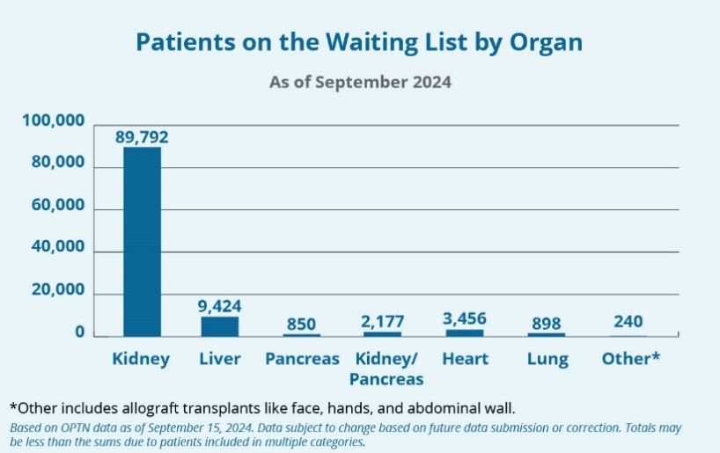

Figure 1. Patients on the waiting list by organ (September 2024) worldwide [7].

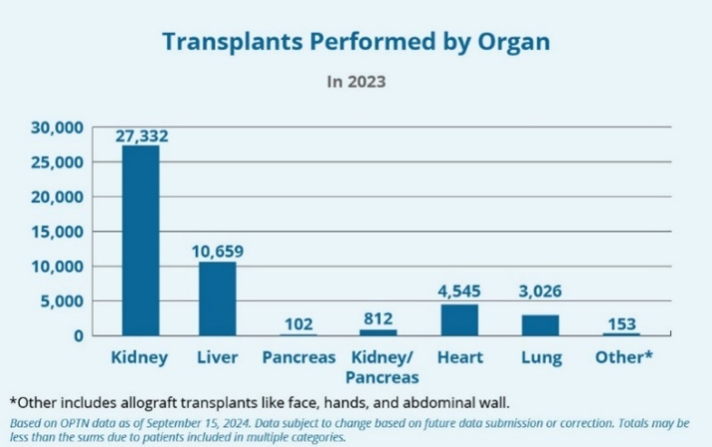

Figure 2. Transplants performed by organ (in 2023) worldwide [7].

Each year, for 100,000 people awaiting kidney transplantation, fewer than 17,000 donor kidneys are available. Given the continuously increasing number of patients in need of transplantation and the acute shortage of donor organs, it is necessary to expand the criteria for donor organ selection. The donor organ supply must be expanded to meet the rapidly and constantly growing demand from the large number of patients awaiting transplantation [6]. Due to the limited number of deceased donor kidneys available for transplantation, living donors play a crucial role in improving access to transplantation [4]. Additionally, kidney transplantation from marginal donors is an important solution to the organ shortage problem [11]. Moreover, dialysis patients have a three times higher overall mortality rate and a more than seven times higher cardiovascular mortality rate compared to patients who have undergone kidney transplantation [7].In kidney transplant recipients from living donors, one-year graft survival improved from 93.9% to 97.8% (a 4.2% improvement when comparing the 1995–1999 period to 2014–2017), while five-year graft survival increased from 79.0% to 86.5% (a 9.5% improvement when comparing the 1995–1999 period to 2010–2013) [11].From 2012 to August 2023, a total of 2,475 transplants were performed in the Republic of Kazakhstan, with 83.4% from living donors and 16.6% from deceased donors. Among these, 1,833 were kidney transplants. According to the Republican Coordination Center for Transplantology, as of July 10, 2024, the total number of patients on the waiting list was 4,112. Among them, 3,671 adults and 85 children were in need of a kidney transplant [23]. The aim of this study is to optimize the evaluation algorithm for living kidney donors in transplantation.

**Materials and Methods**

A comparative analysis of expanded kidney donation was conducted among patients without risk factors and those with at least one risk factor.

Overall, out of 203 living donors, 140 were identified as having no comorbidities, while 63 donors had at least one risk factor. From 2019 to 2022, the total number of living donors was 203, including 100 men and 103 women. The average donor age was 38 years (range: 30–73).

| **Parameter** | **Value** |
| --- | --- |
| **Total number of donors** | 203 |
| **Men** | 100 |
| **Women** | 103 |
| **Average donor age** | 38 years |
| **Age range** | 30-73 year |
| **Donors without comorbidities** | 140 |
| **Donors with risk factors** | 63 |

We retrospectively reviewed the medical data of donors, including age, sex, body mass index (BMI), comorbidities, blood pressure, kidney size, serum creatinine level, and glomerular filtration rate (GFR). We also analyzed recipient data, including age, sex, primary kidney disease, mean arterial pressure, serum creatinine level, duration of dialysis, history of hypertension and/or diabetes, HLA matches, vascular anastomosis time, total surgery time, and surgical complications. Follow-up data for donors were collected at 1 month, 6 months, and 12 months post-donation.

To identify risk factors, a thorough evaluation of donors was conducted, which included: - General history of the living donor - Additional metabolic studies - Kidney-specific tests - Anatomical assessment - Screening for transmissible diseases - Family history related to kidney diseases - Social history - Physical examination - General laboratory and imaging studies - Cancer screening

**Results**

Among the 203 living donors, 188 patients (92.6%) were younger than 60 years, while 15 patients (7.4%) were aged ≥60 years. The mean age in the elderly group was 64.8 ± 3.5 years compared to 35.8 ± 12.1 years in the younger group. Males comprised 52% of the elderly group versus 54.3% in the younger group (p = 0.590).There was no significant difference between the younger and elderly age groups in terms of hospital stay (6.7 ± 4 vs. 7.3 ± 3.8 days, p = 0.053). Acute rejection was observed in 5.5% of the younger group, compared to 6.7% in the elderly group (p = 0.535). Delayed graft function was noted in 4.3% of the younger group and 8.5% of the elderly group (p < 0.001).Serum creatinine levels measured at 1, 6, and 12 months post-transplantation were similar between the younger and elderly groups (p = 0.417, p = 0.231, p = 0.322, respectively). There was no difference in graft survival between the younger and elderly recipient groups after a median follow-up period of 120 months.

**Table: Comparative Analysis of Young and Elderly Donors**

| Parameter | **Younger Group (≤60 years)** | **Elderly Group (≥60 years)** | **p-value** |
| --- | --- | --- | --- |
| Total number of patients | 188 | 15 | - |
| Mean age (years) | 35,8 ± 12,1 | 64,8 ± 3,5 | - |
| Percentage of males | 54,3% | 52% | 0,590 |
| Hospital stay duration (days) | 6,7 ± 4 | 7,3 ± 3,8 | 0,053 |
| Acute rejection | 5,5% | 6,7% | 0,535 |
| Delayed graft function | 4,3% | 8,5% | < 0,001 |
| Creatinine level at 1 month | - | - | 0,417 |
| Creatinine level at 6 months | - | - | 0,231 |
| Creatinine level at 12 months | - | - | 0,322 |

The impact of donor age on kidney transplantation outcomes remains controversial. The older and younger age groups exhibited similar long-term kidney function. Additionally, the incidence of acute rejection was lower in the older age group compared to the younger group, although this difference did not reach statistical significance. It is suggested that aging is associated with a progressive decline in immune function, which may explain the higher incidence of acute rejection in the younger age group. This finding is consistent with recent studies. Following nephrectomy, close monitoring of donors with hypertension is crucial, as these patients have an increased lifetime risk of developing end-stage renal disease (ESRD). Even with normal pre-donation kidney function, every kidney donor carries a potential risk of developing at least stage 1 chronic kidney disease (CKD), according to the KDIGO 2012 classification.

Potential living donors vary in age, comorbidities, and their relationship with the recipient. All potential living donors must fully understand all components and stages of the donation process. It is essential to provide them with information about the evaluation, procedures, risks, benefits, and alternatives to living donation. Additionally, the individual must confirm that they are willing to become a donor voluntarily, without coercion, and without receiving valuable compensation in exchange for donation. They should also understand that they have the right to withdraw from the process at any time.

**Conclusion**

The main strength of this study is that it provides a comprehensive picture of the donor and recipient experience throughout the donation process, based on empirical published literature using a rigorous and systematic approach. These findings may be particularly valuable for new professionals working in the field of living kidney transplantation, as well as for specialists involved in specific stages of the process. Healthcare professionals can also gain insights into their role and impact on the transplantation process.

At a time when living kidney donation is being actively promoted and new donation approaches, such as paired exchange, are becoming more accessible, it is especially important to have a deeper understanding of the donor and recipient experience in this process. Our study results showed lower survival rates and a higher prevalence of delayed graft function (DGF) in recipients aged ≥60 years compared to younger recipients. However, the two groups had similar graft survival rates. These findings align with previous studies comparing elderly and younger recipients, which concluded that graft survival did not differ significantly between these groups.

**References**

1. Fehrman-Ekholm I. Transplantation. 1997;64(7):976-978. doi:10.xxxx/xxxx
2. van Dellen D, Burnapp L, Citterio F, Mamode N, Moorlock G, van Assche K, Zuidema WC, Lennerling A, Dor FJ. Pre-emptive live donor kidney transplantation-moving barriers to opportunities: An ethical, legal and psychological aspects of organ transplantation view. World J Transplant. 2021;11(4):88-98. doi:10.5500/wjt.v11.i4.88
3. Moore DR, Serur D, Rudow DL, Rodrigue JR, Hays R, Cooper M. Living donor kidney transplantation: improving efficiencies in live kidney donor evaluation–recommendations from a consensus conference. Clin J Am Soc Nephrol. 2015;10(9):1678-1686. doi:10.2215/CJN.01040115
4. Yohanna S, Naylor KL, Mucsi I, McKenzie S, Belenko D, Blake PG, et al. A quality improvement intervention to enhance access to kidney transplantation and living kidney donation (EnAKT LKD) in patients with chronic kidney disease: clinical research protocol of a cluster-randomized clinical trial. Can J Kidney Health Dis. 2021;8:2054358121997266. doi:10.1177/2054358121997266
5. Frutos MÁ, Crespo M, Valentín MO, Alonso-Melgar Á, Alonso J, Fernández C, et al. Recommendations for living donor kidney transplantation. Nefrologia (Engl Ed). 2022;42(Suppl 2):5-132. doi:10.1016/j.nefroe.2022.07.001
6. Sayin B. Living kidney donation criteria of Baskent University. Exp Clin Transplant. 2022;20(Suppl 4):62-64. doi:10.6002/ect.DonorSymp.2022.O4
7. Lentine KL, Smith JM, Miller JM, Bradbrook K, Larkin L, Weiss S, et al. OPTN/SRTR 2021 annual data report: Kidney. Am J Transplant. 2023;23(Suppl 1):S21-S120. doi:10.1016/j.ajt.2023.02.004
8. Plage H, Pielka P, Liefeldt L, Budde K, Ebbing J, Sugünes N, et al. Extended criteria donors in living kidney transplantation including donor age, smoking, hypertension and BMI. Ther Clin Risk Manag. 2020;16:787-793. doi:10.2147/TCRM.S256962
9. Lim HJ, Jambaldorj E, Lee Y, et al. Increasing use of the expanded criteria for living kidney donation and good outcomes of living kidney donors in Korea. Transplant Proc. 2016;48(7):2407–2411. doi:10.1016/j.transproceed.2016.02.091
10. Hamano I, Hatakeyama S, Fujita T, Murakami R, Hamaya T, Togashi K, et al. Living kidney transplantation from marginal donors presents feasible donor renal function despite inferior recipient renal function. Transplant Proc. 2020;52(6):1723-1728. doi:10.1016/j.transproceed.2020.01.157
11. Danovitch GM. Handbook of Kidney Transplantation. 4th ed. Boston, MA: Little, Brown and Company; 1996:323-328.
12. WHO Classification of Tumours Editorial Board. WHO Classification of Tumours of Soft Tissue and Bone. 5th ed. Lyon, France: IARC Press; 2020.
13. Lapach SN, Chubenko AV, Babich PN. Osnovnyye printsipy primeneniya statisticheskikh metodov v biologicheskikh ispytaniyakh. Kyiv, Ukraine: Morion; 2002:125-160.
14. Novick AC. Alternative bypass techniques in renal revascularization. In: Novick AC, Scoblle J, Hamilton G, eds. Renal Vascular Disease. London, UK: W.B. Sanders; 1995:497-509.
15. Davison AM, Cameron JS, Grunfeld JP, Kerr DNS, Ritz E, Winerals CG. Mesangiocapillary glomerulonephritis. In: Williams G, ed. Oxford Textbook of Clinical Nephrology. New York, NY: Oxford University Press; 1998:591-613.
16. Poggio ED, Augustine JJ, Arrigain S, Brennan DC, Schold JD. Long-term kidney transplant graft survival—making progress when most needed. Am J Transplant. 2021;21(8):2824-2832. doi:10.1111/ajt.16718
17. Bek JR, et al. The role of education in living kidney donation: a review. Transplant Proc. 2020;52(4):1298-1304. doi:10.1016/j.transproceed.2020.02.089
18. Cohen AJ, et al. The impact of social support on psychological well-being of living kidney donors. Am J Transplant. 2019;19(3):861-869. doi:10.1111/ajt.15128
19. Fitzgerald A, et al. Living kidney donation: a review of medical and psychosocial aspects. Transplant Rev. 2018;32(3):174-182. doi:10.1016/j.trre.2018.02.002
20. Gordon EJ, et al. Ethical considerations in living kidney donation. Am J Kidney Dis. 2019;73(5):657-664. doi:10.1053/j.ajkd.2018.12.016
21. Harris JR, et al. Socioeconomic barriers to living kidney donation: a qualitative study. Transplant Proc. 2021;53(5):1352-1356. doi:10.1016/j.transproceed.2021.03.035
22. Kirk AM, et al. Standardization of living kidney donation process: a systematic review. J Nephrol. 2020;33(3):639-648. doi:10.1007/s40620-020-00749-5
23. Kuo H, et al. Psychological well-being of living kidney donors: a literature review. Transplant Proc. 2021;53(6):2143-2149. doi:10.1016/j.transproceed.2021.03.045
24. Miller AJ, et al. Follow-up care for living kidney donors: a critical review. Transplant Int. 2021;34(4):678-686. doi:10.1111/tri.13839
25. Mok SH, et al. Outcomes of living kidney donor transplantation: a literature review. J Transplantol. 2020. doi:10.1016/j.transproceed.2020.04.089
26. Petersen ML, et al. Effectiveness of preoperative education for living kidney donors: a systematic review. Patient Educ Couns. 2022;105(2):345-356. doi:10.1016/j.pec.2021.09.012
27. Perry AE, et al. Emotional responses in living kidney donors: a systematic review. Transplant Proc. 2020;52(5):1498-1505. doi:10.1016/j.transproceed.2020.02.060
28. Министерство здравоохранения Республики Казахстан. Официальный сайт. Доступно по ссылке: https://www.gov.kz/memleket/entities/dsm/press/news/details/633699?lang=ru