# **Correlation between apolipoprotein B/A1 and the risk of metabolic-related fatty liver disease depending on the lipid profile**

Bekbossynova, M., Myrzakhmetova, G., Seitkasym, S., Sailybaeva, A., Khamitov, S., Daniyarova, G., Akzholova, K.

Makhabbat Bekbossynova - «University Medical Center» CF, Astana, Kazakhstan,. ORCID ID: <https://orcid.org/0000-0003-2834-617X>

Myrzakhmetova Gulzhan Shalataevna - «University Medical Center» CF, Astana, Kazakhstan,. ORCID ID: 0000-0001-8325-1267;

Seitkasym Sholpan Kanatovna - «University Medical Center» CF, Astana, Kazakhstan;

Sailybaeva Aliya Ibaidullaevna - «University Medical Center» CF, Astana, Kazakhstan,. ORCID ID: <https://orcid.org/0000-0002-1489-3837>

Khamitov Sadyk Rishatovich - «University Medical Center» CF, Astana, Kazakhstan,. ORCID ID: <https://orcid.org/0000-0001-6296-0507>

Daniyarova Gulnur Daniyarkyzy - «University Medical Center» CF, Astana, Kazakhstan,. ORCID ID: <https://orcid.org/0000-0001-5876-7528>

Akzholova Kamila Talgatkyzy - Nazarbayev University, Astana, Kazakhstan

ORCID ID: <https://orcid.org/0009-0000-2527-8947>

**Corresponding author:** Daniyarova Gulnur, Research Department, Corporate Fund “University Medical Center,” Kazakhstan, Astana, Turan Avenue, 38. Tel.: +77055965060, email: daniyarova.g@umc.org.kz

**Funding:** This research has been funded by the Science Committee of the Ministry of Science and Higher Education of the Republic of Kazakhstan (Grant No. BR21881970, Name: Development of new screening methods, to prevent early mortality and treatment of cardiovascular-diseases of atherosclerotic genesis in patients with atherosclerosis). The funders had no role in study design, data collection and analysis, decision to publish, or preparation of the manuscript.

**Conflicts of interest**: none

**Корреляция между аполипопротеином B/A1 и риском метаболически ассоциированной жировой болезни печени в зависимости от липидного профиля**

**Бекбосынова М., Мырзахметова Г., Сейткасим Ш., Сайлыбаева А., Хамитов С., Даниярова Г., Акжолова К.**

Махаббат Бекбосынова – Корпоративный фонд «University Medical Center», Астана, Казахстан. ORCID ID: https://orcid.org/0000-0003-2834-617X

Гульжан Шалатаевна Мырзахметова – Корпоративный фонд «University Medical Center», Астана, Казахстан. ORCID ID: 0000-0001-8325-1267

Шолпан Канатовна Сейткасим – Корпоративный фонд «University Medical Center», Астана, Казахстан

Алия Ибайдуллаевна Сайлыбаева – Корпоративный фонд «University Medical Center», Астана, Казахстан. ORCID ID: https://orcid.org/0000-0002-1489-3837

Садык Ришатович Хамитов – Корпоративный фонд «University Medical Center», Астана, Казахстан. ORCID ID: https://orcid.org/0000-0001-6296-0507

Гулнур Данияркызы Даниярова – Корпоративный фонд «University Medical Center», Астана, Казахстан. ORCID ID: https://orcid.org/0000-0001-5876-7528

Камила Талгаткызы Акжолова – Назарбаев Университет, Астана, Казахстан. ORCID ID: https://orcid.org/0009-0000-2527-8947

**Автор для корреспонденции:** Даниярова Гулнур, Научный департамент, Корпоративный фонд «University Medical Center», Казахстан, Астана, проспект Туран, 38. Тел.: +77055965060, email: [daniyarova.g@umc.org.kz](mailto:daniyarova.g@umc.org.kz)

**Финансирование:** Данное исследование было финансировано Комитетом науки Министерства науки и высшего образования Республики Казахстан (Грант № BR21881970, Название: Разработка новых методов скрининга для предотвращения ранней смертности и лечения сердечно-сосудистых заболеваний атеросклеротического генеза у пациентов с атеросклерозом). Финансирующие организации не принимали участия в разработке дизайна исследования, сборе и анализе данных, принятии решения о публикации или подготовке рукописи.

**Конфликт интересов:** отсутствует.

**Липидтік профильге байланысты аполипопротеин B/A1 мен метаболизммен байланысты майлы бауыр ауруының қаупі арасындағы корреляция**

Бекбосынова М., Мырзахметова Г., Сейтқасым Ш., Сайлыбаева А., Хамитов С., Даниярова Г., Ақжолова К.

**Махаббат Бекбосынова** – «University Medical Center» Корпоративтік қоры, Астана, Қазақстан. ORCID ID: <https://orcid.org/0000-0003-2834-617X>  
**Гүлжан Шалатайқызы Мырзахметова** – «University Medical Center» Корпоративтік қоры, Астана, Қазақстан. ORCID ID: 0000-0001-8325-1267  
**Шолпан Қанатқызы Сейтқасым** – «University Medical Center» Корпоративтік қоры, Астана, Қазақстан  
**Әлия Ібайдуллақызы Сайлыбаева** – «University Medical Center» Корпоративтік қоры, Астана, Қазақстан. ORCID ID: <https://orcid.org/0000-0002-1489-3837>  
**Садық Ришатұлы Хамитов** – «University Medical Center» Корпоративтік қоры, Астана, Қазақстан. ORCID ID: <https://orcid.org/0000-0001-6296-0507>  
**Гүлнұр Даниярқызы Даниярова** – «University Medical Center» Корпоративтік қоры, Астана, Қазақстан. ORCID ID: <https://orcid.org/0000-0001-5876-7528>  
**Қамила Талғатқызы Ақжолова** – Назарбаев Университеті, Астана, Қазақстан. ORCID ID: <https://orcid.org/0009-0000-2527-8947>

**Хат алмасуға жауапты автор:** Гүлнұр Даниярова, Ғылыми департамент, «University Medical Center» Корпоративтік қоры, Қазақстан, Астана, Тұран даңғылы, 38.  
Тел.: +77055965060, email: [daniyarova.g@umc.org.kz](mailto:daniyarova.g@umc.org.kz)

**Қаржыландыру:** Бұл зерттеу Қазақстан Республикасының Ғылым және жоғары білім министрлігі Ғылым комитеті тарапынан қаржыландырылды (Грант № BR21881970, Тақырыбы: Атеросклерозбен ауыратын науқастардағы ерте өлімнің алдын алу және атеросклеротикалық генездің жүрек-қантамыр ауруларын емдеуге арналған жаңа скрининг әдістерін әзірлеу). Қаржыландырушы ұйымдар зерттеу дизайнын әзірлеуге, деректерді жинау мен талдауға, жариялау туралы шешім қабылдауға немесе қолжазбаны дайындауға қатысқан жоқ.

**Мүдделер қақтығысы:** жоқ.

**Abstract**

**Objective.** This study aims to investigate the relationship between the Apo B/Apo A1 ratio and the risk of MAFLD, considering lipid profile variations. By analyzing the correlation between these biomarkers and clinical outcomes, we seek to determine whether the Apo B/Apo A1 ratio can serve as an independent predictor of MAFLD and its associated cardiovascular risks.

**Methods.** A total of 377 patients diagnosed with cardiovascular disease and coexisting MAFLD were were stratified into high-risk and very high-risk groups based on established clinical and imaging criteria. Lipid profiles, Apo B, and Apo A1 levels were measured, and their associations with cardiovascular and metabolic parameters were analyzed using correlation and regression models.

**Results.** The findings reveal a strong positive correlation between Apo B levels and atherogenic lipid markers such as LDL cholesterol and total cholesterol, as well as a moderate correlation with triglycerides. In contrast, Apo A1 demonstrated a strong positive association with HDL cholesterol and an inverse correlation with metabolic indicators such as HbA1c and glucose, suggesting a potential protective role. The Apo B/Apo A1 ratio emerged as a more accurate predictor of cardiovascular and metabolic risk than traditional lipid ratios. Furthermore, the Apo B/Apo A1 ratio was significantly associated with the presence and severity of MAFLD, reinforcing its potential utility as a biomarker for metabolic liver disease.

**Conclusion.** This study highlights the clinical relevance of incorporating apolipoprotein measurements into routine assessments for individuals at risk of metabolic and cardiovascular disorders.

**Keywords:** *Apolipoprotein B, Apolipoprotein A1, metabolic-associated fatty liver disease, cardiovascular disease, lipid metabolism, dyslipidemia, risk assessment*

**Аннотация**

**Цель.** Данное исследование направлено на изучение взаимосвязи между соотношением Apo B/Apo A1 и риском метаболически ассоциированной жировой болезни печени (МАЖБП) с учетом вариаций липидного профиля. Анализируя корреляцию между этими биомаркерами и клиническими исходами, мы стремимся определить, может ли соотношение Apo B/Apo A1 выступать в качестве независимого предиктора МАЖБП и связанных с ней сердечно-сосудистых рисков.

**Методы.** В исследование включены 377 пациентов с сердечно-сосудистыми заболеваниями и сопутствующей МАЖБП, которые были стратифицированы на группы высокого и очень высокого риска на основе клинических и визуализационных критериев. Были измерены показатели липидного профиля, уровни Apo B и Apo A1, а их взаимосвязь с кардиометаболическими параметрами анализировалась с помощью корреляционного и регрессионного анализа.

**Результаты.** Обнаружена сильная положительная корреляция между уровнем Apo B и атерогенными липидными маркерами, такими как ЛПНП-холестерин и общий холестерин, а также умеренная связь с триглицеридами. В то же время Apo A1 продемонстрировал сильную положительную ассоциацию с ЛПВП-холестерином и обратную корреляцию с метаболическими показателями, такими как HbA1c и уровень глюкозы, что свидетельствует о его потенциальной защитной роли. Соотношение Apo B/Apo A1 оказалось более точным предиктором кардиометаболического риска по сравнению с традиционными липидными индексами. Кроме того, установлена значимая связь между соотношением Apo B/Apo A1 и наличием и выраженностью МАЖБП, что подтверждает его перспективность в качестве биомаркера метаболической болезни печени.

**Заключение.** Настоящее исследование подчеркивает клиническую значимость включения измерений аполипопротеинов в рутинные обследования пациентов с риском метаболических и сердечно-сосудистых нарушений.

***Ключевые слова:*** аполипопротеин B, аполипопротеин A1, метаболически ассоциированная жировая болезнь печени, сердечно-сосудистые заболевания, липидный обмен, дислипидемия, оценка риска.

**Аңдатпа**

**Мақсат.** Бұл зерттеу липидтік профильдің өзгерістерін ескере отырып, Apo B/Apo A1 арақатынасы мен метаболизммен байланысты майлы бауыр ауруының (МБМБА) қаупі арасындағы өзара байланысты зерттеуге бағытталған. Осы биомаркерлер мен клиникалық нәтижелер арасындағы корреляцияны талдай отырып, Apo B/Apo A1 арақатынасының МБМБА және онымен байланысты жүрек-қантамырлық қауіптердің тәуелсіз предикторы ретінде қызмет ете алатынын анықтау көзделді.

**Әдістер.** Зерттеуге жүрек-қантамыр аурулары мен қатар жүретін МБМБА диагнозы қойылған 377 пациент енгізілді. Олар клиникалық және визуализациялық критерийлер негізінде жоғары және өте жоғары қауіп тобына жіктелді. Липидтік профиль көрсеткіштері, Apo B және Apo A1 деңгейлері өлшенді, олардың кардиометаболикалық параметрлермен байланысы корреляциялық және регрессиялық талдау әдістері арқылы зерттелді.

**Нәтижелер.** Apo B деңгейі мен атерогендік липидтік маркерлер (ТТЛП-холестерин және жалпы холестерин) арасында күшті оң корреляция, сондай-ақ триглицеридтермен орташа байланыс анықталды. Ал Apo A1 ТЖЛП-холестеринмен күшті оң байланыс көрсетті және HbA1c мен глюкоза деңгейімен кері корреляцияға ие болды, бұл оның ықтимал қорғаныштық рөлін айғақтайды. Apo B/Apo A1 арақатынасы дәстүрлі липидтік көрсеткіштермен салыстырғанда кардиометаболикалық қауіптің дәлірек предикторы ретінде анықталды. Сонымен қатар, Apo B/Apo A1 арақатынасы мен МБМБА бар-жоғы және оның айқындылығы арасында маңызды байланыс анықталды, бұл оның метаболизммен байланысты бауыр ауруының биомаркері ретіндегі болашағын көрсетеді.

**Қорытынды.** Бұл зерттеу аполипопротеиндерді өлшеуді метаболизмдік және жүрек-қантамырлық бұзылыстар қаупі бар пациенттерді рутиндік тексеруге енгізудің клиникалық маңыздылығын көрсетеді.

**Түйінді сөздер:** аполипопротеин B, аполипопротеин A1, метаболизммен байланысты майлы бауыр ауруы, жүрек-қантамыр аурулары, липидтік алмасу, дислипидемия, қауіпті бағалау.

**Introduction**

Apolipoproteins A and B, essential in lipid metabolism, are associated with the risk of cardiovascular disease [1, 2]. High levels of Apo B, associated with low-density lipoproteins (LDL), may indicate an increased risk of atherosclerosis and cardiovascular disease [3]. In contrast, higher levels of Apo A may indicate a favorable lipid profile, as the latter are associated with high-density lipoproteins (HDL).

Apolipoprotein B is a protein component of atherogenic low, intermediate and very low density lipoproteins (LDL, IDL, VLDL), the main carrier of circulating cholesterol. Excess cholesterol forms atherosclerotic plaques in blood vessels, leads to atherosclerosis and increases the risk of heart attacks and strokes. ApoB is one of the indicators of atherogenic dyslipidemia and is considered a more accurate marker than total cholesterol. Apo B is elevated in: familial hypercholesterolemia, liver disease, cholestasis, obesity, diabetes mellitus, renal failure, hypothyroidism, when taking diuretics, androgens, steroids, smoking [4, 15]. Apo B is reduced in the following cases: genetic diseases, alcoholism, hyperthyroidism, acute infections, starvation, intestinal malabsorption, diets high in polyunsaturated fatty acids, and when taking statins, thyroxine, and phenobarbital.

Apolipoprotein A1 (Apo A1) is a protein component of high-density lipoproteins which binds excess cholesterol and triglycerides and transports them back to the liver as part of HDL. Apo A1 reflects the antiatherogenic activity of lipoproteins. Even with a normal concentration of Apo B, a decrease in Apo A1 is a marker of atherosclerotic processes and a risk factor for cardiovascular diseases. Apo A1 is reduced in: hepatitis, cirrhosis, diabetes mellitus, renal failure, taking steroids, diuretics, and androgens [5]. An elevated level of Apo A1 has no diagnostic value and is observed when taking statins , phenobarbital , contraceptives, and during pregnancy [8]. The ratio of atherogenic Apo B particles to antiatherogenic Apo A1 is a marker of dyslipidemia and the risk of developing cardiovascular disorders [13, 14]. The higher the Apo A1 and the lower the Apo B, the lower the likelihood of developing these diseases.

Apolipoproteins are essential in systemic lipid metabolism, especially for the lipoproteins to which they are bound [9]. There is a close link between lipid metabolism in adipose tissue and the liver, since the latter behaves as a metabolic sensor of dysfunctional adipose tissue and is a major target of lipotoxicity [16]. Given that the energy balance between these two major lipogenic organs is closely related to the pathogenesis of obesity and metabolically associated fatty liver disease (MAFLD) [10, 11], the recent data regarding the intracellular function of exchangeable apolipoproteins in triglyceride metabolism in adipocytes and hepatocytes is reviewed in this research. These apolipoproteins may act as mediators between adipose tissue and liver, influencing the development of obesity and hepatosteatosis [7, 12]. This article provides new insights into the physiological role of exchangeable apolipoproteins and identifies hidden targets for therapeutic intervention in obesity and related disorders.

**Methods and materials**

From 2023 to February 2024 at the Heart Center of University Medical Center, 377 patients with cardiovascular diseases and concomitant metabolically associated fatty liver disease were selected. The group included patients with very high risk and high risk of cardiovascular complications. The criteria for inclusion in the very high-risk (VHR) group required the presence of at least one of the following factors: documented atherosclerotic cardiovascular disease, confirmed clinically or through imaging methods, including a history of acute coronary syndrome (ACS) (myocardial infarction, unstable angina), stable angina, coronary artery revascularization (percutaneous coronary intervention, coronary artery bypass grafting), stroke or transient ischemic attack, significant coronary artery stenosis (atherosclerotic plaques) detected via coronary angiography or CT angiography, or multi-vessel coronary artery disease. Additionally, a calculated 10-year risk of fatal cardiovascular events of ≥10% based on the SCORE scale was considered a criterion. The age range of participants was 18 to 65 years, with a mean age of 58 ± 6.7 years in the VHR group and 48 ± 10.4 years in the control group.

This study assessed the impact of Apo B/A1 ratio for the presence of MAFLD. The analysis was applied to examine the association between ApoB/A1 ratio and MAFLD in all subgroups of participants with different lipid profiles.

**Results**

MAFLD is the most common liver disease, and dyslipidemia is generally considered an important risk factor [for](https://www.sciencedirect.com/topics/medicine-and-dentistry/non-alcoholic-fatty-liver-disease) MAFLD. The findings demonstrate significant sex differences in a number of anthropometric and behavioral characteristics, such as smoking and alcohol consumption, as well as differences in ethnic composition between men and women, presented in Table 1.

Table 1. Demographic characteristics of patients.

|  |  |  |  |  |
| --- | --- | --- | --- | --- |
| **Characteristic** | **Total  (n= 377 )** | **Women**  **(n=167) (44.29%)** | **Men  (n=210) (55.7%)** | **Quantity observations** |
| Age ( years ) | 53.14 ± 8.88 | 54.05 ± 8.79 | 52.41 ± 8.90 | 377 |
| Height ( cm ) | 166.32 ± 10.15 | 158.89 ± 9.29 | 172.29 ± 6.04 | 375 |
| Weight ( kg ) | 81.67 ± 16.55 | 75.06 ± 15.40 | 86.97 ± 15.53 | 375 |
| BMI ( kg /m2) | 29.47 ± 5.32 | 29.75 ± 5.95 | 29.24 ± 4.76 | 374 |
| Smoking ( yes / no ) | 76 (20.16%) | 6 (3.59%) | 70 (33.33%) | 377 |
| Alcohol ( yes / no ) | 76 (20.16%) | 26 (15.57%) | 50 (23.81%) | 377 |
| Kazakh | 322 (85.41%) | 150 (89.82%) | 172 (81.90%) | 365 |
| Russian | 29 (7.69%) | 8 (4.79%) | 21 (10.00%) | 365 |
| Other | 14 (3.71%) | 5 (2.99%) | 9 (4.29%) | 365 |
| NAFLD | 15 (3.98%) | 6 (3.59%) | 9 (4.29%) | 377 |

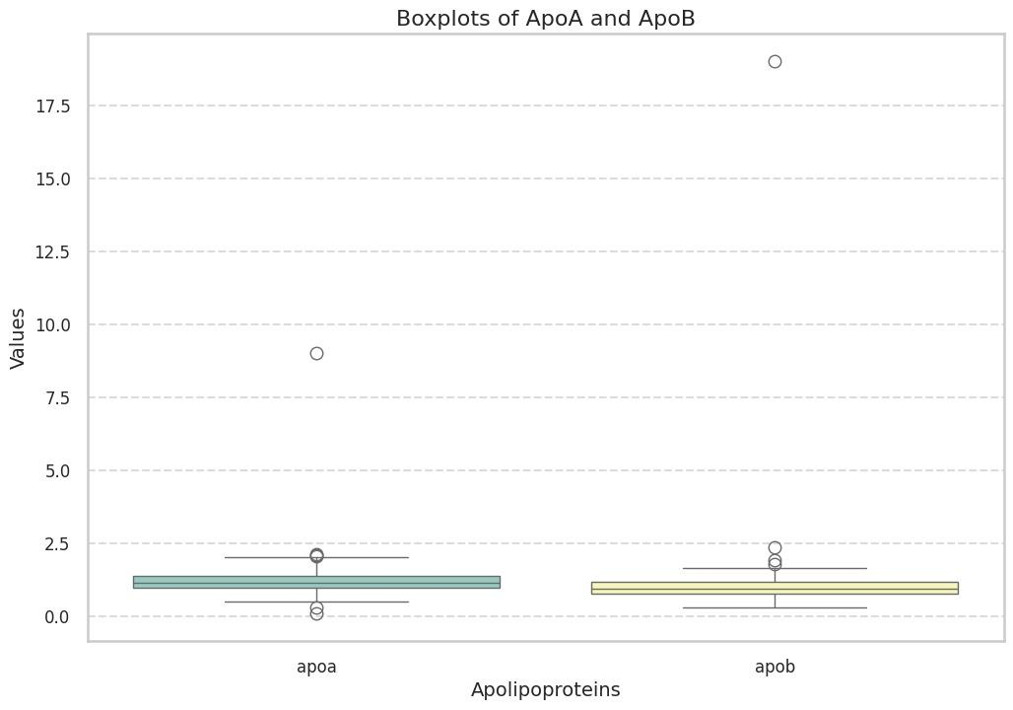

Figure 1. Whisker plot of Apo A and Apo B levels distribution. *The first graph shows a box plot of the distribution of Apo A levels in the study sample, and the second shows the distribution of Apo B levels.*

Apo A (g/L): The average value is in the range of 1.0–2.0 g/L, however, there are outliers, including a value above 8.0 g/L, which may indicate extreme values in the data or possible measurement errors. Apo B (g/L): The bulk of the data is concentrated in the range of 0.5–2.0 g/L, but there is an outlier with a level above 17.5 g/L, which may also indicate individual patient characteristics or methodological aspects.

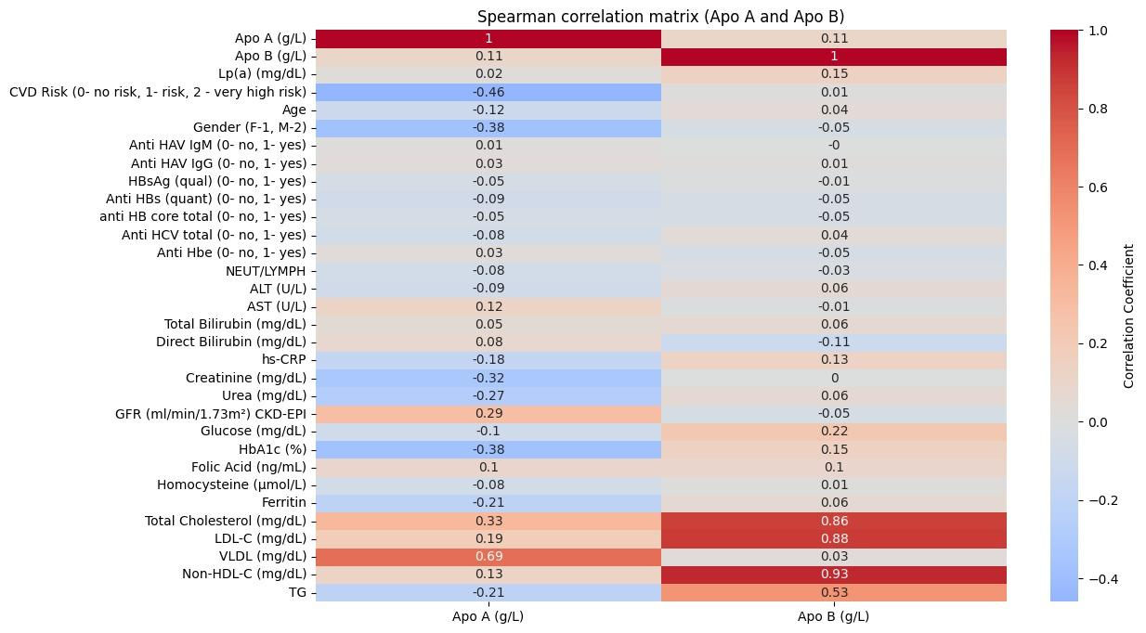

Figure 2. Spearman correlation analysis of Apo A and Apo B

Based on Spearman correlation analysis , presented as a heat map in Figure 2, relationships were identified between Apo A and Apo B levels with various clinical and biochemical parameters.

*Correlations of Apo A with different parameters*

Apo A levels show a moderate positive correlation with total cholesterol (r = 0.33) and high-density lipoprotein (HDL, r = 0.69) as shown in Figure 2. This is expected since Apo A is a key component of HDL. A weak negative correlation with HbA1c (r = -0.38) and glucose (r = -0.19) was found, which may indicate a protective role of Apo A in metabolic disorders. A moderate negative association with creatinine (r = -0.32) and SCF (r = 0.29) was found, which may indicate the influence of renal function on Apo A levels.

*Correlations of Apo B with different parameters*

Apo B correlates strongly with blood lipids: total cholesterol (r = 0.86), LDL (r = 0.88), non- HDL-C (r = 0.93). These indicators confirm the role of Apo B as the main protein component of atherogenic lipoproteins. A moderate positive association is observed with triglycerides (r=0.53).

A weak positive relationship with glucose (r = 0.22) and HbA1c (r = 0.15) may indicate its influence on the development of insulin resistance and diabetes. The negative association with gender (r = -0.38) may indicate higher Apo B levels in men.

**Discussion**

*Correlation of Apo A with lipid profile*

Our results show that Apo A is positively correlated with HDL levels (r = 0.687), as shown in Figure 2. This is consistent with literature data, where Apo A1, the main component of HDL, is associated with the antiatherogenic properties of lipoproteins [1]. Apo A is also associated with total cholesterol and LDL, which is confirmed by other studies showing a moderate positive correlation of Apo A with lipid parameters [2].

*Correlation of Apo B with lipid profile*

In our analysis of the results, Apo B has strong positive correlations with LDL (0.883) and non- HDL cholesterol (0.933). This is also confirmed in the literature, where Apo B is considered a better marker for assessing the risk of cardiovascular disease than LDL itself [3].

*Apo A, Apo B and cardiovascular risk*

Apolipoprotein B is important for consideration in conventional lipid ratios in predicting cardiovascular risk. Elevated plasma levels of apolipoprotein B remain an independent risk factor for predicting ischemic coronary events. Studies have demonstrated that Apo B is a superior marker of cardiovascular risk compared to LDL-C, particularly in individuals with desirable LDL-C levels, regardless of gender. In this study, the Apo B/Apo A-I ratio was identified as the only variable most strongly associated with an increased risk of fatal myocardial infarction, especially when lipid levels were within the desirable range. Additional findings from this study indicated that the total cholesterol/HDL-C ratio significantly underestimates cardiovascular risk, whereas the Apo B/Apo A-I ratio proved to be the best lipid-related variable for quantifying coronary risk, giving more significant outcomes that the total cholesterol/HDL-C, LDL-C/HDL-C, and non-HDL-C/HDL-C ratios. The key outcome of this study was the strong association between elevated Apo B levels and an increased risk of MI, whereas higher Apo A-I levels were not significantly correlated with a reduced MI risk. However, multivariate analysis revealed that the Apo B/Apo A-I ratio remained strongly associated with MI risk even after adjusting for other factors as age, body mass index, smoking, diabetes, and hypertension.

The correlation analysis showed that Apo A has a negative correlation with cardiovascular risk (-0.459), while Apo B does not show a significant correlation. The research also highlights that high Apo A1 and low Apo B are associated with low CVD risk [4]. Risk is better defined through the Apo B/ Apo A1 ratio, which has also been highlighted as an important risk indicator.

*Association with other factors*

Moderate correlations of Apo A with kidney function (GFR), as well as negative correlations of Apo B with inflammation (CRP) and glucose are also supported by literature data on the role of Apo A and Apo B in various metabolic processes (MAFLD) and their relationship with inflammation.

Outliers in the data require further analysis. Possible explanations include individual metabolic characteristics, the influence of drug therapy, and possible errors in laboratory measurements. Further analysis of the data taking into account the clinical characteristics of the patients will help clarify the causes of the observed deviations and identify their clinical significance.

Fatty liver disease associated with metabolic dysfunction is the most common liver disease (LD), which is increasingly becoming one of the causes of liver cirrhosis and liver cancer worldwide [16]. Global data indicated that the incidence and mortality of chronic liver disease due to MAFLD was higher than that of other causes of LD, and the standardized incidence rate of liver cirrhosis and cancer increased by 30% in 2017 compared with 2007, so the global burden of LD is substantial. In addition, there is no approved drug therapy for MAFLD [18, 19]. Some studies have shown an increase in the incidence of advanced liver disease and liver-related mortality in the coming years, to predict the burden of liver disease [20, 21]. Therefore, the ability of biomarkers to determine the risk of MAFLD is of great importance for the prevention and treatment of MAFLD.

Dyslipidemia is generally considered an important risk factor for MAFLD. Intrahepatic lipid accumulation in MAFLD results from abnormalities in lipid metabolism, such as increased whole-body lipolysis and very-low-density lipoprotein (VLDL) synthesis, and decreased triglyceride (TG) export [22].

As we have previously noted, Apo B is the major apolipoprotein and is the carrier of chylomicrons , LDL, VLDL and IDL. Another study showed that liver fat is the driving force of VLDL secretion–apoB-100. Several studies have consistently demonstrated that ApoB is an excellent predictor of coronary artery disease (CAD) and MAFLD risk and can be used as a target for CAD and MAFLD therapy [23]. Apo A1 is the major protein of HDL particles and plays a critical role in reverse cholesterol transport. Apo A1 expression can reduce steatosis by reducing lipid accumulation in hepatocytes and can also reduce endoplasmic reticulum stress, further reducing liver steatosis . A study by Bril, et al showed that although the differences in triglycerides and HDL-cholesterol between patients with and without fatty liver disease were small, but the difference in the ratio of Apo B to Apo A1 (Apo B/A1) was significant, and the Apo B/A1 ratio was significantly higher in patients with MAFLD. It was found that higher serum apo B level and lower Apo A1 level, higher Apo B/A1 ratios were significantly associated with the risk of MAFLD in the Korean population. Thus, fatty liver disease is negatively correlated with Apo A and positively correlated with Apo B. We suggest that Apo B/A1 ratio is a more accurate index to predict the risk of fatty liver disease compared with routine lipid, Apo B and Apo A1 determination.

**Conclusion**

According to the results of our study, the relationship between the apolipoprotein B/A1 ratio (Apo B/A1) and the risk of metabolically associated fatty liver disease is reliable and requires additional research for use in clinical practice.

The data of the correlation analysis highlight the differences in the metabolic role of apolipoproteins A and B. Apo A is associated with antiatherogenic processes, while Apo B is associated with atherogenic lipoproteins and metabolic risk factors. These results confirm the clinical significance of assessing Apo A and Apo B levels for cardiovascular risk stratification and diagnostics of metabolic disorders.

Correlation analysis confirmed the expected relationships between Apo A and high-density lipoproteins, as well as between Apo B and atherogenic lipids. Negative correlations of Apo A with metabolic parameters (glucose, HbA1c) and renal function ( creatinine , SCF) may indicate its protective role in cardiometabolic health. At the same time, positive correlation of Apo B with lipid fractions and glycemic parameters emphasizes its atherogenic potential.

# **Conflict of interests**

# The authors declare that they have no potential conflicts of interest that require disclosure in this article.

**Reference list**

1. Walldius, G., & Jungner, I. (2004). Apolipoprotein B and apolipoprotein A‐I: Risk indicators of coronary heart disease and targets for lipid‐modifying therapy. Journal of Internal Medicine, 255, 229–238. <https://doi.org/10.1046/j.1365-2796.2003.01276.x>
2. Zhu, Y., Verma, S., Fung, M., McQueen, M., Anderson, T., & Lonn, E. (2017). Association of apolipoproteins B and A-1 with markers of vascular health or cardiovascular events. The Canadian Journal of Cardiology, 33(10), 1305–1311. <https://doi.org/10.1016/j.cjca.2017.08.004>
3. Boekholdt, S., Arsenault, B., Mora, S., Pedersen, T., Larosa, J., Nestel, P., Simes, R., Durrington, P., Hitman, G., Welch, K., Demicco, D., Zwinderman, A., Clearfield, M., Downs, J., Tonkin, A., Colhoun, H., Gotto, A., Ridker, P., & Kastelein, J. (2012). Association of LDL cholesterol, non-HDL cholesterol, and apolipoprotein B levels with risk of cardiovascular events among patients treated with statins: A meta-analysis. JAMA, 307(12), 1302–1309. <https://doi.org/10.1001/jama.2012.366>
4. Tamang, H., Timilsina, U., Singh, K., Shrestha, S., Raman, R., Panta, P., Karna, P., Khadka, L., & Dahal, C. (2014). Apo B/Apo A-I ratio is statistically a better predictor of cardiovascular disease (CVD) than conventional lipid profile: A study from Kathmandu Valley, Nepal. Journal of Clinical and Diagnostic Research: JCDR, 8(2), 34–36. <https://doi.org/10.7860/JCDR/2014/7588.4000>
5. Walldius, G., & Jungner, I. (2007). Is there a better marker of cardiovascular risk than LDL cholesterol? Apolipoproteins B and A-I—New risk factors and targets for therapy. Nutrition, Metabolism, and Cardiovascular Diseases: NMCD, 17(8), 565–571. <https://doi.org/10.1016/J.NUMECD.2007.02.010>
6. Carr, S., Hooper, A., Sullivan, D., & Burnett, J. (2019). Non-HDL-cholesterol and apolipoprotein B compared with LDL-cholesterol in atherosclerotic cardiovascular disease risk assessment. Pathology, 51(2), 148–154. <https://doi.org/10.1016/j.pathol.2018.11.006>
7. Young Gil, C., Wook Jin, Y. K., Won Gil, C., Hong Joo, K., Woo Kyu, J., & Byung Ik, K. (2017). Apolipoprotein B/A1 ratio is independently associated with non-alcoholic fatty liver disease in nondiabetic subjects.
8. Younossi, Z. M., et al. (2016). Global epidemiology of nonalcoholic fatty liver disease—Meta-analytic assessment of prevalence, incidence, and outcomes. Hepatology, 64(1), 73–84.
9. Eckel, R. H., Grundy, S. M., & Zimmet, P. Z. (2005). The metabolic syndrome. The Lancet, 365(9468), 1415–1428.
10. Siddiqui, M. S., et al. (2015). Severity of nonalcoholic fatty liver disease and progression to cirrhosis are associated with atherogenic lipoprotein profile. Clinical Gastroenterology and Hepatology, 13(5), 1000–1008.e3.
11. Griffin, B. A. (1999). Lipoprotein atherogenicity: An overview of current mechanisms. Proceedings of the Nutrition Society, 58(1), 163–169.
12. Charlton, M., et al. (2002). Apolipoprotein synthesis in nonalcoholic steatohepatitis. Hepatology, 35(4), 898–904.
13. Shang, Y., et al. (2022). Risk of cardiovascular disease and loss in life expectancy in NAFLD. Hepatology, 76(5), 1495–1505.
14. McPherson, S., et al. (2015). Evidence of NAFLD progression from steatosis to fibrosing-steatohepatitis using paired biopsies: Implications for prognosis and clinical management. Journal of Hepatology, 62(5), 1148–1155.
15. Younossi, Z. M., et al. (2016). Global epidemiology of nonalcoholic fatty liver disease—Meta-analytic assessment of prevalence, incidence, and outcomes. Hepatology, 64(1), 73–84.
16. Hassen, G., et al. (2022). Nonalcoholic fatty liver disease: An emerging modern-day risk factor for cardiovascular disease. Cureus, 14.
17. Taylor, R. S., et al. (2020). Association between fibrosis stage and outcomes of patients with nonalcoholic fatty liver disease: A systematic review and meta-analysis. Gastroenterology, 158(6), 1611–1625.e12.
18. Younossi, Z., et al. (2019). Global perspectives on nonalcoholic fatty liver disease and nonalcoholic steatohepatitis. Hepatology, 69(6), 2672–2682.
19. Younossi, Z., et al. (2019). Global perspectives on nonalcoholic fatty liver disease and nonalcoholic steatohepatitis. Hepatology, 69(6), 2672–2682.
20. Liu, Y., et al. (2019). Nonalcoholic fatty liver disease and mortality from all causes, cardiovascular disease, and cancer: A meta-analysis. Scientific Reports, 9(1), 11124.
21. Sanyal, A. J., et al. (2021). Prospective study of outcomes in adults with nonalcoholic fatty liver disease. New England Journal of Medicine, 385(17), 1559–1569.
22. Katsiki, N., Mikhailidis, D. P., & Mantzoros, C. S. (2016). Non-alcoholic fatty liver disease and dyslipidemia: An update. Metabolism, 65(8), 1109–1123.
23. Siddiqui, M. S., et al. (2015). Severity of nonalcoholic fatty liver disease and progression to cirrhosis are associated with atherogenic lipoprotein profile. Clinical Gastroenterology and Hepatology, 13(5), 1000–1008.e3.
24. Hwang, H. W., et al. (2020). Correlation between the small dense LDL level and nonalcoholic fatty liver disease: Possibility of a new biomarker. Medicine, 99(28).