Autalipov Darkhan - Corporate Fund "University Medical Center" https://orcid.org/0000-0002-6458-6712
Bekpan Almat - MD, PhD, Corporate Fund "University Medical Center" https://orcid.org/0000-0003-2185-6345
Sagandykova Nazym - MD, MMSc, PhD, Corporate Fund "University Medical Center", https://orcid.org/0000-0002-7274-8101
Baurzhan Madina - PhD, Research Institute of Balneology and Medical Rehabilitation, Astana, Kazakhstan, https://orcid.org/0000-0003-1244-8673

Author for correspondence: Sagandykova Nazym S., Ph.D, clinical researcher, CF “UMC”, +7 701 8888 542, doctor.ent.alm@gmail.com
Conflict of Interest The authors declare no conflicts of interest. The study was conducted objectively without external influence.

CLINICAL CASE

CLINICAL CASE OF MONOSTOTIC FIBROUS DYSPLASIA IN A CHILD

Autalipov Darkhan¹, Bekpan Almat¹, Sagandykova Nazym¹, Baurzhan Madina²

1 - Corporate Fund "University Medical Center" Astana, Kazakhstan
2 - Research Institute of Balneology and Medical Rehabilitation, Astana, Kazakhstan

Abstract
Background. Fibrous dysplasia is a rare tumor-like condition characterized by the replacement of normal bone with fibrous tissue, with an etiology of uncertain origin. Diagnosis relies on clinical and radiological data, with biopsies used in doubtful cases. The aim of our study is to demonstrate our experience in working with a rare pathology such as fibrous dysplasia of the pterygoid process.
Materials and methods. The report a clinical case of isolated fibrous dysplasia affecting the pterygoid process of the left sphenoid bone, treated in the Pediatric Head and Neck Surgery Department of the University Medical Center, Astana, Kazakhstan. The patient, a 15-year-old girl, presented with a diagnosis of fibrous osteodysplasia of the left pterygoid process of the sphenoid bone.
Results. As a result of surgical treatment, we did not observe an increase in the tumor during a 3-year follow-up.
Conclusion Diagnosis of some tumors, such as fibrous dysplasia, is difficult and requires modern diagnostic methods.
Keywords: fibrous dysplasia, tumor-like process, children, histiocytosis, bone tissue lesion.

Introduction
The onset of fibrous dysplasia is usually subtle, with initial symptoms such as headaches [1, 2] or ocular disturbances. Early diagnostic efforts typically involve neurologists, ophthalmologists, and pediatricians [3]. Diagnosing craniofacial bone disorders in children is challenging due to the variability of clinical presentations, the subtlety of symptoms, and the extended latent periods [4]. This complexity often delays diagnosis, which may negatively impact the child’s development or lead to disability [5].
Fibrous dysplasia affects the craniofacial region in 10–29% of cases in children, according to international data [6, 7]. However, no specific epidemiological data exist for Kazakhstan or other CIS countries. Among all bone pathologies, fibrous dysplasia accounts for approximately 2.5% [8] and up to 7.5% in cases of bone-related cancers [9]. The condition affects boys and girls equally, with the age of diagnosis typically ranging from 5 to 30 years [10]. Most cases manifest during childhood, with disease progression often coinciding with skeletal growth. Bone lesions usually develop soon after puberty [11], with a sarcomatous transformation risk ranging from 0.5% to 4% [12].
Monostotic forms are most commonly found in the ribs, craniofacial bones (mandible and maxilla), and femur [13]. Polyostotic forms often involve the lower limbs, pelvis, and may include skin and endocrine pathologies as part of McCune-Albright syndrome [14].
Cranial fibrous dysplasia may be asymptomatic or present with symptoms such as exophthalmos, facial pain, dizziness, facial asymmetry, cranial nerve impairment, sinusitis, or headaches, depending on the lesion’s location [15-17]. Radiologically, affected areas can appear dense or lucent compared to surrounding bone, sometimes resembling "ground glass." Lesions may have sclerotic borders or diffuse margins, particularly in cranial bones. Fractures may present with pronounced periosteal reactions [18-20].

Clinical presentation
A 15-year-old girl presented with complaints of persistent headaches. Her symptoms reportedly began in 2019 with episodes of dizziness, primarily at night. Initial physical examinations revealed no significant abnormalities except signs of medicamentous rhinitis. An otorhinolaryngologist identified nasal congestion linked to frequent use of decongestant nasal sprays and referred her for radiographic imaging of the paranasal sinuses, which revealed an abnormality. Subsequent computed tomography (CT) identified a lesion in the sphenoid bone.
Diagnostic Imaging
CT of the paranasal sinuses (November 9, 2021) (Figure 1):
- Axial and 3D reconstructed scans revealed abnormal "ground glass"-like changes in the left sphenoid sinus with intact cortical layers, measuring approximately 3.7 × 1.8 × 2.0 cm.
- A polypoid formation in the left maxillary sinus was noted, measuring 1.2 × 1.0 cm with clear borders and a density of 51 HU.
- Additional MRI (July 25, 2019) confirmed the lesion in the left sphenoid bone.

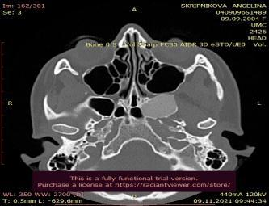 | 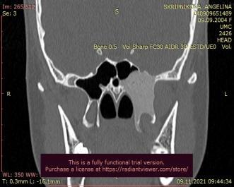
Figure 1. Patient's CT scans before surgery dated 09.11.2021 (a-axial, b-coronary)

Treatment
The patient underwent endoscopic surgical removal of the lesion on December 14, 2021, performed under general anesthesia during a master class in the Pediatric Head and Neck Surgery Department of "UMC." Specialists from Dmitry Rogachev National Medical Research Center, Moscow, participated in the procedure. The lesion was removed using a surgical burr without complications. Histopathological analysis confirmed the diagnosis of fibrous dysplasia. Postoperative recovery was uneventful, and the patient was discharged on the 10th day in satisfactory condition.On subsequent tomography of the paranasal sinuses 10 months after the surgery, partial fibrous dysplasia of the pterygoid process was determined (Figure 2).
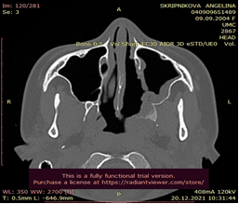 | 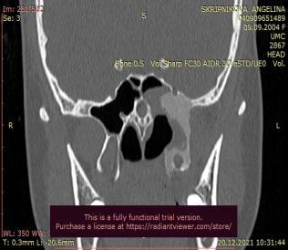
Figure 2 After surgery dated 09.09.2022 (a-axial, b-coronary)

Follow-Up
Three years postoperatively, CT imaging (2024) showed residual fibrous dysplasia in the left sphenoid bone without progression (Figure 3). A postoperative defect in the medial wall of the left maxillary sinus was observed.
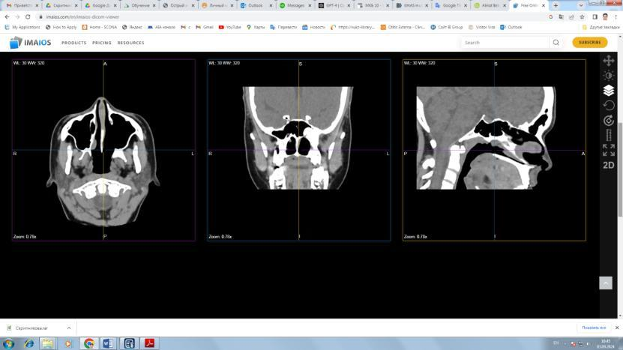
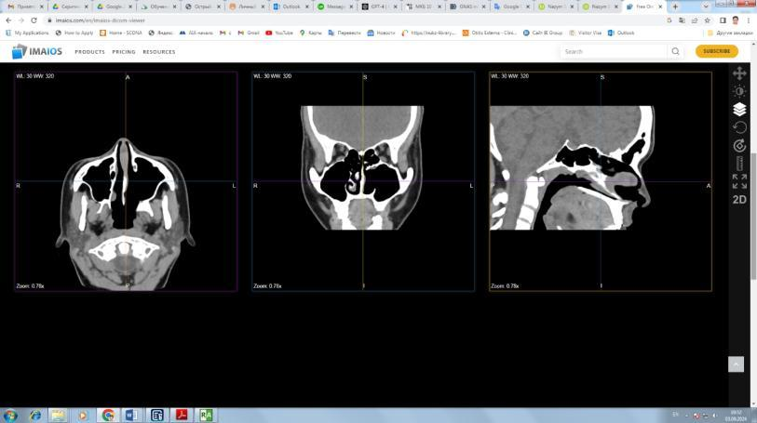
Figure 3 –Follow up after surgery dated 09.09.2024 (a-axial, b-coronary)

Discussion
This work is devoted to such a rare pathology as fibrous dysplasia (FD), which is classified as a benign formation [21]. This formation can affect several bones at the same time, which can subsequently lead to its change, progress in the form of bone atrophy and, accordingly, to deterioration [22]. It is noted that fibrous bone lesions in childhood occur more in the craniofacial bones, especially in the upper jaw, lower jaw and sphenoid bone [23].
Our study is devoted to a rarer form of FD of the cranial bones, which, according to the literature, occurs in less than 3% [24], especially the monostotic form of sphenoid bone lesion. A clinical case of a 15-year-old female patient with isolated fibrous dysplasia of the left pterygoid process of the sphenoid bone is presented. With scanty symptoms (headaches), the tumor was detected by routine examination by neurologists using magnetic resonance imaging, followed by contrast computed tomography of the brain.
The pathognomic sign of FD of bone tissue was changes of the "ground glass" type on the X-ray picture, which corresponds to the literature data [25, 26]. It was this picture that was of decisive importance in the correct diagnosis of FD in a child, since differentiation is needed from similar conditions, such as ossifying fibromas or other benign bone tumors. The patient's treatment based on transnasal endoscopic partial removal of the affected tissue. This therapeutic tactic allows us to reduce the invasive intervention risks in the head in the postoperative period, which is confirmed by other authors [27].
The patient's recovery was successful, and no signs of process progression were found during subsequent observations. Despite this, it is important to note that bone tissue FD, especially is monoaxial, are subject to gradual growth and malignancy [28].
It is important to monitor such patients for a long time, with repeated CT scans of the brain every year. We periodically examined her during this period and did not notice any signs of progression.
This clinical case is unique in that the lesion of the sphenoidal bone is casuistic and we did not find a similar description of the case in the literature. Most often, FD is observed in long bones (forearm, femur), sometimes in the pelvic bones [29]. There are cases of craniofacial lesions of fibrous dysplasia in the literature among children [30], where endoscopic approaches were also used in treatment. The peculiarity of our case is that a gentle minimally invasive approach was used in the treatment, which reduced the cosmetic and psychological damage to the child, but was no less effective in therapy.

Limitations. Despite the favorable outcome, the postoperative period was only 3 years. This category of patients requires long-term follow-up (10-20 years), and sometimes lifelong. In addition, it is necessary to conduct a genetic study of patients admitted to FD to exclude mutation of GNAS genes, which is often associated with FD [31].

Conclusion. Isolated lesion of the sphenoydal bone by fibrous dysplasia is a rare pathology. In diagnostics, it is necessary to use computed tomography with contrast, which will reveal the complex structure of the disease. Endoscopic transnasal resection of the tumor is currently a gentle and effective tactic in the treatment of these patients. However, longer follow-up and annual imaging (CT of the brain) are required to monitor disease progression.
Acknowledgments. We would like to express our gratitude to the specialists from the Dmitry Rogachev National Medical Research Center, Moscow, for their collaboration during the surgical procedure. Additionally, we thank the Pediatric Head and Neck Surgery Department of the University Medical Center for their support in the treatment and follow-up of this patient.

Authors' Contribution. Autalipov Darkhan: conceptualization, methodology, and writing of the manuscript, Surgical intervention and postoperative care. Bekpan Almat: clinical management of the patient and data collection. Sagandykova Nazym: Radiological analysis and imaging data interpretation, conceptualization, methodology. Baurzhan Madina: conceptualization, methodology, clinical management of the patient and data collection.

References
- Gun ZH, Arif A, Boyce AM. Fibrous dysplasia in children and its management. Curr Opin Endocrinol Diabetes Obes. 2024;31(1):60-66. doi:10.1097/MED.0000000000000847
- Szymczuk V, Taylor J, Boyce AM. Craniofacial Fibrous Dysplasia: Clinical and Therapeutic Implications. Curr Osteoporos Rep. 2023;21(2):147-153. doi:10.1007/s11914-023-00779-6
- Tucker-Bartley A, Selen DJ, Golden E, et al. Pharmacological Interventions Targeting Pain in Fibrous Dysplasia/McCune-Albright Syndrome. Int J Mol Sci. 2023;24(3):2550. Published 2023 Jan 29. doi:10.3390/ijms24032550
- Szymczuk V, Taylor J, Michel Z, Sinaii N, Boyce AM. Skeletal Disease Acquisition in Fibrous Dysplasia: Natural History and Indicators of Lesion Progression in Children. J Bone Miner Res. 2022;37(8):1473-1478. doi:10.1002/jbmr.4618
- Cherian KE, Paul TV. Inherited fibroblast growth factor 23 excess. Best Pract Res Clin Endocrinol Metab. 2024;38(2):101844. doi:10.1016/j.beem.2023.101844
- Gun ZH, Arif A, Boyce AM. Fibrous dysplasia in children and its management. Curr Opin Endocrinol Diabetes Obes. 2024;31(1):60-66. doi:10.1097/MED.0000000000000847
- 2. Szymczuk V, Taylor J, Boyce AM. Craniofacial Fibrous Dysplasia: Clinical and Therapeutic Implications. Curr Osteoporos Rep. 2023;21(2):147-153. doi:10.1007/s11914-023-00779-6
- Rutkowski M, Niewinska K. The Epidemiology of Benign Proliferative Processes of the Skeletal System in Children. Int J Environ Res Public Health. 2021;18(17):9338. Published 2021 Sep 3. doi:10.3390/ijerph18179338
- Vilos I, Nieminen MT, Mäkitie RE. Fibrous dysplasia of the head and neck in Southern Finland: a retrospective study on clinical characteristics, diagnostics, and treatment. Eur Arch Otorhinolaryngol. 2024;281(6):3189-3195. doi:10.1007/s00405-024-08595-z
- Golden E, van der Heijden H, Ren B, et al. Phenotyping Pain in Patients With Fibrous Dysplasia/McCune-Albright Syndrome. J Clin Endocrinol Metab. 2024;109(3):771-782. doi:10.1210/clinem/dgad589
- Garg RK, O'Connor MK, Sterling DA, Jacob L, Hammoudeh JA, Andrews BT. Pediatric Odontogenic and Maxillofacial Bone Pathology: A Global Analysis. J Craniofac Surg. 2022;33(3):870-874. doi:10.1097/SCS.0000000000008201
- Ghidei L, Bruno-Gaston JA, Guner JZ, Dietrich JE. Prevalence of Polycystic Ovary Syndrome in Patients With McCune Albright Syndrome. J Pediatr Adolesc Gynecol. 2022;35(1):48-52. doi:10.1016/j.jpag.2021.05.014
- Yang K, Ellenbogen Y, Algird AR, Sommer DD, Reddy K. Visual Outcomes After Endoscopic Endonasal Resection of Orbital Lesions. World Neurosurg. 2020;139:e501-e507. doi:10.1016/j.wneu.2020.04.050
- Benaessa MM, Mahomed F, Ngwenya SP. A retrospective clinico-pathologic analysis of cemento-osseous dysplasia in a South African patient population. Afr Health Sci. 2019;19(4):3154-3159. doi:10.4314/ahs.v19i4.38
- Brody A, Zalatnai A, Csomo K, Belik A, Dobo-Nagy C. Difficulties in the diagnosis of periapical translucencies and in the classification of cemento-osseous dysplasia. BMC Oral Health. 2019;19(1):139. Published 2019 Jul 10. doi:10.1186/s12903-019-0843-0
- Meier ME, Vágó E, Abrahamsen B, et al. Incidence and Prevalence of Fibrous Dysplasia/McCune-Albright Syndrome: A Nationwide Registry-Based Study in Denmark. J Clin Endocrinol Metab. 2024;109(6):1423-1432. doi:10.1210/clinem/dgad744
- Carmoi T, Freche G. Dysplasie fibreuse polyostotique [Polyostotic fibrous dysplasia]. Rev Prat. 2022;72(9):990-991.
- Xu Y, Li Y, Dong H, et al. Craniofacial Fibrous Dysplasia in Fronto-Orbital Region: A Single-Center Retrospective Study of 38 Cases. World Neurosurg. 2024;181:e1130-e1137. doi:10.1016/j.wneu.2023.11.054
- Blum JD, Cho DY, Villavisanis DF, et al. The Natural History of Fibrous Dysplasia of the Orbit. Plast Reconstr Surg. 2024;153(5):962e-970e. doi:10.1097/PRS.0000000000010680
- Bertin H, Huon JF, Guillot P, et al. Fibrous dysplasia of the orbital region: Series of 12 cases and review of the literature. J Fr Ophtalmol. 2020;43(6):467-476. doi:10.1016/j.jfo.2019.10.012
- van der Bruggen W, Hagelstein-Rotman M, de Geus-Oei LF, et al. Quantifying skeletal burden in fibrous dysplasia using sodium fluoride PET/CT. Eur J Nucl Med Mol Imaging. 2020;47(6):1527-1537. doi:10.1007/s00259-019-04657-1
- Duarte PS, Sapienza MT. Normalization by bone volume instead of body weight or lean body mass may be better for quantifying skeletal burden in fibrous dysplasia using sodium fluoride PET/CT. Eur J Nucl Med Mol Imaging. 2020;47(6):1349-1350. doi:10.1007/s00259-020-04688-z
- Shi C, Li ZM, Sun HC. Zhonghua Kou Qiang Yi Xue Za Zhi. 2023;58(2):124-130. doi:10.3760/cma.j.cn112144-20220905-00477
- Mainville GN, Turgeon DP, Kauzman A. Diagnosis and management of benign fibro-osseous lesions of the jaws: a current review for the dental clinician. Oral Dis. 2017;23(4):440-450. doi:10.1111/odi.12531
- Ling Z, Xiao N, Li Y, et al. Differential expression profiles and function prediction of tRNA-derived fragments in fibrous dysplasia. Arch Oral Biol. 2022;135:105347. doi:10.1016/j.archoralbio.2022.105347
- Ma M, Liu L, Shi R, et al. Copy number alteration profiling facilitates differential diagnosis between ossifying fibroma and fibrous dysplasia of the jaws. Int J Oral Sci. 2021;13(1):21. Published 2021 Jun 30. doi:10.1038/s41368-021-00127-3
- Tucker-Bartley A, Selen DJ, Golden E, et al. Pharmacological Interventions Targeting Pain in Fibrous Dysplasia/McCune-Albright Syndrome. Int J Mol Sci. 2023;24(3):2550. doi:10.3390/ijms24032550
- Wormald PJ, et al. Endoscopic Surgery for Fibrous Dysplasia of the Craniofacial Region. J Laryngol Otol. 2020;134(3):215-221. doi:10.1017/S0022215119002195
- 5. Meier ME, et al. Incidence and Prevalence of Fibrous Dysplasia/McCune-Albright Syndrome: A Nationwide Registry-Based Study in Denmark. J Clin Endocrinol Metab. 2024;109(6):1423-1432. doi:10.1210/clinem/dgad744
- 6. Xu Y, Li Y, Dong H, et al. Craniofacial Fibrous Dysplasia in Fronto-Orbital Region: A Single-Center Retrospective Study of 38 Cases. World Neurosurg. 2024;181:e1130-e1137. doi:10.1016/j.wneu.2023.11.054
- 7. Vilos I, Nieminen MT, Mäkitie RE. Fibrous dysplasia of the head and neck in Southern Finland: a retrospective study on clinical characteristics, diagnostics, and treatment. Eur Arch Otorhinolaryngol. 2024;281(6):3189-3195. doi:10.1007/s00405-024-08595-z

