Diagram #1. Frequency of unjustified studies per month.

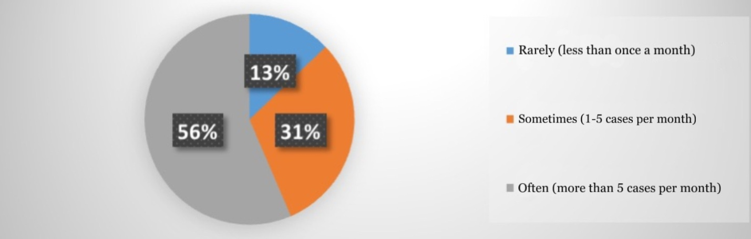

Diagram #2. Distribution of unjustified appointments by type of trials

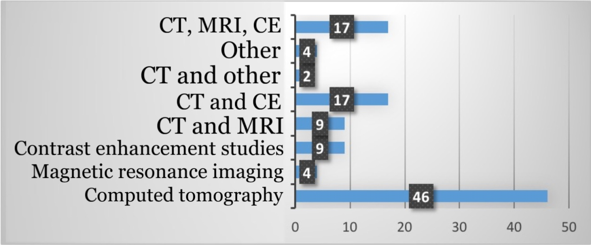

Diagram #3. Main difficulties in prescribing CT and MRI scans

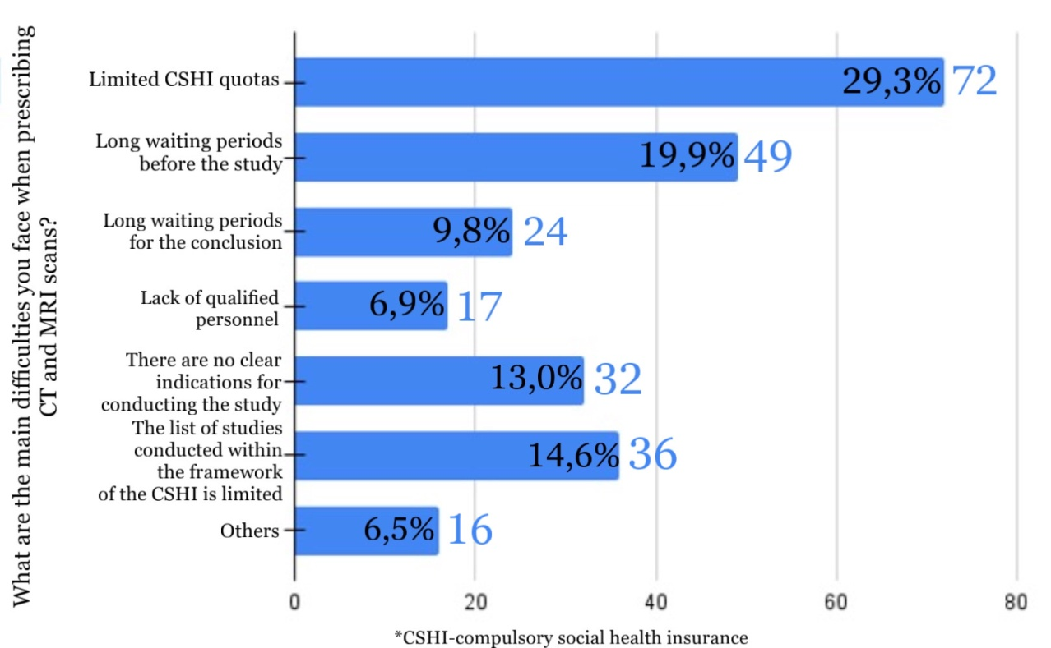

Diagram #4. The need to develop approaches to determining the need for high-tech methods of radiology diagnostics

