**Author’s list**

**Yermashov Bolat Shaikhidinovich –** врач-хирург, АО ННЦХ им.А.Н. Сызганова, <https://orcid.org/0000-0002-3801-848Х>, [bula.tex@mail.ru](mailto:bula.tex@mail.ru)

**Nurlanbayev Yerik Kumarbekovich** – PhD, врач-хирург, АО ННЦХ им.А.Н. Сызганова, <https://orcid.org/0000-0001-8758-5061>, [nurlanbayevyerik@gmail.com](mailto:nurlanbayevyerik@gmail.com)

**Nagasbekov Madiyar Sabyrkhanovich** – врач-хирург, АО ННЦХ им.А.Н. Сызганова, <https://orcid.org/0000-0003-3355-8679>, [nagasbekov@inbox.ru](mailto:nagasbekov@inbox.ru)

**Doskhanov Maksat Onalbayevich** – врач-хирург, АО ННЦХ им.А.Н. Сызганова, <https://orcid.org/0000-0002-8578-8567>, [max8616@mail.ru](mailto:max8616@mail.ru)

**Zharmenov Samat Madikhanovich** – профессор, врач-хирург, Казахстанский медицинский университет «ВШОЗ», <https://orcid.org/0009-0006-8958-8307>, [szharmenov@mail.ru](mailto:szharmenov@mail.ru)

**Kaniyev Shokan Akhmetbekovich** – PhD, врач-хирург, АО ННЦХ им.А.Н.Сызганова, <https://orcid.org/0000-0002-1288-0987>, [shokan.kaniyev@gmail.com](mailto:shokan.kaniyev@gmail.com)

**Baimakhanov Bolatbek Bimendeyevich** – профессор, врач-хирург, АО ННЦХ им.А.Н.Сызганова, <https://orcid.org/0000-0002-9839-6853>, [info@nnch.kz](mailto:info@nnch.kz)

**Conflict of Interest:** There is no conflict of interest.

**Minimally Invasive Percutaneous Surgical Treatment of Multivesicular Hepatic Echinococcosis Using the Modern catheterization (MoCaT) Technique: A Clinical Case**

Ermashоv B.Sh. 1,2, Nurlanbayev Ye.K. 1, Nagasbekov M.S. 1, Doskhanov M.O. 1, Zharmenov S.M. 2, Kaniyev Sh.A. 1, Baimakhanov B.B. 1

1. JSC 'National Scientific Center of Surgery named after A.N. Syzganov'; 050004, 62 Zheltoksan Street, Almaty, Republic of Kazakhstan.

2. Kazakhstan Medical University 'Higher School of Public Health'; 050060, Republic of Kazakhstan, Almaty, 19a Utepova Street.

**Abstract**

Cystic echinococcosis (CE) is a widespread and complex parasitic disease, representing a significant public health challenge. The stages of CE exhibit high endemicity in regions where dogs are used for herding livestock or where animal husbandry involves close contact with domestic animals. The clinical picture is often subtle, requiring careful and detailed monitoring. Clinical symptoms become apparent only with the development of numerous complications related to this pathology. The treatment of hepatic CE is considered a complex surgical procedure due to anatomical features and the high recurrence rates of this condition. Open surgeries have long been considered an indispensable part of treatment. However, with the advancement of medical technologies, an increasing number of procedures worldwide are being performed using minimally invasive percutaneous methods.

The aim of this study is to present the first experience of using the MoCaT minimally invasive percutaneous surgical method in a patient with multivesicular hepatic CE at stage CE2 according to WHO classification.

**Keywords:** cystic echinococcosis of the liver; hepatic hydatidosis; Echinococcus granulosus; MoCaT, PAIR.

**Introduction**

Echinococcosis is a severe zoonotic disease caused by cestodes of the genus *Echinococcus* from the *Taeniidae* family, affecting both humans and animals. The genus comprises eight currently recognized species and one genotypic cluster, *Echinococcus canadensis*. This pathology is cosmopolitan, occurring on all continents except Antarctica, primarily affecting the liver, lungs, spleen, and other organs, with a predominant localization in the liver and lungs. According to many researchers, isolated hepatic localization accounts for 31–92% of cases [1].

The most dangerous and significant public health concerns are *Echinococcus granulosus* and *Echinococcus multilocularis*, which cause cystic and alveolar echinococcosis, respectively. According to the consensus of experts on the diagnosis and treatment of hepatic echinococcosis, the global prevalence ranges from 1 to 200 cases per 100,000 population. High prevalence is observed in countries where livestock farming is predominant. Overall, the global costs associated with human echinococcosis are estimated to range from $171,567,331 to $217,773,513 annually [2].

Echinococcosis is endemic to many countries in the Mediterranean Basin, the Middle East, Central Asia, and is also found in some parts of India, China, Australia, and Africa. In our country, the incidence of hepatic echinococcosis was assessed using data from the Kazakhstan Scientific and Practical Center for Sanitary and Epidemiological Assessment, which ranges from 2.23 to 11 cases per 100,000 population, with an average of 5.19 [3].

**Clinical Case:**

Patient A., a 14-year-old female, was admitted with complaints of pain in the right upper quadrant, which first began troubling her about a month ago. The patient herself stated that she had been ignoring the periodic pain symptoms throughout this time. At the time of admission, there were no signs of jaundice. Consequently, she underwent an abdominal ultrasound and CT scan, which revealed cystic echinococcosis of the liver in segments V-VISg, at stage CE2, measuring 8.0 × 7.0 cm (Figure 1). The ELISA test for echinococcosis was positive. The patient lives in a rural area and had close contact with domestic animals. Based on these findings and according to WHO criteria (Cystic Echinococcosis at stage CE2), the decision was made to opt for minimally invasive surgical treatment using the MoCat (Modified Catheterization 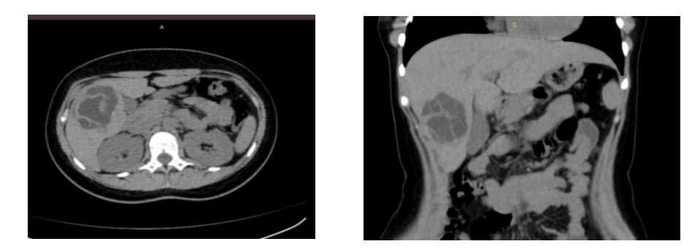Technique) method.

**Figure 1**. Preoperative abdominal CT showing echinococcal cyst in the right lobe of the liver, segments V-VI, at stage CE2.

Under general anesthesia and under ultrasound guidance, a Chiba needle 18G - 20 cm was used to puncture the echinococcal cyst in segments V-VI of the liver through the avascular liver parenchyma. Hydatid fluid was aspirated. Fistulography was performed, showing a cystic echinococcosis measuring 8.0 × 7.0 cm with multiple daughter cysts present in the lumen. The hydatid fluid was fully aspirated. A catheter was placed, and a 14 Fr Pigtail drain was introduced through the catheter. An injection of 0.9% hypertonic saline with active irrigation was initiated, leading to the evacuation of daughter scolices. A repeat fistulography showed no remaining daughter cysts. No connection to the bile ducts was observed. To induce sclerosis of the residual cavity, 70% ethanol was introduced with exposure up to 10 minutes. Reaspiration was performed, and the drain was secured to the skin. The culture of the cystic fluid revealed the presence of *Echinococcus granulosus*, confirming our diagnosis. The patient was discharged in satisfactory condition for outpatient care, with specific antiparasitic medications prescribed (Figure 2).

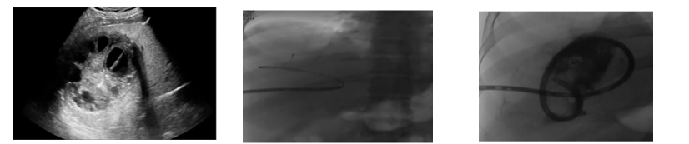

1. b) c)

**Figure 2.** Intraoperative data. Cystic echinococcosis of the liver at stage CE2.

(a) Cyst puncture with a Chiba 18G needle. (b) Catheter insertion. (c) Placement of a 14 Fr Pigtail drain with cystography.

Furthermore, the patient underwent postoperative treatment with a 1-month course of albendazole (2 months). A follow-up CT scan performed 8 months after the surgery showed a reduction in the residual cavity of the echinococcal cyst.

It was found that albendazole chemotherapy is a primary pharmacological treatment to consider in the medical management of cystic echinococcosis, generally used to reduce cysts, prevent infection, and avoid recurrences [4].

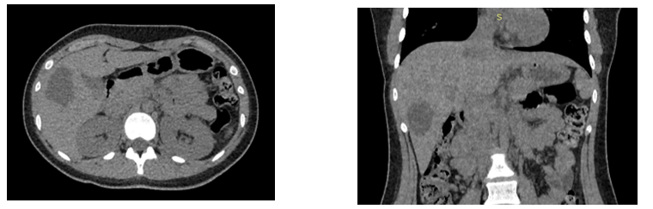

**Figure 3.** Postoperative abdominal CT scan 8 months after MoCat.

**Discussion**

Cystic hydatid disease poses a global health problem and continues to be a serious health issue in Kazakhstan. The two main species of *Echinococcus* are *Echinococcus granulosus*, which causes cystic echinococcosis (CE), and *Echinococcus multilocularis*, which causes alveolar echinococcosis (AE). Regions with high CE infection rates include Central and Northern Europe, Asia, and North America, whereas South America, including Brazil, Argentina, and Uruguay, reports many new CE cases annually. Additionally, new endemic regions have been identified, such as Belgium, Poland, and the Netherlands, where people live in close proximity to domestic or wild canids. AE is found in the Northern Hemisphere, particularly in the Arctic and sub-Arctic regions of Europe, Asia, and North America, with high prevalence in Europe. Hydatid disease presents with a wide range of signs and symptoms, depending on the location, size, and number of cysts in the body. Many individuals may be asymptomatic for many years, while others may experience serious and potentially life-threatening complications. Signs and symptoms can include abdominal pain and discomfort, nausea and vomiting, loss of appetite and weight, fatigue, weakness, and jaundice. Large echinococcal cysts may obstruct the bile ducts, leading to liver swelling and inflammation with subsequent mechanical jaundice, cholangitis, or external biliary fistula. Obstruction of the portal vein may result in portal hypertension or even Budd-Chiari syndrome due to displacement of the inferior vena cava and hepatic veins [5].

Echinococcosis is most commonly caused by *Echinococcus granulosus*, a parasitic organism whose survival depends on its host. It is believed that the cysts formed by the parasite evade the host's immune system by producing immunomodulatory molecules, such as cystatin and a protein known as antigen. The cysts can also cause tissue damage by compressing surrounding structures, inducing fibrosis, and promoting the formation of new blood vessels (angiogenesis). In addition to these mechanisms, cystic echinococcosis also involves the absorption of nutrients and metabolic adaptation by the parasite. Cyst rupture can cause severe pain, anaphylactic shock, or even death. Patients with a history of echinococcal cysts who present with fever, chills, abdominal pain, or general malaise should be suspected of possible infection. Additionally, the rupture of an infected hydatid cyst can have life-threatening consequences. Leakage of purulent cyst contents into the bile ducts or abdominal/pleural cavities can lead to secondary infection, abscess formation, or even anaphylaxis and septic shock [6].

Imaging tests are essential for diagnosing echinococcosis and may include ultrasound (US), computed tomography (CT), or magnetic resonance imaging (MRI) to visualize the cyst and assess its location, size, and morphology. CT is considered the gold standard. Echinococcal cysts typically appear as well-defined round or oval cystic lesions with thick, smooth walls and homogeneous low-density contents. The cysts may also contain internal septations or calcifications, which are more commonly seen in older cysts. In cases of infected echinococcal cysts, CT may reveal thick, irregular walls, heterogeneous attenuation, and/or gas within the cyst contents. CT can also assist in differentiating cystic echinococcosis from other liver lesions such as liver abscesses, cystadenomas, or cystadenocarcinomas. Additionally, serological tests with high sensitivity and specificity for detecting antibodies against the parasite (such as enzyme-linked immunosorbent assay (ELISA) and immunoblotting) can aid in confirming the diagnosis [6-7].

Optimal methods for managing echinococcal cysts include surgical excision using either a radical or conservative approach. Currently, the incorporation of chemotherapy into the therapeutic regimen with the antihelminthic drug albendazole offers the advantage of preventing worm proliferation and reducing the risk of disease recurrence due to inadequate cyst removal or previously undetected cysts. Avoiding any leakage of cyst contents into the abdominal cavity and careful removal of the parasite are primary goals of surgical treatment for primary echinococcal cysts [8].

This discussion pertains to two different approaches for treating liver echinococcal cysts: total pericystectomy and partial pericystectomy. Total pericystectomy is preferred due to its lower risk of recurrence and postoperative complications. However, this approach can be more dangerous if the surgeon lacks sufficient experience, potentially increasing morbidity and mortality among patients. Partial pericystectomy is used when the cyst is large, associated with inflammatory changes, or closely adheres to critical anatomical structures such as bile ducts or major vessels. These factors make total pericystectomy riskier and may increase the likelihood of intraoperative complications. Thus, the choice between total and partial pericystectomy depends on the size and location of the cyst and the presence of inflammation [9].

The necessity of postoperative monitoring to prevent possible recurrence and detect newly forming cysts at an early stage or identify previously undetected but still viable cysts is indisputable. This can be achieved by detecting persistence of granulosa antibodies against *Echinococcus* through serological tests, including latex agglutination, passive hemagglutination, immunoelectrophoresis, and specific ELISA for IgE, IgM, and IgG. These tests are generally recommended at 3, 6, and 12 months post-operation, and then annually for 3 years. Additionally, other important tools for proper follow-up include imaging studies such as CT and MRI. The frequency of imaging studies depends on the size and location of the cyst, but they are usually recommended at 6 and 12 months post-operation, and then annually for 5 years [10].

**4. Conclusions**

The primary methods of open surgical intervention include pericystectomy and echinococcectomy. MoCat (Modified Catheterization Technique) represents a significant alternative to traditional surgical approaches. Despite the advances achieved in surgical treatment, the choice of a rational method and the extent of surgical intervention for multivesicular hepatic echinococcosis remains an open question. Our experience indicates that MoCat aims to minimize the invasiveness of the procedure and the associated risks for the patient. It is particularly recommended for treating uncomplicated cysts (e.g., CE2 and CE3b) located in the liver, proving to be an effective and safe treatment option in such cases. This approach underscores the importance of individualized method selection based on the specifics of each clinical case and disease stage, presenting a promising direction for the treatment of multivesicular hepatic echinococcosis while remaining a less invasive alternative to traditional surgery.

5. Literature Review:

1.Nagasbekov M. S., BaimakhanovZh. B., Nurlanbayev E. K., Kaniyev Sh. A., Chormanov A. T., Baimakhanov B. B. (2022). MODERN APPROACHES IN THE DIAGNOSTICS AND TREATMENT OF CYSTIC LIVER ECHINOCOCCOSIS. LITERATURE REVIEW. BULLETIN OF SURGERY IN KAZAKHSTAN, 2022-12-30. DOI: 10.35805/BSK2022IV040

2.Brunetti, E., Kern, P., Vuitton, D. A., & Writing Panel for the WHO-IWGE (2010). Expert consensus for the diagnosis and treatment of cystic and alveolar echinococcosis in humans. Acta tropica, 114(1), 1–16. https://doi.org/10.1016/j.actatropica.2009.11.001

3.Abdybekova, A; Sultanov, A; Karatayev, B; Zhumabayeva, A; Shapiyeva, Z; Yeshmuratov, T; Toksanbayev, D; Shalkeev, R; Torgerson, Paul R (2015). Epidemiology of echinococcosis in Kazakhstan: an update. Journal of Helminthology, 89(6):647-650. DOI: https://doi.org/10.1017/S0022149X15000425

4.Shmueli, M., Elamour, S., Sagi, O., Grupel, D., Assi, Z., & Ben-Shimol, S. (2023). Albendazole Monotherapy for Pediatric Cystic Echinococcosis: A Case Series. Acta parasitologica, 68(3), 651–658. https://doi.org/10.1007/s11686-023-00699-6

5.Balli, O., Balli, G., Cakir, V., Gur, S., Pekcevik, R., Tavusbay, C., & Akhan, O. (2019). Percutaneous Treatment of Giant Cystic Echinococcosis in Liver: Catheterization Technique in Patients with CE1 and CE3a. Cardiovascular and interventional radiology, 42(8), 1153–1159. https://doi.org/10.1007/s00270-019-02248-z

6.M. S. Nagasbekov, Zh. B. Baimakhanov, Sh. A. Kaniyev, A. T. Chormanov, B. B. Baimakhanov (2022). Treatment of echinococcosis of the liver by the mini – invasive method PAIR. Vestnik, №4 (63) – 2022, DOI: 10.53065/s5593-4050-6382-o

7.ULTRASONIC MONITORING OF ECHINOCOCCAL CYSTS AFTER PAIR PROCEDURE Sadykov Ch.T., Nagasbekov M.S., Baimakhanov Zh.B. BULLETIN OF SURGERY IN KAZAKHSTAN, №72 – 2022

8.Nagasbekov M.S., Baimakhanov Z.B., Kaniyev S.A., Nurlanbayev E.K., Chormanov A.T., Baimakhanov B.B. Results of minimally invasive treatment of liver echinococcosis in comparison with traditional surgical methods. Annaly khirurgicheskoygepatologii = Annals of HPB Surgery. 2021;26(4):61-68. (In Russ.) https://doi.org/10.16931/1995-5464.2021-4-61-68

9.Akhan, O., Salik, A. E., Ciftci, T., Akinci, D., Islim, F., &Akpinar, B. (2017). Comparison of Long-Term Results of Percutaneous Treatment Techniques for Hepatic Cystic Echinococcosis Types 2 and 3b. AJR. Americanjournalofroentgenology, 208(4), 878–884. https://doi.org/10.2214/AJR.16.16131

10.Khuroo M. S. (2021). Percutaneous Drainage in Hepatic Hydatidosis-The PAIR Technique: Concept, Technique, and Results. Journal of clinical and experimental hepatology, 11(5), 592–602. https://doi.org/10.1016/j.jceh.2021.05.005