Author’s list
- Kuatbekov Kairat N. Candidate of Medical Sciences, Head of the Department of Cardiac Surgery and Cardiology, «Erensau Hospital» Almaty, Kazakhstan. k.kuatbekov@mail.ru ORCID: 0000-0002-2679-5097.
- Tugambaev Arman E. Cardiac surgeon of the Department of Cardiac Surgery and Cardiology, «Erensau Hospital» Almaty, Kazakhstan. arman-tugambaev@mail.ru ORCID: 0000-0002-4346-4468.
- Mishin Alexandr V. Cardiac surgeon of the Department of Cardiac Surgery and Cardiology, «Erensau Hospital» Almaty, Kazakhstan. avm_miishin@mail.ru ORCID: 0000-0003-2858-6181.
- Nurbekov Alibek M. 4th year cardiac surgery resident of NC JSC «S.D. Asfendiyarov Kazakh National Medical University», Almaty, Kazakhstan. nurbekov.alik@bk.ru ORCID: 0000-0003-4192-8940.

Author for correspondence: Mishin Alexandr – Cardiac surgeon of the Department of Cardiac Surgery and Cardiology (avm_miishin@mail.ru, 87477231170) ORCID 0000-0003-2858-6181

Declaration of conflicting interest. The authors declared no potential conflicts of interest with respect to the research, authoship, and/or publication of this article.

CLINICAL CASE
Stepwise application of aortic wall autoplasty, VAС-system and combined sterno-osteosynthesis in tandem cardiac surgical complications in one patient

K.N. Kuatbekov,¹ A.E. Tugambaev,¹ A.V. Mishin,¹ A.M. Nurbekov²

1 – Erensau Hospital Almaty, Kazakhstan
2 – Asfendiyarov S.D. Kazakh National Medical University, Almaty, Kazakhstan

Abstract

This paper describes the effective management of successive early postoperative complications, using aortic wall autoplasty, VAC-system, with completion of combined sterno-osteosynthesis in one cardiac surgical patient. The paper presents a clinical case of management of postoperative complications in a 67-year-old patient after aortic valve replacement and three-vessel myocardial revascularization by applying a combined and step-by-step approach for each complication: 1. In case of surgical bleeding - formation of flap plasty of the damaged aortic wall with autopericardium by in situ fixation method; 2. In case of profuse bleeding - application of VAC-system; 3. In case of high risk of sternum divergence - its closure by preferential rheosteosynthesis with tie-fixation devices. The described methods of control, carried an individual approach and the choice of the optimal method of their application, which requires knowledge of the entire arsenal of relevant and effective ways of emergency elimination of complications. In our case, unfortunately, against the background of successful one-stage treatment of all complications, the outcome was unfavorable, due to the exhaustion of compensatory mechanisms of the body against the background of severe combined acquired cardiac pathology. Autopericardium plasty by the method of fixation on the stem created additional protection of the aortic bleeding zone, and further installation of the VAC-system successfully stopped the uncontrollable non-surgical bleeding that was festering. Clamp-buckle osteosynthesis, which we applied as a standard in reoperations, contributed to more active intensive care in intensive care with improved repair of the sternum.
Key words: bleeding, vacuum system, thoracoplasty, case report; cardiac surgery

Introduction
The standard method of treatment of patients with combined aortic stenosis and coronary heart disease (CHD) is one-stage surgical aortic valve replacement and aortocoronary artery bypass grafting. The number of such surgeries is steadily increasing [1], and complications are growing proportionally. According to the data of the study by Stefanov S.A., Faibushevich A.G., Musoev T.Y., Tarichko Yu., which included 244 patients, the risk assessment of the ascending aorta leakage during aortic valve prosthetic operations was given, where the ascending aorta leakage was noted in 20.5% of patients, in 4.9% of cases it was accompanied by intensive bleeding. In 88% of cases aortic leakage was localized in the area of aortic sutures and its cannulation sites. The independent predictors of aortic leakage with high risk of bleeding were aortic diameter 46 mm and higher and its calcinosis. The combination of aortic stenosis and III degree calcinosis was also associated with moderate risk of aortic leakage.
Unsatisfactory results of aortic surgeries are mainly associated with intra- and postoperative bleeding, therefore, the use of various methods of anastomosis formation and sealing is primarily aimed at reducing the volume of blood loss in order to achieve a favorable outcome of the operation. These are either wrapping with own aortic tissues [2], or using synthetic materials such as: vascular prostheses, tetrafluoroethylene gaskets, as well as the use of various medical adhesives and foams. Aortic surgeries are often complicated by coagulopathy, a factor of which is the disruption of normal blood coagulation mechanisms due to: blood loss, massive hemotransfusions, duration of artificial circulation, temperature regime, degree of hemodilution [3; 4].
The risk of developing postoperative sternomediastinitis and sternal instability depends on the patient's comorbidities (diabetes, obesity, smoking, renal insufficiency) and surgical techniques (bilateral extraction of the internal thoracic artery, excessive use of coagulation, duration of surgery, postoperative bleeding) [5; 6]. Deferred thorax apertum is extremely important in case of low-fraction heart function and myocardial edema after prolonged surgery [7], and the use of the innovative method of VAC-system has proved to be safe and highly effective not only for the prevention of infectious complications and mediastinal stabilization, but also its hemostatic effect in profuse bleeding [8]. Developments and clinical applications of negative pressure wound therapy belong to Russian surgeons Y. A. Davydov and A. B. Larichev. The method of negative pressure wound treatment is highly effective and multifunctional, its drainage-evacuation and stabilizing effect, as well as antiseptic and hemostatic effect, are widely used in the treatment and prevention of many complications after open cardiac surgery.
An important step in the completion of open surgery is the restoration of the integrity of the sternal rib cage using various types of alternative fixation devices to conventional wire. Studies on the use of pectoral implants with extrasternal fixation, demonstrate clinical advantages in sternum divergence after surgery using tie-clamps compared to surgical wire [9. Reoperations always increase the risk of postoperative sternal destabilization and infectious complications, while thoracic cable ties provide reliable closure of the sternum, reducing the risk of these complications [10].

In the present work we present a clinical case of several complications after combined surgery on the valve and vascular apparatus of the heart in one patient, with combined methods of their effective elimination.

The purpose of the study is present work presents a description of the effective management of one after another early postoperative complications that arose by the use of aortic wall autoplasty, VAC-system, with completion of combined sterno-osteosynthesis in one cardiac surgical patient.

Ethical approval

All procedures performed in research involving human subjects conformed to institutional and national research committee ethical standards, as well as to the 1964 Declaration of Helsinki and its more recent amendments

Case presentation
Patient A. 67 years old, diagnosis: Multifocal atherosclerosis. Stenosis, calcinosis of aortic valve of IV degree. Multivessel coronary lesion. Unstable angina pectoris class IIIB according to Braunwald. CHF stage B (ACC/AHA), III FC according to NYHA. According to ECHO: aortic valve fibrous ring 1.8 cm, peak systolic gradient on the valve 40 mm Hg, calcinosis of III degree. The diameter of the ascending aorta is 43 mm. Left ventricle: QDR 3.9 cm; CSR 2.3 cm; LV 66 ml; CSR 18 ml; hypokinesis of the anterior septal segment; EF 62%.
Aortic valve replacement with a mechanical prosthesis "Medtronic №21", mammary coronary artery bypass grafting of PMLV, aortocoronary bypass of DV and PCA were performed routinely. On the 4th postoperative day there was abundant scarlet blood flow through the antegrade drains, the patient was operated urgently. On operation: 500 ml of hemopericardium, a 4 x 7 mm diameter aortic wall rupture above the aortic suture was identified on the anterior aortic wall proximal from the previous three sutures with Teflon pads. The site of the rupture was sutured with prolene 4/0 thread on Teflon pads with hemostatic sponge application. Taking into account the technical impossibility to bypass the posterior wall of the aorta, in order to enhance the hemostatic effect, it was decided to form an encircling half-ring (8 x 3 cm) with autopericardium by the type of artificial adventitia without cutting off its proximal part with the effect of a stretched "roof", the dome of which created hermetic compression in the rupture zone (Fig. 1). Due to unstable hemodynamics, it was decided to leave the sternum open.

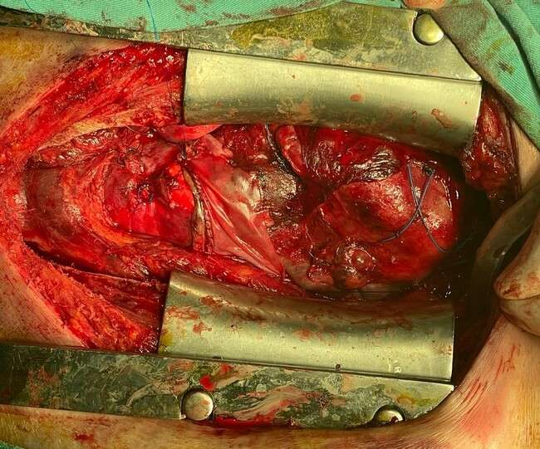
Figure 1 Right pericardial flap fixed to the anterior aortic stack
During the first postoperative day, 1200 ml of blood was released through the drains despite intensive conservative hemostatic therapy. It was decided to install a VAC-system to stop diffuse, uncontrolled bleeding (Fig. 2).
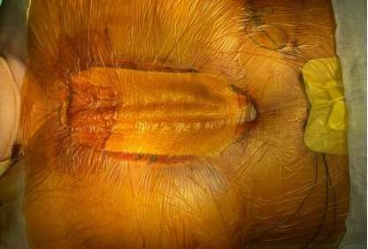
Figure 2 Installed VAC-system on the open mediastinum
The dynamics of bleeding reduction by drains amounted to: the first day - 250 ml, the second day - 150 ml, the third day - 110 ml. After 5 days of continuous course of VAC therapy, it was possible to completely stop coagulopathic bleeding (Fig. 3).

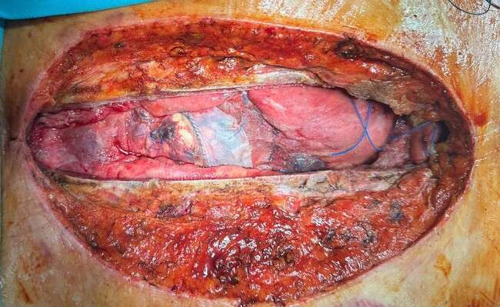
Figure 3 Result of a 5-day course of negative pressure therapy: control of diffuse bleeding with antiseptic effect
On the 11th day after the first elective surgery, the mediastinum was closed by combined osteosynthesis of the sternum with two 12 mm clamp ties and two surgical wires (Figure 4).
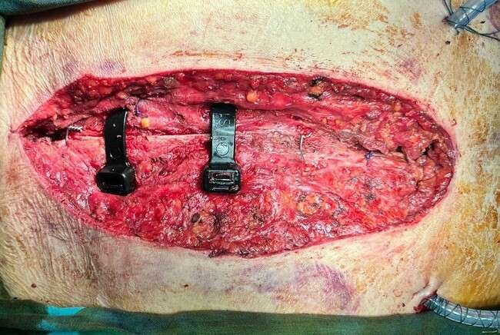
Figure 4 Combined osteosynthesis of the sternum
Despite all measures taken, death could not be avoided due to progressive heart failure.

Discussion
External wrapping of aortic anastomoses with a vascular prosthesis is the method of choice for hemostasis in case of diffuse bleeding of the aortic wall [11]. For total closure of the extensive bleeding zone of the aorta, we needed to pass its posterior wall, which was technically impossible without the latter, so we decided to use the separated autopericardium by moving its flap on the feeding pedicle with preservation of its vascularized proximal part. The distal part of the pericardium directly covered the area of the lesion of the anterior wall of the aorta. After completion of the plasty, its reliable operation was checked during hypertensive peaks, when the load on the suture line was submaximal. In contrast to artificial patches or tanned pericardium, which lack the properties of extensibility, static suture zone of attachment on the working heart is always at risk of rupture, while our method of plasty with autopericardium on a mobile stem reduces this risk due to the preservation of elasticity with damping effect of such a patch, which at the same time enhances the tread compression of the damaged aortic zone especially in the systolic phases of contraction.
The use of VAC therapy for the treatment of mediastinitis significantly reduces mortality, complication rate, and the need for surgical procedures, thus leading to a significant reduction in labor costs [12; 13]. Using multifunctional VAC-system, we pursued the aim to use first of all its hemostatic function to stop uncontrolled non- surgical bleeding, together with its highly effective antiinfection protection and simultaneous stabilization of the open mediastinum in unstable hemodynamics. For myocardial protection, we placed povidone-impregnated dense tissue directly on the anterior surface of the heart and main vessels. The mode parameters of VAC were set as standard: 5 minutes of operation with pressure of 125 mmHg and 2 minutes of stopping.
Sternum fixation systems with the help of clamp ties provide a larger bone contact of the implant with a better distribution of the tension force, preventing the sternum from erupting [14]. The use of these devices in comparison with conventional steel wire excludes intraosseous damage of the spongy substance without disturbing its trophism with better repair. In sternum osteosynthesis, we adhere to our approach of using clamp ties in almost all reoperations, as well as initially in cardiac surgery patients with a high risk of sternum instability in the postoperative period. Given the patient's excessive body weight (BMI 29.7), we used a 12 mm width of the ties 6 times the contact area of conventional wire, which allowed us to use only 2 ties in the areas of greatest load (upper third of the sternum) for reliable stabilization.
Thus, the above-mentioned methods of control in each specific case had an individual approach and the choice of the optimal method of their application, which requires knowledge of the entire arsenal of relevant and effective ways of emergency elimination of complications. In our case, unfortunately, against the background of successful one-stage management of all complications, the outcome was unfavorable, due to the exhaustion of compensatory mechanisms of the body against the background of severe combined acquired heart pathology.

Limitations:

What were the limitations of your work?

The only limitation of our work may have been the unfavorable patient outcome, but the sequential application of all three treatment modalities successfully managed successive complications, indicating their high efficacy.

What's known? What has been previously known on this issue?

The tactics of management of diffuse bleeding was and still is therapeutic treatment aimed at homeostasis of rheological properties of blood by transfusion of SPP and individual factors of the coagulation system.

Prevention of local bleeding is the use of various methods of anastomosis formation and sealing by wrapping with own aortic tissues, or the use of synthetic materials (vascular prostheses, tetrafluoroethylene gaskets, as well as the use of various medical adhesives and foams).

In case of sternal diastasis, various methods of osteosynthesis with wire cerclages have been used, for example, according to Robichek.

What's new? What's new about your case?

In the available literature we have not found a similar method of formation of a protective hemostatic patch from autopericardium on a mobile stem, as well as methods of treatment of three complications in one and the same patient by the new methods described in the article.

Conclusion
After complex combined cardiac surgery, it is necessary to always keep in mind the high risk of various complications that require knowledge of the entire arsenal of relevant and effective ways of their urgent elimination. Our proposed method of aortic wall strengthening by autolusculature on a pedicle gives an alternative to mechanical hemostasis by "inanimate" patches in case of impossibility to envelop the whole aortic tube. Highly effective VAC-therapy should be applied not only at the moment of clinical manifestation of diffuse and uncontrolled mediastinal bleeding, but also immediately after planned surgeries in patients with high risks of its development. The use of sternal clamp fixators should be the standard for all reoperations and primary use in patients with a high risk of postoperative sternal diastasis.
Acknowledgement We would like to express our gratitude to the staff of the operating unit of the «Erensau Hospital».
Author’s contributions
Study concept: Mishin A. Study design: Mishin A., Nurbekov A. Data analysis: Mishin F., Kuatbekov K. Drafting of manuscript: Mishin A., Nurbekov A. Writing the text of the article: Mishin A., Tugambaev A. Critical revision of the manuscript: Kuatbekov K., Mishin A. All authors approved the final version of the manuscript: All authors.
Funding This study was not funded.

References
- Zubarev, D. D., Helimsky, D. A., Krestyaninov, O. V., Grankin, D. S., Kretov, E. I., Ibragimov, R. U., ... & Naryshkin, I. A. Choice of surgical tactics in the combination of coronary atherosclerosis with aortic valve stenosis // Complex problems of cardiovascular diseases. - 2016. - Т. 5. - №. 3
- Tanaka A, Smith HN, Safi HJ, Estrera AL. Open Treatments for Thoracoabdominal Aortic Aneurysm Repair. Methodist Debakey Cardiovasc J. 2023 Mar 7;19(2):49-58. doi: 10.14797/mdcvj.1178. PMID: 36910546; PMCID: PMC10000325.
- Brown JA, Kilic A, Aranda-Michel E, Navid F, Serna-Gallegos D, Bianco V, Sultan I. Long-Term Outcomes of Reoperation for Bleeding After Cardiac Surgery. Semin Thorac Cardiovasc Surg. 2021 Autumn;33(3):764-773. doi: 10.1053/j.semtcvs.2020.11.013. Epub 2020 Nov 10. PMID: 33186737.
- Qureshi SH, Ruel M. Commentary: A Long-Lasting Complication: Re-exploration for Bleeding and Its Negative Correlation With Long-Term Survival. Semin Thorac Cardiovasc Surg. 2021 Autumn;33(3):776-777. doi: 10.1053/j.semtcvs.2020.12.025. Epub 2021 Feb 15. PMID: 33600978.
- Goh, SS. Post-sternotomy mediastinitis in the modern era. J Card Surg. 2017; 32: 556- 566. https://doi.org/10.1111/jocs.13189
- Sá MPBO, Ferraz PE, Soares AF, Miranda RGA, Araújo ML, Silva FV, Lima RC. Development and Validation of a Stratification Tool for Predicting Risk of Deep Sternal Wound Infection after Coronary Artery Bypass Grafting at a Brazilian Hospital. Braz J Cardiovasc Surg. 2017 Jan-Feb;32(1):1-7. doi: 10.21470/1678-9741-2016-0030. PMID: 28423122; PMCID: PMC5382897
- Bakaeen FG, Haddad O, Ibrahim M, Pasadyn SR, Germano E, Mok S, Halbreiner MS, McCurry KR, Johnston DR, Mick SL, Navia JL, Roselli EE, Smedira NG, Soltesz EG, Tong MZ, Wierup P, Gillinov AM, Svensson LG, Houghtaling PL, Blackstone EH, Pettersson GB. Advances in managing the noninfected open chest after cardiac surgery: Negative-pressure wound therapy. J Thorac Cardiovasc Surg. 2019 May;157(5):1891-1903.e9. doi: 10.1016/j.jtcvs.2018.10.152. Epub 2018 Nov 27. PMID: 30709676
- Lorenz, Veronica; Muzzi, Luigi; Neri, Eugenio (2023). Negative Pressure Wound Therapy for Patient Bleeding Management. CTSNet, Inc. Media. https://doi.org/10.25373/ctsnet.21950663.v1
- Nezafati P, Shomali A, Kahrom M, Omidvar Tehrani S, Dianatkhah M, Nezafati MH. ZipFix Versus Conventional Sternal Closure: One-Year Follow- Up. Heart Lung Circ. 2019 Mar;28(3):443-449. doi: 10.1016/j.hlc.2018.01.01.010. Epub 2018 Feb 8. PMID: 29548913
- Marasco SF, Fuller L, Zimmet A, McGiffin D, Seitz M, Ch'ng S, Gangahanumaiah S, Bailey M. Prospective, randomized, controlled trial of polymer cable ties versus standard wire closure of midline sternotomy. J Thorac Cardiovasc Surg. 2018 Oct;156(4):1589-1595.e1. doi: 10.1016/j.jtcvs.2018.04.025. Epub 2018 Apr 16. PMID: 29778340
- Song L, Gao Y, Xu M, Wang B, Li X, Wang X. "Sleeve" Sinus of Valsalva Repair in Patients with Acute Type A Aortic Dissection. Heart Surg Forum. 2021 May 11;24(3):E418-E421. doi: 10.1532/hsf.3629. PMID: 34173762.
- Tarzia V, Carrozzini M, Bortolussi G, Buratto E, Bejko J, Comisso M, Mescola V, Penzo V, Guarino M, De Franceschi M, Pagnin C, Castoro M, Guglielmi C, Testolin L, Bottio T, Gerosa G. Impact of vacuum-assisted closure therapy on outcomes of sternal wound dehiscence†. Impact of vacuum- assisted closure therapy on outcomes of sternal wound dehiscence†. Interact Cardiovasc Thorac Surg. 2014 Jul;19(1):70-5. doi: 10.1093/icvts/ivu101. Epub 2014 Apr 9. PMID: 24722512
- Pericleous A, Dimitrakakis G, Photiades R, von Oppell UO. Assessment of vacuum-assisted closure therapy on the wound healing process in cardiac surgery. Int Wound J. 2016 Dec;13(6):1142-1149. doi: 10.1111/iwj.12430. Epub 2015 Feb 26. PMID: 25728664; PMCID: PMC7950034
- Stelly MM, Rodning CB, Stelly TC. Reduction in deep sternal wound infection with use of a peristernal cable-tie closure system: a retrospective case series. J Cardiothorac Surg. 2015 Nov 14;10:166. doi: 10.1186/s13019-015-0378-7. PMID: 26577944; PMCID: PMC4650955.

