Surgical aspects of DiGeorge syndrome

Ismailova G.N., Khamidulla A.K., Yakupova I.A., Omarkyzy I., Temirkhanov A.
Ismailova G.N. 1.2*MD, PhD, https://orcid.org/0000-0002-7461-4190
Khamidulla A.K. https://orcid.org/0009-0005-9575-2778
Yakupova I.A. https://orcid.org/0000-0003-4833-0239
Omarkyzy Ingkar https://orcid.org/0009-0008-5820-4117
Temirkhanov Abzal https://orcid.org/0000-0003-4153-321X

Abstract
Introduction. DiGeorge syndrome is a rare congenital disease associated with a deletion of chromosome 22q11.2, which is characterized by the occurrence of various anomalies, such as hypo/aplasia of the thymus and parathyroid glands, which leads to T-cell immunodeficiency and hypoparathyroidism; this syndrome is also characterized by congenital heart disease (tetralogy of Fallot), anomalies in the development of craniofacial structures are observed, in the form of non-fusion of the hard palate and upper lip (cleft palate and cleft lip).
Results. This article will examine a clinical case of DiGeorge syndrome in a child, with the classic triad characteristic of this condition (immunodeficiency, hypoparathyroidism and congenital heart disease). The patient underwent the first stage of correction of a combined heart defect against the background of constant (monthly) immunocorrection. Due to the COVID-19 pandemic, our patient was unable to receive scheduled hospitalization for blood replacement and immunocorrective therapy in a timely manner. The key to increasing the survival rate of patients with DiGeorge syndrome is prenatal screening, timely correction of the anomaly and immunoreplacement therapy, which are actively used in foreign countries. Also, incomplete treatment of DiGeorge syndrome can subsequently lead to various other manifestations, such as autoimmune diseases, infectious diseases, etc.
Conclusion. The prognosis of DiGeorge syndrome is that this disease has various clinical manifestations, is combined with other variants of the anomaly that are incompatible with life and lead to delayed psychomotor development and have an unfavorable prognosis.
Key words: DiGeorge syndrome, thymic hypo/aplasia, tetralogy of Fallot, thymus transplantation.
Introduction
DiGeorge syndrome or velocardiofacial syndrome is associated with a deletion of chromosome 22q11.2 and is one of the most common deletions in the human genome, second in frequency only to Down syndrome associated with trisomy 21. The prevalence of DiGeorge syndrome, according to various literature data, ranges from 1:1000 to 1:4000 - 1:6000 newborns. Chromosomal deletion 22q11.2 leads to impaired development of the pharyngeal gut, from which the posterior part of the oral cavity, tongue, salivary glands, palatine tonsils, glands derived from the epithelium of the pharyngeal pouches (thyroid, parathyroid, thymus) and the outflow tract of the heart are formed.¹
Clinically, the full DiGeorge syndrome can be observed, which includes the entire spectrum of typical manifestations and severe immunodeficiency. Partial DiGeorge syndrome includes only some manifestations, without signs of severe immunodeficiency. The diagnostic criterion is to determine the number of native T cells (CD4+CD45RA+ T-cell), which is a reliable indicator for distinguishing between complete and incomplete DiGeorge syndrome. T cell deficiency is often accompanied by B cell deficiency and hypogammaglobulinemia.
Initial reports suggest that DiGeorge syndrome is a clinical triad of immunodeficiency, hypoparathyroidism, and congenital heart disease (conotruncal anomaly). Further studies of DiGeorge syndrome have identified a variety of clinical manifestations of the disease, including many congenital anomalies and pathological conditions, such as non-fusion of the hard palate and upper lip (cleft palate and cleft lip), as well as later manifestations of gastrointestinal or renal anomalies , autoimmune diseases, various manifestations of delayed development of cognitive functions.
Purpose of the study: to discuss the complexity of managing DiGeorge syndrome in diagnosis and choice of treatment tactics.
Case presentation
Patient A., boy 2.1 years old. For the first time he was admitted to the emergency room of a children's city clinical infectious diseases hospital at the age of 3.5 months with complaints of shortness of breath, intermittent and rapid breathing, fever, cough, and runny nose.
Life history: Childbirth G4P4, birth weight 2500g. The pregnancy proceeded without any special features. There was no family history of facial dysmorphism or other congenital anomalies.
History of the disease: The first physical examination in the emergency room revealed cyanosis of the skin, reduced skin turgor, body temperature - 37.4 C°, tachycardia 146 per minute, tachypnea 54 per minute, low weight 3500g, bottle-fed, sucking weakly. The pharynx is bright, hyperemia of the tonsils, defect of the hard palate, rare non-productive cough, shortness of breath of an expiratory nature. There is no vomiting or convulsions, meningeal symptoms are negative.
In the area of the heart there is a bulge, similar to a “heart hump”, with systolic tremors on palpation. The borders of the heart are expanded in diameter. Auscultation of breathing in the lungs is harsh, dry wheezing. Accessory muscles are involved in the act of breathing. Heart sounds are muffled, rough systolic “machine murmur” at all points. During the initial physical examination, oxygen saturation was 85%, blood pressure was 72/46 mm Hg, and heart rate was 150 beats/min. On the ECG, the heart axis is deviated to the right 100°, hypertrophy of both ventricles.

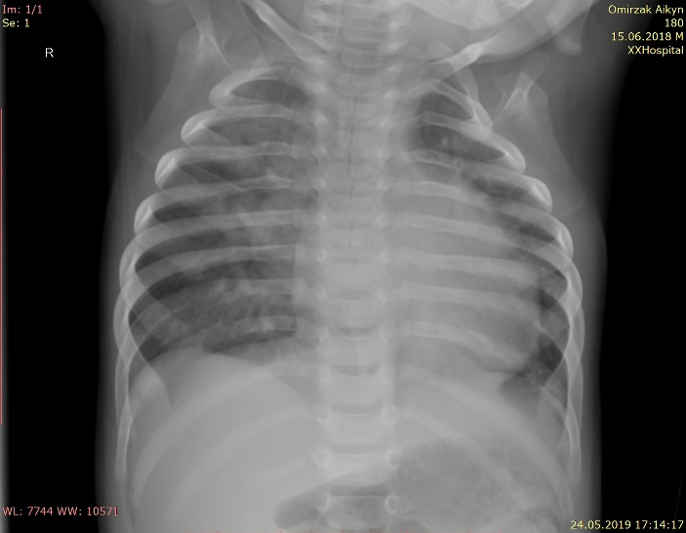 | 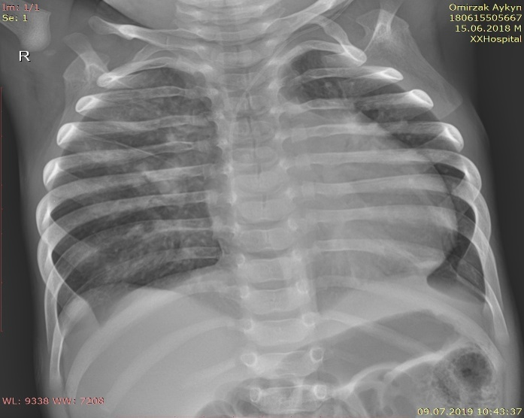
Figure 1. X-ray shows signs of bilateral focal pneumonia. Cardiomegaly. Hypo/aplasia of the thymus. | Figure 2. Dynamics after 10 days – convalescence. Cardiomegaly, heart waist is flattened.
The patient was sent to the center for pediatric cardiac surgery, where echocardiography revealed: The left chambers of the heart were enlarged. Wide open aortic duct. Atrial septal aneurysm with atrial septal defect. Ventricular septal defect. Hypertrophy of the walls of the left ventricle.
Based on echocardiography, a combined congenital heart defect was identified: tetralogy of Fallot.

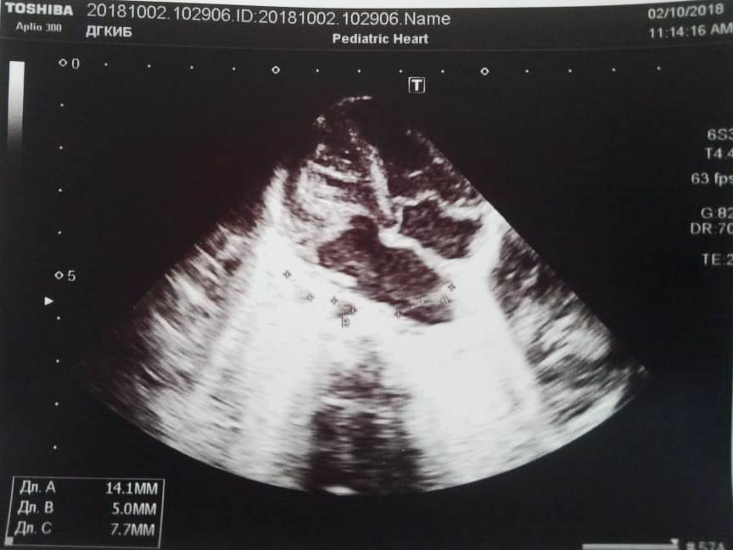 | 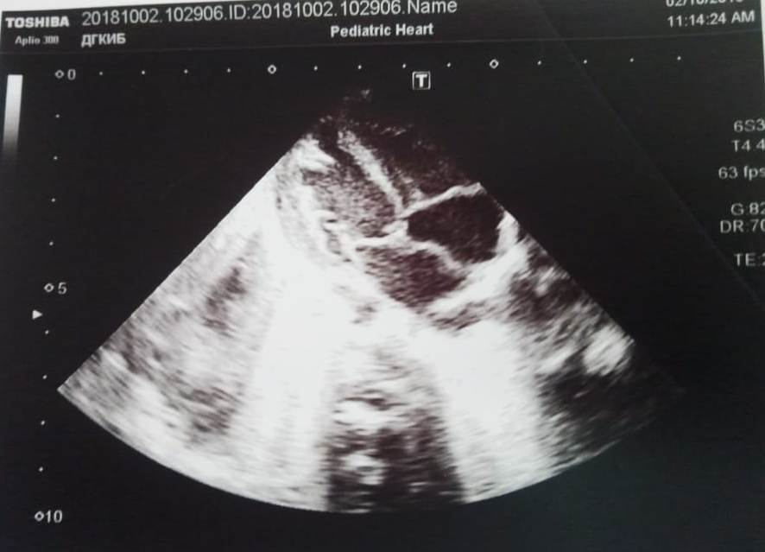
Figure 3 and 4. Ultrasound of the heart revealed a congenital heart defect: Minor anomalies of cardiac development. Ventricular septal defect, multiple moderate dilatations of the right and left ventricles. Severe hypertrophy of the walls of the right ventricle.
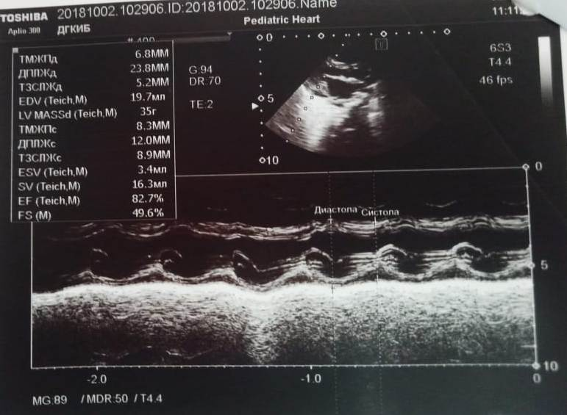 | 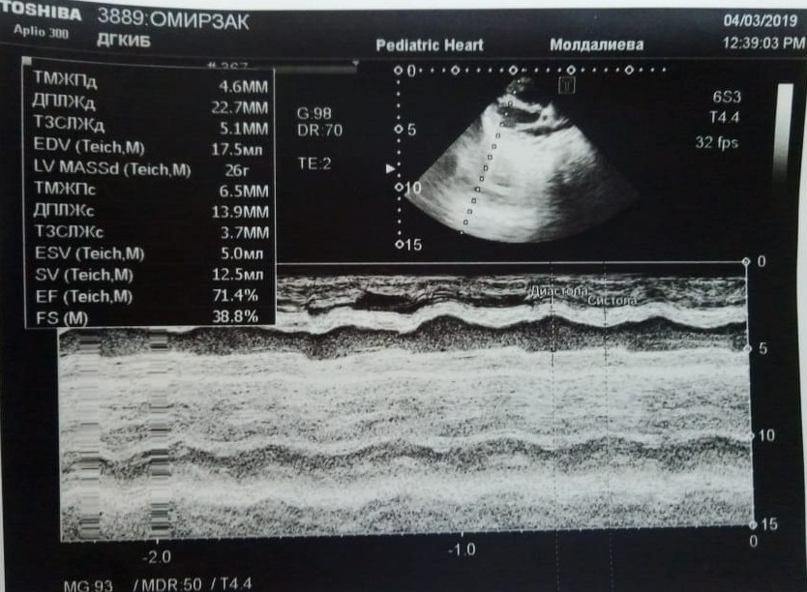
Figures 5 and 6. Patent aortic duct. Signs of pulmonary hypertension. Accessory group of papillary muscles. Aneurysm of the sinuses of Valsava. Insufficiency of the mitral and tricuspid valves. Myocardial contractility is satisfactory.
Ultrasound of the abdominal organs revealed a congenital malformation of the urinary system. Pelvic dystopia of the right kidney.
Neurosonography revealed a slight expansion of the external cerebrospinal fluid ducts. Right choroid plexus cyst. Dopplerographic signs of increased tone in the anterior cerebral artery and basilar artery.
Due to low birth weight - 2500g. and complex combined velofacial defect, instead of completely correcting the congenital heart defect, parents were recommended to undergo staged surgical correction of the congenital heart defect. At the initial stage, an anastomosis is performed to connect the subclavian artery to the ipsilateral pulmonary artery. With subsequent closure of ventricular septal and atrial septal defects.
The patient underwent the first stage of surgical correction with closure of the ventricular septal defect before the next stage of surgical correction to restore the aortic arch. Trunk repair was performed by closing the ventricular septal defect from the right ventriculotomy and creating continuity between the right ventricular outflow tract and the bifurcation. There was a simple postoperative course.
Discussion
DiGeorge syndrome is caused by a chromosomal microdeletion of 22q11.2 and has a wide range of clinical manifestations. Congenital heart defects occur in 80% of cases, the most common are interruption of the aortic arch, common truncus arteriosus, and tetralogy of Fallot. There may be other developmental defects that do not exclude DiGeorge syndrome. Hypocalcemia due to hypoparathyroidism may manifest as seizures in infancy. Damage to the nasopharyngeal apparatus is detected in approximately 70% of cases and manifests itself in the form of velopharyngeal anomalies, cleft palate, lips, bifurcation of the frenulum of the palate, a nasal tone of voice, there may be olfactory disturbances and hearing loss. There may be different stigmas of disembryogenesis, characteristic facial features, such as an elongated face, macrognothia, wide bridge of the nose, small teeth. Delayed physical, speech and psychomotor development is observed in 70–90% and manifests itself with age. Immunological disorders occur in 77% of cases. Infectious manifestations, as a consequence of immunodeficiency, do not occur from birth, more often due to fungal diseases, Pneumocystis infection, as well as other bacterial and viral infections, with a predominant lesion of the respiratory system. Lack of T cell deficiency may predispose to autoimmune diseases, the proportion of which may be as high as 8.5%, especially in patients with CD4+ deficiency.²
DiGeorge syndrome is not uncommon in adults in the form of various types of congenital malformations: tetralogy of Fallot, unilateral absence of the pulmonary artery, etc. Among patients with congenital malformations, 55% had chromosomal changes, 71% of patients with chromosomal changes had congenital heart defects, of which four had the triad: congenital laryngeal membrane, deletion of chromosome 22q11 and congenital cardiovascular anomalies.³
According to the data obtained, surgical correction and complete restoration of tetralogy of Fallot consists of eliminating the ventricular septal defect by applying a patch, expanding the outflow tract of the right ventricle through muscle resection, pulmonary valvuloplasty and, if necessary, increasing the patch of the pulmonary trunk. If there is significant hypoplasia of the pulmonary valve annulus, a transannular patch is placed. Surgery is usually performed electively between 2 and 6 months of age, but can be performed at any time if symptoms are present or if severe right ventricular outflow tract obstruction is present.⁴
Most patients with DiGeorge syndrome with incomplete immunodeficiency are recommended to undergo prophylactic measures against infection, and for patients with complete immunodeficiency, thymus transplantation.⁵
Therefore, the next important treatment strategy for DiGeorge Syndrome is thymus transplantation. Thymic transplantation is a promising treatment strategy for complete DiGeorge syndrome. According to the literature, complete DiGeorge anomaly was detected in 71 children, of which 59 children underwent thymus transplantation. After thymus transplantation, 12 (20%) infants required emergency admission to the intensive care unit. Of these, 7 (58%) of 12 infants survived to NICU discharge and six were alive 6 months after thymus transplantation. 42 (71%) of 59 infants who received thymus transplantation had congenital heart disease, 9 (75%) of whom were treated in the intensive care unit. There was a correlation between days without ventilation and age at transplantation (R 0.17; p = 0.423). Age at transplant and the presence of congenital heart disease were not associated with the risk of intensive care unit admission (odds ratio 0.95; 95% CI 0.78-1.15 and odds ratio 1.27; 95% CI 0.30-1.15). 5.49, respectively) or ICU mortality, (odds ratio 0.98; 95% CI 0.73–1.31 and odds ratio 0.40; 95% CI 0.15–1.07, respectively).⁶
The causes of early postoperative mortality were viral infections in the absence of thymopoiesis, and late death from autoimmune thrombocytopenia, septic shock, with graft rejection and the need for re-transplantation of the thymus. Signs of thymopoiesis developed after 5–6 months, also at 12 and 24 months after thymus transplantation; in 10 patients, a dynamic increase in the level of circulating naïve CD4 and T cells was observed. Although the age-specific norm cannot always be achieved, the risk of new infections is reduced. After an average of 49 months, antimicrobial prophylaxis and immunoglobulin replacement therapy were discontinued. Histological confirmation of thymopoiesis in patients who underwent biopsy of transplanted tissue showed full maturation to the terminal stage of Hassall body formation and expression of the autoimmune regulator.^{7,8}
However, autoimmune complications have occurred after thymus transplantation. Untimely therapy, namely correction of congenital heart defects and thymus transplantation, can lead to an unfavorable outcome, as happened in our clinical case.⁹
Recent research since the COVID-19 pandemic has found that many respiratory viruses are more severe in people with T-cell immunodeficiency. Patients with 22q11.2 deletion syndrome were at risk of severe COVID-19.¹⁰
Conclusion. Patient A. received the first stage of surgical correction to correct a congenital heart defect. The presented clinical case coincided with the COVID-19 pandemic. During the period of rising incidence (May-June 2020), restrictive measures were introduced, including limited planned hospitalization of immunocompromised patients. As a result, Patient A. was unable to receive monthly scheduled immunoreplacement therapy to compensate for primary immunodeficiency, which was the cause of death from a viral infection of unknown origin during the rise in the incidence of COVID-19.

Literary references.
1. Nain E, Kiykim A, Ogulur I, et al. Immune system defects in DiGeorge syndrome and association with clinical course. Scand J Immunol. Nov 2019;90(5):e12809. doi:10.1111/sji.12809
2. McDonald-McGinn DM, Sullivan KE. Chromosome 22q11.2 deletion syndrome (DiGeorge syndrome/velocardiofacial syndrome). Medicine (Baltimore). Jan 2011;90(1):1-18. doi:10.1097/MD.0b013e3182060469
3. Elizondo-Plazas A, Lopez-Uriarte GA, Gonzalez-Gonzalez JG, et al. Late-Onset 22q11.2 Deletion Syndrome With Mild Cardiac Phenotype: A Unique Adult Presentation Diagnosed at 45 Years of Age. Cureus. Dec 2023;15(12):e50367. doi:10.7759/cureus.50367
4. Bassett AS, McDonald-McGinn DM, Devriendt K, et al. Practical guidelines for managing patients with 22q11.2 deletion syndrome. J Pediatr. Aug 2011;159(2):332-9.e1. doi:10.1016/j.jpeds.2011.02.039
5. Davies EG, Cheung M, Gilmour K, et al. Thymus transplantation for complete DiGeorge syndrome: European experience. J Allergy Clin Immunol. Dec 2017;140(6):1660-1670.e16. doi:10.1016/j.jaci.2017.03.020
6. Lee JH, Markert ML, Hornik CP, et al. Clinical course and outcome predictors of critically ill infants with complete DiGeorge anomaly following thymus transplantation. Pediatr Crit Care Med. Sep 2014;15(7):e321-6. doi:10.1097/PCC.0000000000000219
7. Bernstock JD, Totten AH, Elkahloun AG, et al. Recurrent microdeletions at chromosome 2p11.2 are associated with thymic hypoplasia and features resembling DiGeorge syndrome. J Allergy Clin Immunol. Jan 2020;145(1):358-367.e2. doi:10.1016/j.jaci.2019.09.020
8. Biggs SE, Gilchrist B, May KR. Chromosome 22q11.2 Deletion (DiGeorge Syndrome): Immunologic Features, Diagnosis, and Management. Curr Allergy Asthma Rep. Apr 2023;23(4):213-222. doi:10.1007/s11882-023-01071-4
9. Óskarsdóttir S, Boot E, Crowley TB, et al. Updated clinical practice recommendations for managing children with 22q11. 2 deletion syndrome. Genetics in Medicine. 2023:100338.
10. Crowley TB, McGinn DM, Sullivan KE, report IqCg. 22q11.2 Deletion and Duplication Syndromes and COVID-19. J Clin Immunol. May 2022;42(4):746-748. doi:10.1007/s10875-022-01246-0

