Information about the authors

ФИО, место работы, должность, ученую степень (если есть) адрес, ORCID, e-mail
- Satanova Karina, CF «University Medical Center», endoscopist of Surgery Department, MD, Astana, Turan avenue, 32. ORCID 0009-0006-8370-9972. phone: + 7753637472 karina11b@mail.ru
- Fursov Alexandr, NJSC «Astana Medical University», Head of the Department of Surgical Diseases, Bariatric Surgery and Neurosurgery. M.D., DMSc. Professor of Medicine and Surgery, Astana, Beybitshilik street 49a, ORCID 0000-0002-6992-8646 phone: + 77013177547 fabcom2@yandex.ru
- Balmukhamedova Zhanar, NJSC «Astana medical university», assistant of the department of General medical practice with a course of Evidence-Based Medicine, master of medicine, Astana, Beybitshilik street 49a, ORCID 0000-0003-2626-0591, phone: +77012212325 balmukhamedova_zhanar@gmail.com
- Roman Fursov, NJSC «Astana Medical University» Associate Professor at the Department of Surgical Diseases, Bariatric Surgery and Neurosurgery. M.D., PhD. Astana, Beybitshilik street 49a, ORCID 0000-0003-1617-5991 phone + 7705101501, e-mail: fursrom@mail.ru
- Kaipova Asemgul, NJSC «Astana Medical University», assistant of Department of biostatistics, bioinformatics and IT, Astana, Beybitshilik street 49a, ORCID 0000-0002-2538-3007, phone: + 77011856694, e-mail: aru.as@mail.ru
- Talassov Alisher, «Multidisciplinary city hospital №3», General Surgeon, 26b, Aliya Moldagulova street, ORCID: 0009-0001-0960-7509, phone: +77757108659, e-mail: dr.talassov@gmail.com

Author for correspondents: ФИО, место работы, должность, ученую степень (если есть) адрес, ORCID, телефон номер, e-mail

Satanova Karina, CF «University Medical Center», endoscopist of Surgery Department, MD, Astana, Turan avenue, 32. ORCID 0009-0006-8370-9972. phone: + 7753637472 karina11b@mail.ru

What’s Known (50 words and up to two bullets)
Previously used methods of surgical treatment of hemorrhoids were accompanied by:
- Severe pain syndrome in the postoperative period. Long-term rehabilitation. Frequent development of complications and relapses.
- Long stay in a 24-hour hospital, which incurs high costs for each treated case

What’s New (50 words and up to two bullets)
The use of laser technologies in the treatment of hemorrhoids has made it possible to:
- Minimize pain after surgery, almost completely eliminate the use of narcotic analgesics. Significantly reduce the risks and development of postoperative complications, as well as relapses.
- Eliminate the use of 24-hour hospitals and carry out this type of treatment in ambulatory surgery centers, which significantly reduces the financial burden spent on each patient.
ORIGINAL ARTICLE

Анализ эффективности лазерной вапоризации в сравнении с другими методиками лечения геморроидальной болезни на основе процента осложнений.
Сатанова К. А.¹, Фурсов А.Б.², Бальмухамедова Ж. А. ², Фурсов Р.А. ² Каипова А. Ш. ², Таласов А.С. ²
1 - КФ«University Medical Center», г. Астана, Казахстан
2 - НАО «МУА», Астана, Казахстан

Резюме.
Геморрой является одним из наиболее распространенных колопроктологических заболеваний человека. Распространенность его так высока, что в хирургической оперативной помощи нуждается каждый третий больной. В работе проведен краткий анализ историй болезни пациентов с геморроидальной болезнью и осложнениями после геморроидэктомии. Всего проанализировано 1450 операций, ранние и отдаленные результаты хирургического лечения больных, оперированных в хирургическом отделении Корпоративного фонда «UniversityMedicalCenter». Проведено сравнение эффективности лазерной вапоризации в сравнении с другими методами хирургического лечения.
Ключевые слова. Геморрой, оперативное лечение, лазерная вапоризация, геморроидэктомия, осложнение, свищ, лигирование.

Analysis of the effectiveness of laser vaporization in comparison with other methods of treating hemorrhoidal disease based on the percentage of complications.
Satanova K. A. ¹, Fursov A.B. ², BalmukhamedovaZh. A. ², Fursov R.A. ² Kaipova A. Sh. ², Talassov A.S. ²

1 - CF "University Medical Center", Astana, Kazakhstan
2 - NJSC “MUA”, Astana, Kazakhstan

Summary.
Hemorrhoids are one of the most common coloproctological diseases in humans. Its prevalence is so high that every third patient needs surgical intervention. The paper provides a brief analysis of case histories of patients with hemorrhoidal disease and complications after hemorrhoidectomy. A total of 1450 operations, early and long-term results of surgical treatment of patients operated on in the surgical department of the Corporate Foundation “University Medical Center” were analyzed. The effectiveness of laser vaporization was compared with other methods of surgical treatment.
Keywords. Hemorrhoids, surgical treatment, laser vaporization, hemorrhoidectomy, complication, fistula, ligation.

Асқынулардыңпайызынегізіндегеморроидальдыаурудыемдеудіңбасқаәдістеріменсалыстырғандалазерлікбуланудыңтиімділігінталдау.

Сатанова К.А. ¹, Фурсов А.Б. ², Балмұхамедова Ж.А. ², Фурсов Р.А. ², Каипова А.Ш. ², Таласов А.С. ²

1 - КҚ «University Medical Center», Астана, Қазақстан
2 - «МУА» КЕАҚ, Астана, Қазақстан

Түйіндеме.
Геморрой - адамдарда жиі кездесетін колопроктологиялық аурулардың бірі. Оның таралуы соншалықты жоғары, әрбір үшінші науқас хирургиялық араласуды қажет етеді. Бұл мақалада геморроидальды аурумен ауыратын науқастардың тарихы мен геморроидэктомиядан кейінгі асқынулардың қысқаша талдауы берілген. «UniversityMedicalCenter» Корпоративтік қорының хирургиялық бөлімшесінде барлығы 1450 ота, операция жасалған науқастардың ерте және ұзақ мерзімді хирургиялық емінің нәтижелері талданды. Лазерлік буланудың тиімділігі хирургиялық емдеудің басқа әдістерімен салыстырылды.
Түйінді сөздер. Геморрой, хирургиялық емдеу, лазерлік булану, геморроидэктомия, асқыну, фистула, байлау.

Introduction.
According to global statistics, hemorrhoids are one of the most common human diseases and the most frequent reason for patients to seek a consultation with a colorectal surgeon. [1]
At the same time, individual researchers acknowledge that currently, even after many years of research worldwide, there is no complete picture and scale of this disease among the population. [2]
It is widely believed that its prevalence ranges from 100 to 150 individuals per 1000 adult population, with hemorrhoids accounting for 34 to 41% of the structure of colorectal diseases. [3]
There are numerous methods for treating this disorder, the most common of which are the Milligan-Morgan procedure, ligation of hemorrhoidal nodes, and the HAL-RAR procedure (Hemorrhoidal Artery Ligation and Recto Anal Repair). [4]
Each of the aforementioned methods has its own set of advantages and disadvantages and may be associated with various early and late postoperative complications. [5] Recent global data has been comprehensively analyzed and systematized in a review article by Romaguera V.P. et al. in 2021. [6]
Thus, among the most frequent complications following operations for hemorrhoidal disease, clinicians attribute pain, urinary retention, and among the most severe are bleeding from anorectal wounds, development of purulent-inflammatory processes, and strictures of the anal canal. Various combinations of complications with significant pain syndrome should also be included in this category. These data are visually presented in Figure 1.
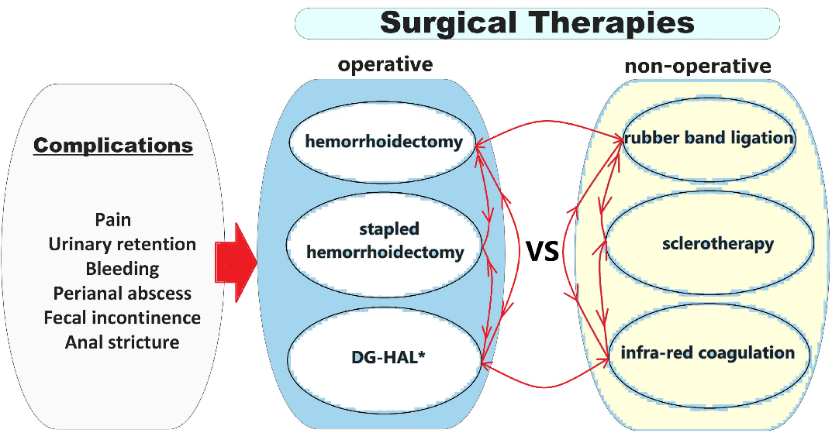

Figure 1. Common operations for hemorrhoidal disease and postoperative complications; *Doppler-Guided Hemorrhoidal Artery Ligation (the diagram was reconstructed based on the figure by Romaguera VP, Sancho-Muriel J, Alvarez-Sarrdo E, Millan M, Garcia-Granero A, Frasson M., 2021) [6]
In recent years, the outpatient surgery center of the Corporate Foundation "University Medical Center" has actively implemented a minimally invasive method for treating hemorrhoidal disease, such as laser vaporization.
The accumulated long-term experience of observing patients with hemorrhoids, using various treatment methods, and the lack of a sufficient number of publications comparing postoperative complications have necessitated conducting this scientific analysis.
The aim of the study was to investigate the structure of complications after various methods of treating hemorrhoidal disease in patients undergoing treatment and to evaluate the effectiveness of laser vaporization of hemorrhoidal nodes.
Materials and Methods
A retrospective analysis of medical records of patients diagnosed with hemorrhoidal disease I-IV stages, treated at the CF "UMC" from January 2020 to September 2023, was conducted. During this period, 1450 operations were performed on patients aged 18 to 70 years.
На какие группы сравнения вы разделили? Если нет, то что с чем сравнивали? Написать какие диагностические методы и лечебные тактики вы анализировали. – ответ на эти 2 вопроса вследующем обзаце
Among women, the frequency of surgical interventions was 60.3%, while among men it was 39.7%.A total of 1100 hemorrhoidectomies were performed using the laser vaporization method, 190 surgeries were conducted using the traditional Milligan-Morgan technique, and 160 hemorrhoidectomies were performed by placing ligating rings.

Ethical Approval….. Permission was obtained from the local ethical commission of the NJSC «Astana Medical University» to conduct this study.

Statistical methods… для обработки статистических данных использовался хи квадрат Пирсона и анализ качественных признаков.
The recurrence rate after laser vaporization was 32 cases, which corresponds to 2.9% of the total number of operations. Early and late postoperative complications were observed in 20 cases, constituting 1.8%. There were 10 cases of bleeding from the anal canal within the first 24 hours after the operation and 2 cases within the first 10 days. This complication was the most common after laser vaporization, accounting for 60% of the total number of complications and 1% of the total number of operations. Later complications included anal canal strictures - 2 cases (0.18%) and the development of paraproctitis in 6 cases (0.54%).
The recurrence rate after Milligan-Morgan's operation was 37 cases (19.47%). Complications were observed in 22 individuals (11.57%). Bleeding occurred in the early postoperative period in 9 patients, accounting for 4.7%. One case of perianal hematoma was detected (0.52%). In the late period, anal canal stricture was noted in 4 patients (2.1%), and paraproctitis was diagnosed in 8 operated individuals (4.2%). It is noteworthy that 78 patients experienced significant pain syndrome (41%).
The fewest number of operations was performed using the method of applying ligating rings, which, similar to the Milligan-Morgan operation, showed a higher recurrence rate and complications.
Recurrences amounted to 22 cases (13.75%). Complications were observed in 19 individuals (11.8%). Bleeding occurred in 9 patients (5.6%) within the first week after the operation. Purulent-inflammatory processes were observed in 5 patients (3.12%) within 1-3 months after the surgical intervention. Anal fissure developed in 4 patients (6.6%), and a single case of formation of a subcutaneous posterior rectal fistula was noted (0.62%). During the early postoperative period, 40 patients complained of significant pain syndrome (25%).
The frequency of complications depending on the applied method of treating hemorrhoidal disease is presented in the form of a graph in Figure 2.

As a result of further analysis and processing of statistical data, parameters of the registered frequency of complications to the expected frequency (probability of complication types) depending on the treatment methods were determined. The ratio of complication frequencies (including expected complications) is systematized in Table 1."
Table 1. Ratio of Complication Frequencies Depending on Treatment Method
Treatment Method | Complication Frequency/ Expected Frequency/ in % | Type of Complication |  |  |  |  |  |  |  | total
 |  | EB | LB | AS | P | PH | AF | SF | NC  no complications
LV | Frequency | 9 | 2 | 2 | 7 | 0 | 0 | 0 | 1080 | 1100
 | Expected Frequency | 12,1 | 9,9 | 8,3 | 11,4 | 0,8 | 3,0 | 0,8 | 1053,7 | 1100
 | % | 0,8 | 0,2 | 0,2 | 0,6 | 0,0 | 0,0 | 0,0 | 98,2 | 100
MMHE | Frequency | 3 | 6 | 4 | 8 | 1 | 0 | 0 | 168 | 190
 | Expected Frequency | 2,1 | 1,7 | 1,4 | 2 | 0,11 | 0,5 | 0,11 | 182 | 190
 | % | 1,6 | 3,2 | 2,1 | 4,2 | 0,5 | 0,0 | 0,0 | 88,4 | 100
LH | Frequency | 4 | 5 | 5 | 0 | 0 | 4 | 1 | 141 | 160
 | Expected Frequency | 1,8 | 1,4 | 1,2 | 1,7 | 0,1 | 0,4 | 0,1 | 153,3 | 160
 | % | 2,5 | 3,1 | 3,1 | 0,0 | 0,0 | 2,5 | 0,6 | 88,1 | 100
Total | Frequency | 16 | 13 | 11 | 15 | 1 | 4 | 1 | 1389 | 1450
 | Expected Frequency | 16,0 | 13,0 | 11,0 | 15,0 | 1,0 | 4,0 | 1,0 | 1389,0 | 1450
 | % | 1,1 | 0,9 | 0,8 | 1,0 | 0,1 | 0,3 | 0,1 | 95,8 | 100
Where, LV - Laser vaporization of hemorrhoidal nodes;
MMHE - Milligan-Morgan hemorrhoidectomy;
LH - Ligation of hemorrhoidal nodes;
EB - Early postoperative bleeding
LB - Late postoperative bleeding
AS - Anal stricture
P - Paraproctitis
PH - Perianal Hematoma
AF - Anal Fissure
SF - Subcutaneous rectal fistula
NC - no complications

In the presented table, the frequency of so-called "expected" complications indicates the possible likelihood of a particular event. According to our data, in most cases, the actual figures for complicated cases were lower than what was anticipated from mathematical (statistical) calculations. The lowest complication rates recorded in the clinic were associated with the LV operation, slightly higher after LH, and the highest number of complications occurred after MMHE.
In calculating the "odds ratio" (OR), which indicates the likelihood of the presence of any complication after the treatment of hemorrhoidal disease, it was found that patients had the worst odds after MMHE - 1.025. Then, after LH operation - 0.923. The best result in the odds ranking after LV (laser vaporization) - 0.920. The obtained results are graphically presented in figures 2 and 3.
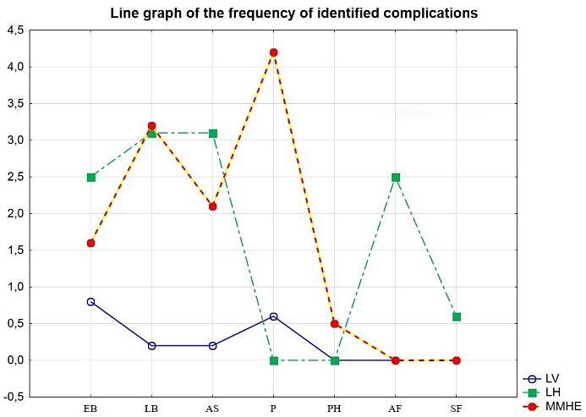
Figure 2. Indicators of the frequency of various complications after LV, LH, and MMHE
Where, LV - Laser vaporization of hemorrhoidal nodes;
MMHE - Milligan-Morgan hemorrhoidectomy;
LH - Ligation of hemorrhoidal nodes;
EB - Early postoperative bleeding
LB - Late postoperative bleeding
AS - Anal stricture
P - Paraproctitis
PH - Perianal Hematoma
AF - Anal Fissure
SF - Subcutaneous rectal fistula
NC - no complications

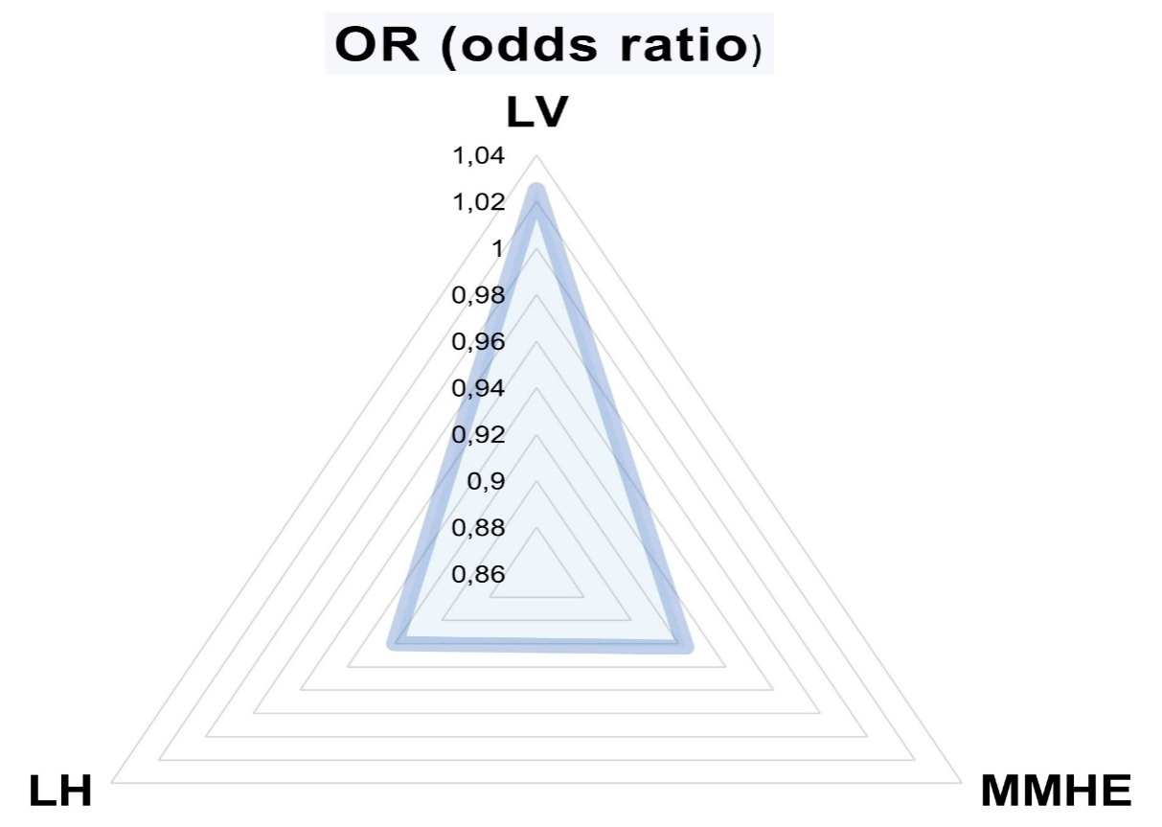
Figure 3. Indicators of the odds ratio (OR) of absence of complications after treatment
Where, LV - Laser vaporization of hemorrhoidal nodes;
MMHE - Milligan-Morgan hemorrhoidectomy;
LH - Ligation of hemorrhoidal nodes
Results and discussion:
Recurrences with the minimally invasive treatment of hemorrhoidal disease were observed in 2.9%, and complications in 1.8%, whereas with the traditional Milligan-Morgan operation, the recurrence rate was 19.47%, and complications were 11.57%. With the procedure of ligation of varicose veins of the rectum, the recurrence and complication rates were 13.75% and 11.8% respectively.
In calculating the "odds ratio" (OR), which indicates the likelihood of the presence of any complication after the treatment of hemorrhoidal disease, it was found that patients had the worst odds after MMHE - 1.025. Then, after LH operation - 0.923. The best result in the odds ranking after LV (laser vaporization) - 0.920. The obtained results are graphically presented in figures 3 and 4.
Considering the high prevalence of the considered disease among working-age patients, these results may indicate one thing - all patients treated with the LV method can promptly return to their normal lifestyle and work immediately after the procedure.
Conclusions: Analysis of the structure of complications leads to the conclusion that laser vaporization shows higher effectiveness compared to other methods of treating chronic hemorrhoids. Additionally, our experience with laser vaporization demonstrates that this method is painless, can be widely used in outpatient settings without mandatory hospitalization in a surgical ward. The use of laser vaporization significantly reduces the number of complications and recurrences compared to other methods of treating hemorrhoidal disease. This positively impacts recovery times, proving to be its undeniable advantage.
Acknowledgement We are indebted to the participants for making this research possible and to all physicians, faculty, and residents of the surgical department and staff of сlinics “University Medical Center” and “Astana Medical University”.
Limitations: There were no limitations during this study that influenced it.

Authors' Contributions:
Satanova K. – development of the general concept of the study, collection, analysis of the results obtained;
Fursov A. – development of study design; making a final decision on the readiness of the manuscript for publication;
Balmukhamedova Zh. – collection and analysis of clinical data;
Fursov R. A. – drafting the manuscript, interpretation of data;
Kaipova A. Sh. – statistical processing of the material, analysis of statistical results;
Talasov A.S. - text editing.

Conflict of Interest: the authors declare no conflicts of interest

Funding: This research is not funded by any organizations or individuals

References
- Sheikh P, Régnier C, Goron F, Salmat G. The prevalence, characteristics and treatment of hemorrhoidal disease: results of an international web-based survey. J Comp Eff Res. 2020 Dec;9(17):1219-1232. doi: 10.2217/cer-2020-0159
- Gallo, G., Sacco, R., Sammarco, G. (2018). Epidemiology of Hemorrhoidal Disease. In: Ratto, C., Parello, A., Litta, F. (eds) Hemorrhoids. Coloproctology. Springer, Cham. https://doi.org/10.1007/978-3-319-51989-0_1-1
- ShelyginYu.A., Blagodarny L.A., Achkasov S.I. Handbook of Coloproctology. - Moscow: LitTerra, 2014. - 596 p.
- Torrinha G, Gonçalves T, Sousa M, Högemann G, Goulart A, Carvalho AF, Leão P. The effects of laser procedure in symptomatic patients with haemorrhoids: A systematic review. Front Surg. 2022 Dec 12;9:1050515. doi: 10.3389/fsurg.2022.1050515
- Moldovan C, Rusu E, Cochior D, Toba ME, Mocanu H, Adam R, Rimbu M, Ghenea A, Savulescu F, Godoroja D, Botea F. Ten-year multicentric retrospective analysis regarding postoperative complications and impact of comorbidities in hemorrhoidal surgery with literature review. World J Clin Cases. 2023 Jan 16;11(2):366-384. doi: 10.12998/wjcc.v11.i2.366
- Romaguera VP, Sancho-Muriel J, Alvarez-Sarrdo E, Millan M, Garcia-Granero A, Frasson M. Postoperative Complications in Hemorrhoidal Disease and Special Conditions. Rev Recent Clin Trials. 2021;16(1):67-74. doi: 10.2174/1574887115666200406114218
- Naderan M. Randomized Controlled Trial Comparing Laser Intra– Hemorrhoidal Coagulation and Milligan–Morgan Hemorrhoidectomy / M. Naderan, S. Shoar, M. Nazari [et al.] // J Invest Surg. 2017;30(5):325–331. 172.
- Nagaraj S.V. Association of Hemorrhoid Vascular Injuries with Cigarette Smoking–An Evaluation with Interesting Prospects / S.V. Nagaraj, A. Mori, M. Reddy // Surg J (N Y). 2019 Nov 7; 5(4): 172–176.
- Long Q. Effect of electroacupuncture preconditioning with different frequencies on anal pain after milligan–morgan hemorrhoidectomy / Q. Long, Y. Li, J. Li [et al.] / Zhongguo Zhen Jiu. 2019 May 12;39(5):477–481.
- Brodovskyi S.P. Оptimization of surgical treatment of hemorrhoidal disease stages III–IV / S.P. Brodovskyi, A.G. Iftodiy, I.M. Kozlovska // Klin Khir. 2017;(2):10–12.
Коллектив авторов просит оставить следующие диаграммы
- “Indicators of the frequency of various complications after LV, LH, and MMHE”
- “Indicators of the odds ratio (OR) of absence of complications after treatment”
которые визуально отражают статистические взаимосвязи между выявленными показателями. В таком виде представленная нами информация только усиливает зрительное восприятие читателя, при этом не загружает текст большим количеством цифр.

