**Improved prognosis in patients undergoing PCI:**

**clinical evidence of trimetazidine efficacy**

**Перкутандық коронарлы араласу жүргізілетін пациенттердің болжамын жақсарту: триметазидин тиімділігінің клиникалық дәлелі**

**Улучшение прогноза у пациентов, перенесших чрескожное коронарное вмешательство: клинические доказательства эффективности триметазидина**

1,2,3Бижанов К.А., 1Баимбетов А.К., 1Баймаханов Б.Б., Каниев Ш.А., Якупова И.А., 1,2Сарсенбаева А.Б., Исмаилова Г.Н., Сапунов А.В., Тулебай А.А.

**Автор для корреспонденции:**

Бижанов Кенжебек Алибекович

kenzhebek10@mail.ru

1 – АО «Национальный научный центр хирургии имени А.Н. Сызганова», Отделение интервенционной кардиологии, аритмологии и эндоваскулярной хирургии, интервенционный кардиолог, аритмолог

2 – НАО «Казахский национальный университет имени аль-Фараби», Факультет медицины и здравоохранения, PhD докторант кафедры политики и организации здравоохранения; старший преподователь кафедры клинических дисциплин

3 – НАО «Казахский национальный медицинский университет имени С.Ж. Асфендиярова», кафедра внутренних болезни, старший преподователь

*Despite the significant successes achieved in the treatment of cardiovascular diseases, coronary artery disease (CAD) and in particular, acute coronary syndrome (ACS), retain a leading position in the structure of the causes of morbidity and mortality of people around the world [1]. At the same time, the introduction of percutaneous coronary intervention (PCI), the improvement of interventional techniques and the increasingly widespread use of PCI in the treatment of stenotic forms of coronary artery disease (CAD), although they contributed to a significant improvement in prognosis, did not finally solve the problem of ischemic complications caused by peri-/postprocedural damage and myocardial necrosis. The cause of the residual risk, not eliminated by successful PCI and even to some extent associated with interventional intervention, is considered to be coronary vascular spasm, endothelial damage, as well as distal embolization of the coronary bed with fragments of atherosclerotic plaques or blood clots - these events lead to ischemia and myocardial necrosis, largely determining the prognosis in patients after percutaneous coronary intervention (PCI) [2].*

*Жүрек-қантамыр ауруларын, жүректің ишемиялық ауруын (ЖИА) және атап айтқанда, жіті коронарлық синдромды (ЖКС) емдеуде қол жеткізілген елеулі жетістіктерге қарамастан, әлем халқының арасында аурушаңдық пен өлім-жітім себептерінің құрылымында жетекші орынды сақтап қалды [1]. Сонымен қатар, перкутандық коронарлық араласуды (ПКА) енгізу, интервенциялық әдістерді жетілдіру және жүректің ишемиялық ауруы (ЖИА) стеноздық түрлерін емдеуде ПКА барған сайын кеңінен қолданылып, болжамы айтарлықтай жақсарды, бірақ миокардтың алдыңғы/кейінгі зақымдануы мен некрозынан туындаған ишемиялық асқынулар мәселесін толық шешпеді. Сәтті ПКА жойылмайтын және тіпті белгілі бір дәрежеде интервенциялық араласумен байланысты қалдық қауіптің себебі коронарлық тамырлардың спазмы, эндотелийдің зақымдануы, сондай-ақ атеросклероздық табақша фрагменттері немесе тромбтар арқылы коронарлық арнаның дистальды эмболизациясы болып саналады. Бұл оқиғалар миокард ишемиясы мен некрозына әкеледі, көбінесе перкутандық коронарлық араласудан кейінгі науқастардың болжамын анықтайды [2].*

*Несмотря на значительные успехи, достигнутые в лечении сердечно-сосудистых (СС) заболеваний, ишемическая болезнь сердца (ИБС) и, в частности, острый коронарный синдром (ОКС), сохраняют лидирующее положение в структуре причин заболеваемости и смертности населения мир [1]. В то же время внедрение чрескожного коронарного вмешательства (ЧКВ), совершенствование интервенционной техники и все более широкое применение ЧКВ в лечении стенотических форм ишемической болезни сердца (ИБС) хотя и способствовали значительному улучшению прогноза, не решили окончательно проблему ишемических осложнений, вызванных пери-/постпроцедурным повреждением и некрозом миокарда. Причиной остаточного риска, не устраняемого успешным ЧКВ и даже в некоторой степени связанного с интервенционным вмешательством, считают спазм коронарных сосудов, повреждение эндотелия, а также дистальную эмболизацию коронарного русла фрагментами атеросклеротических бляшек или тромбами - эти события приводят к ишемии и некрозу миокарда, во многом определяя прогноз у больных после чрескожного коронарного вмешательства (ЧКВ) [2].*

**Trimetazidine* and myocardial protection during and after percutaneous coronary intervention (PCI)**

One of the promising therapeutic techniques to increase the resistance of the heart muscle to the effects of distal embolization, endothelial injury and coronary spasm, thereby reducing the risk and severity of myocardial damage during and after percutaneous coronary intervention (PCI), is the optimization of cardiomyocyte metabolism. This is a new strategy for the treatment of patients with stenotic ischemic heart disease, in the implementation of which the well-known anti-ischemic drug and cardioprotectortrimetazidine* plays a significant role. The pharmacological effects of trimetazidineare based on selective inhibition of the enzyme long-chain 3-ketoacyl-CoA-thiolase, leading to the switching of myocardial energy metabolism in hypoxia from fatty acid oxidation to glucose oxidation. As a result of the action of trimetazidine, the necessary level of ATP is maintained in cardiomyocytes, the severity of intracellular acidosis and the risk of calcium overload are reduced, which reduces the degree of damage and severity of necrosis of the heart muscle [3, 4].

In recent years, many randomized clinical trials (RCTs) have been conducted to assess the effect of trimetazidine administered before and/or after PCI on myocardial damage and heart function, confirming the beneficial effect of the drug on patients undergoing PCI [5, 6]. However, all these studies were distinguished by a small sample size, which imposes certain restrictions on the interpretation of the results obtained. Considering these circumstances, as well as the potential role of trimetazidine in improving prognosis in the target patient population, Zhang et al. A meta-analysis of completed studies was conducted in order to obtain irrefutable evidence in support of the widespread use of trimetazidine in patients with indications for PCI [7].

The meta-analysis included studies presented in PubMed databases (1989-2014), Cochrane database (1993-2014), Chinese Biological Medicine Database (1990-2014), China National Knowledge Infrastructure Database (1989-2014) and meeting the following criteria:

(a) type of study - randomized clinical trials (RCTs);

(b) type of participants - all patients of any gender and age undergoing PCI;

(c) the type of intervention is trimetazidine in combination with standard drugs compared to taking standard drugs without trimetazidine;

(d) performance indicators - markers of myocardial damage (troponin I [TnI], MV-fraction of creatine phosphokinase , parameters of cardiac function (left ventricular ejection fraction (LVEF), finite-diastolic left ventricular size , finite-diastolic volume of the left ventricle and brain natriuretic peptide (BNP).

The authors of the meta-analysis studied the characteristics of participants and studies, information about drug treatment, treatment strategies and clinical outcomes. For binary data, relative risk (RR) or risk ratio (OR) was calculated with 95% confidence intervals (CI), for continuous data - weighted mean difference (HRV) with 95% CI. A p value of less than 0.05 indicated a statistically significant difference in indicators. The criteria for inclusion in the meta-analysis were met by 9 RCTs [2, 4, 11-17], which included a total of 778 patients: 396 in the study therapy group and 382 in the control group. The comparison of the groups showed no significant differences in gender, age and other basic characteristics of the patients.

1. The **function of the left ventricular (LV)**. In the reports of 6 out of 9 included studies (427 patients: 218 people in the study therapy group and 209 in the control group), data on the left ventricular ejection fraction (LVEF) at the end of the follow-up period were presented. The analysis of the combined data showed that the addition of standard therapy with perioperative trimetazidine is superior to standard therapy without trimetazidine in terms of the effect on the left ventricular ejection fraction (LVEF) (HRV 3.11, 95% CI 2.26-3.96, p<0.00001, Fig. 1). After exclusion from the data analysis of the study in which trimetazidine was taken after PCI [11], comparable results were obtained in favor of trimetazidine (HRV 3.24, 95% CI 2.36-4.12, p<0.00001) [7]. In one study, a change in the end-diastolic volume of the left ventricular was recorded as one of the results of therapy: it was shown that, compared with standard therapy, the additional use of trimetazidine significantly reduces the end-diastolic volume of the left ventricular (from 75.1±13.1 to 71.9±7.7 cm%, p=0.01). Similar results were obtained in another study examining the effect of trimetazidine on the left ventricle end-diastolic diameter (a significant decrease in the index from 33.29-2.11 to 31.0014.33 mm) [7].
2. **Troponin level (Tni).** The frequency of an increase in troponin levels by more than 2 times compared to the norm 24 hours after PCI was evaluated in four studies involving 468 patients (236 in the trimetazidine group and 232 in the control group). Meta-analysis of the data showed a significant difference in this indicator between the trimetazidine group and the control group in favor of tri-metazidine (RR 0.69, 95% CI 0.48-0.99, p=0.04, Fig. 2), which confirms the protective effect of the drug on the myocardium. At the same time, the positive effect of trimetazidine did not depend on age (p=0.55), gender of the patient (p=0.61) or the number of affected coronary vessels (p=0.79) 17]
3. **Angina attacks during percutaneous coronary intervention (PCI)** . The effect of trimetazidine on the frequency of angina attacks during PCI (during balloon inflating) was evaluated in two studies (145 patients: 76 in the trimetazidine group and 69 in the control group). The results of the analysis showed that the frequency of angina attacks in the trimetazidine group was significantly lower than in the control group of patients receiving only standard therapy (OR 0.16, 95% Ci 0.07-0.38, p<0.0001, Fig. 3) 17].
4. **Ischemic changes in the ST-T interval on the electrocardiogram during percutaneous coronary intervention (PCI).** The frequency of ischemic changes in the ST-T interval during PCI was evaluated in 2 studies involving 367 patients (190 in the trimetazidine group and 177 in the control group). Meta-analysis of the data showed that the frequency of ischemic changes in the ST-T segment in the trimetazidine group was significantly lower than in the control group (RR 0.76, 95% CI 0.59-0.98, p=0.03, Fig. 4) 17].
5. **Brain natriuretic peptide (BNP) level**. The level of brain natriuretic peptide (BNP) in serum 30 days after PCI was measured in 2 studies involving 117 patients (60 in the trimetazidine group and 57 in the control group). After combining the data, a statistically insignificant decrease in the BNP level was found in the trimetazidine group compared to the control group (HRV-44.42, 95% CI from - 101.05 to 12.21, p=0.12) [7].

|  |  |  |  |  |  |  |  |  |  |
| --- | --- | --- | --- | --- | --- | --- | --- | --- | --- |
| research | Trimetazidine group  Events CO N | | | Control group  Events CO N | | Weight | | Averagedifference  [95% DI] | C:\Users\Professional\Downloads\WhatsApp Image 2023-11-24 at 21.16.37.jpeg |
| B1rand el а]. 1997 | 57,8 | 5,8 | 26 | 56,4 | 6 | 25 | 6.9% | 1,40 [-1,84;4,64] |
| Chen et al. 2010 | 66,5 | 7,1 | 54 | 63 | 7,7 | 47 | 8.6% | 3,50 [0,60:6,40] |
| Demirelh et 2013 | 61,7 | 2,3 | 22 | 59 | 2,7 | 23 | 33.7% | 2,70 [1,24:4,16] |
| Labrou et а! 2007 | 57,2 | 6,5 | 27 | 53,9 | 6,3 | 25 | 6.0% | 3,30 [+-0,18:6,78] |
| Xu et al. 2013 | 65,65 | 3,94 | 51 | 62,29 | 3,06 | 55 | 39.6% | 3,36 [2,01:4,71] |
| Yu et al 2012 | 66,5 | 7,8 | 38 | 61,2 | 8,1 | 34 | 5.3% | 5,30 [ 1,62:8,98] |
| Total (95 CI) Total events; p=0.04 |  |  | 218 |  |  | 209 | 100.0% | 3.11 [2.6;3.96] |
|  | | | | | | | | | |

**Figure 1.** The effect of trimetazidine on LV AF [7]

|  |  |  |  |  |  |  |  |
| --- | --- | --- | --- | --- | --- | --- | --- |
| Research | Trimetazidinegroup  Events total | | Control group  events total | | Weight | RR | |
| Bonello et.al,2007 | 30 | 136 | 26 | 130 | 26.8% | 1.10 [0.69; 1.76] | C:\Users\Professional\Downloads\WhatsApp Image 2023-11-24 at 21.15.55.jpeg |
| Labrou et al. 2007 | 7 | 27 | 11 | 25 | 15.1% | 0.59 [0,27; 1,28] |
| Polonskietal. 2013 | 8 | 22 | 24 | 22 | 19.4% | 0,57 [0,30;1,08] |
| Xuetal. 2002 | 28 | 51 | 52 | 55 | 38.7% | 0,58[ 0,45;0,75] |
| Total (95 CI) Total events  p=0.04 | 73 | 236 | 103 | 232 | 100.0% | 0,69 [0,48; 0,99] |
|  | | | | | | | |

**Figure 2.** The effect of trimetazidine on the level of ThI [7]

|  |  |  |  |  |  |  |  |
| --- | --- | --- | --- | --- | --- | --- | --- |
| Research | Trimetazidinegroup  events total | | Control group  events total | | Weight | RR | |
| Chen et.al,2007 | 0 | 54 | 12 | 47 | 52.1% | 0.09 [0.03;0.30] | C:\Users\Professional\Downloads\WhatsApp Image 2023-11-24 at 21.16.12.jpeg |
| Polonski et al. 2007 | 12 | 22 | 18 | 22 | 47.9% | 0.29 [0,08; 1,03] |
| Total (95 CI) Total events  p<0.0001 | 12 | 76 | 30 | 69 | 100% | 0,16 [0,07;0.38] |
|  | | | | | | | |

**Figure 3.** The effect of trimetazidine on the frequency of angina pectoris during PCI [7]

|  |  |  |  |  |  |  |  |
| --- | --- | --- | --- | --- | --- | --- | --- |
| Research | Trimetazidinegroup  events total | | Control group  events total | | Weight | RR | |
| Bonello et.al,2007 | 29 | 136 | 36 | 130 | 48.2% | 0.77 [0.50.1.18] | C:\Users\Professional\Downloads\WhatsApp Image 2023-11-24 at 21.16.26.jpeg |
| Chenetal. 2007 | 32 | 54 | 47 | 47 | 51.8% | 0.75 [0,58; 0,98] |
| Total (95 CI) Total events  P=0.03 | 61 | 190 | 73 | 177 | 100% | 0,76 [0,59;0.98] |
|  | | | | | | | |

**Figure 4.** The effect of trimetazidine on the frequency of ischemic changes in the ST-T interval during PCI [7]

**Thus, the results of the meta-analysis by Zhang et al. the cardioprotective effect of trimetazidine is confirmed when it is used before and after percutaneous coronary intervention (PCI); this effect is manifested by a significant decrease in the ejection fraction (LV) of the left ventricle (LV), a decrease in the level of troponin (ThI) in the blood serum, a decrease in the frequency of angina attacks when the balloon is inflated and ischemic changes in the ST-T interval during percutaneous coronary intervention (PCI).**

These data are consistent with the results of a previous meta-analysis of six randomized clinical trials (RCTs) [8] evaluating the effects of trimetaziline in patients undergoing coronary artery bypass grafting. According to the analysis of the combined data, trimetazidine also provided myocardial protection under these conditions, which was expressed in a significant decrease in the levels of creatine phosphokinase, MV-fraction of creatine phosphokinase CK-MV, troponin T and Tni compared with conventional treatment.

***Trimetazidine and the risk of coronary stent restenosis***

One of the most formidable complications of PCI, which has an extremely negative effect on the prognosis of patients with coronary heart disease, is stent restenosis. According to histological studies, restenosis is based on proliferation and migration of smooth mouse cells [9-12], as well as endothelial dysfunction (ED) [13-16], associated with both coronary artery disease itself and the presence of an intravascular implant. The introduction of drug eluting stent (DES), suppressing the proliferation of smooth muscle cells, allowed to reduce the frequency of restenosis from 25% (an indicator characteristic of metal stents) to 3.6-10% [17-22] without signs of further improvement of the situation, which caused an active search for medicinal techniques that further reduce the risk of restenosis after implantation of stents with medicinal coated (SLP).

Studies have shown that trimetazidine may be one of the drugs capable of protecting coronary vessels from ED through a beneficial effect on NO-dependent support of the endothelial barrier [23, 24], thereby reducing the risk of development and progression of restenosis and improving the prognosis in patients with SLP. The evaluation of this possibility of trimetazidine was sanctified by the RCT of Chen ey al. [25].

This study enrolled patients who underwent the first PCI procedure with implantation of drug eluting stents (DES) in the period from January 2009 to December 2011 at the PLA General Hospital in China. The criteria for inclusion in the study were: the presence of clinical indications for PCI, age 18 years and older, severe de po stenosis in the native coronary artery, a lesion suitable for stent placement, the size of the target vessel from 2.5 to 4.0 mm and implantation of only drug eluting stent (DES) (with sirolimus or paclitaxel). After PCI and stabilization of the condition, patients were randomly assigned to the trimetazidine treatment group (in addition to standard therapy) or the control group (standard therapy without trimetazidine). In the trimetazidine group, patients received a loading dose of 60 mg on the day of PCI, and then took the drug 20 mg 3 times a day for at least 1 month after discharge from the hospital. Patients in the control group received neither placebo nor additional therapy.

During the follow-up period, large adverse cardiac and cerebrovascular events (MASS) were recorded, including death from any cause, nonfatal myocardial infarction (MI), cases of myocardial revascularization, stroke and cerebral hemorrhage. 9-13 months after the initial PCI or, if necessary, coronary angiography was performed earlier; angiographic restenosis was defined as narrowing of the artery lumen by 50% or more. Echocardiography was performed 30 days after PCI. The primary endpoint of the study was angiographic restenosis; The MASS events were evaluated as a secondary endpoint.

The final analysis included data from 635 patients who formed two approximately equal study groups (312 in the trimetazidine group and 323 in the control group) with balanced demographic, clinical and angiographic characteristics.

The duration of the follow-up period was 11.9±1.8 months; during this period, MASS events occurred in 19 patients in the trimetazidine group and in 35 patients in the control group, which corresponded to a significant decrease in the frequency of the indicator by 43.5% in the trimetazidine group (p=0.034, Fig. 5, Table). Repeated angiography performed in the follow-up period revealed restenosis in 13 (4.2%) patients from the trimetazidine group and in 36 (11.1%) people from the control group, which corresponded to a significant reduction in the risk of restenosis by 62% in the trimetazidine group (OR 0.376, 95% CI 0.966-0.721, p=0.003). Echocardiography performed after 30 days of follow-up showed that the average LV EF in the trimetazidine group was significantly higher compared to the indicator in the control group (65.4±10.7 vs 63.1±10.4%, p=0.006, Fig. 6, Table 1) [25].

**Thus, in a study by Chen et al. it was shown for the first time that at least 30-day therapy with trimetazidine after implantation of DES:**

**- significantly reduces the frequency of restenosis during the year of follow-up;**

**- associated with a significant decrease in the frequency of events MASS after a year of observation;**

**- provides higher LVEF compared to the control group according to echocardiography performed 30 days after PCI.**

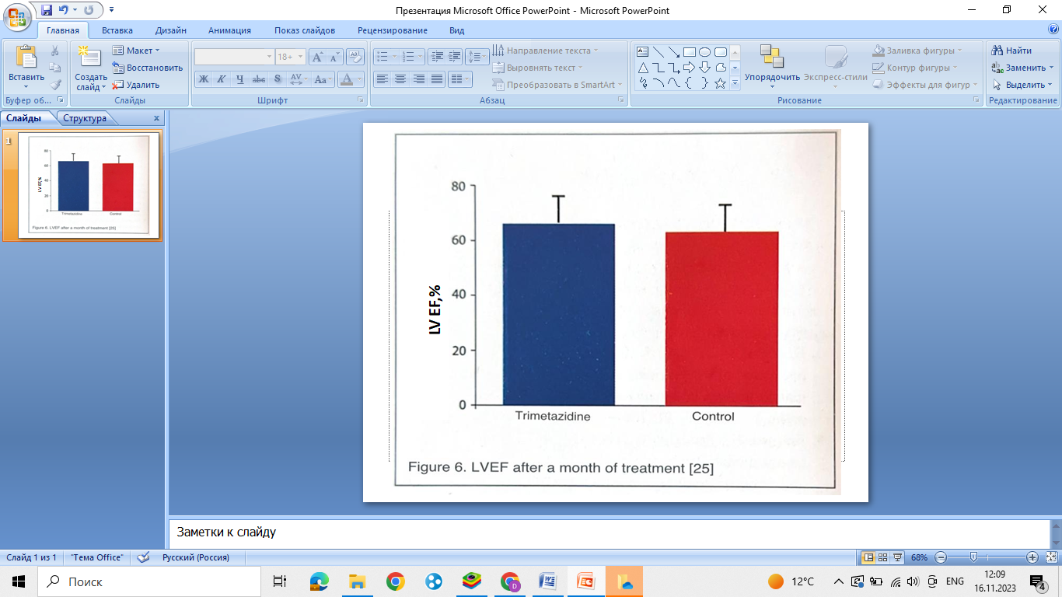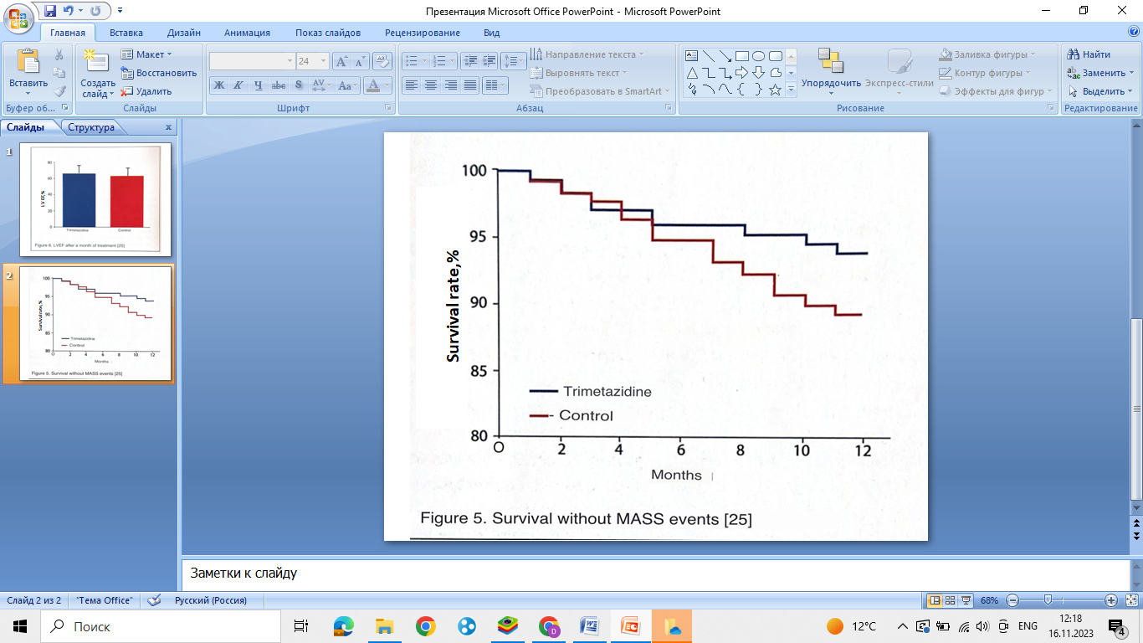

These findings are consistent with the results of other studies [28-33] and confirm the ability of trimetazidine to suppress pathophysiological processes leading to the development of restenosis after implantation of drug eluting stents (DES), including the development and progression of endothelial disfunction (ED).

**Table 1. The main clinical and angiographic indicators in the study Chen et al.** **[25]**

|  |  |  |  |
| --- | --- | --- | --- |
| **Indicator** | **Trimetazidine (n=322)** | **Control (n=323)** | **p** |
| Annual events, n |  |  |  |
| MACCE, total | 19 (6,1%) | 35(10,85) | 0,032 |
| Death | 3 | 6 |  |
| Unfatal MI | 6 | 10 |  |
|  | 3 | 5 |  |
| Revascularization of the target vessel | 4 | 7 |  |
| Bleeding | 3 | 8 |  |
| **Echocardiography after 30 days** |  |  |  |
| EF LV,% | 65,4±10,7 | 63,1±10,4 | 0,006 |
| BDO LV (of course - diastolic volume of the left ventricular), ml | 108,3±19,6 | 112,6±21,8 | 0,009 |
| LV CSR (of course - systolic volume of the left ventricular), ml | 44,7±15,1 | 48,4±16,7 | 0,004 |
| Angiography 11.4-12.6 months after discharge |  |  |  |
| Restenosis,(%) | 13 (4,2%) | 36 (11,1%) | 0,001 |
| Hyperplasia of intima, n(%) | 87 (27,9) | 102 (31,6%) | 0,309 |
| Defeat de novo, n(%) | 35 (11,2%) | 57 (17,6%) | 0,021 |

***Conclusion***

After the widespread introduction of interventional methods of treatment of stenotic coronary heart disease (CHD), the primary task remains to reduce the residual risks of ischemic complications of PCI. Due to the effect on myocardial metabolism (optimization of energy metabolism) and the condition of the coronary vessel wall in the stent implantation zone (inhibition of muscle cell proliferation and ED development), trimetazidine added to standard therapy reduces the risk of intra- and post-procedural myocardial damage/necrosis and the risk of restenosis in drug-coated stents (SLP). Taking into account the significant contribution of ischemic complications of interventional interventions to the prognosis of patients with coronary heart disease (CHD), trimetazidine can significantly reduce the morbidity and mortality of patients who have undergone PCI.

**Literature:**

1. Anderson J., Adams C., Antman E. et al. et al. ACC/AHA 2007 guidelines for the management of patients with unstable angi-na/non-ST-elevation myocardial infarction: a report of the American College of Cardiology/American Heart Association Task Force on Practice Guidelines. J Am CollCardiol. 2007; 50: el—e157.

2. Demirelli S., Karakelleoglu S., Gundogdu F. et al. The impact of trimetazidine treatment on left ventricular functions and plasma brain natriuretic peptide levels in patients with non-ST segment elevation myocardial infarction undergoing percutaneous coronary intervention. Korean Circ J. 2013; 43: 462-467.

3. Di Napoli P., Taccardi A., Barsotti A. Long term cardioprotective action of trimetazidine and potential effect on the inflammatory process in patients with ischaemic dilated cardiomyopathy. Heart. 2005; 91: 161-165.

4. Fragasso G., Perseghin G., De Cobelli F. et al. Effects of metabolic modulation by trimetazidine on left ventricular function and phosphocreatine/adenosine triphosphate ratio in patients with heart failure. Eur Heart J. 2006; 27: 942-948.

5. Zhou X., Chen J. Is treatment with trimetazidine beneficial in patients with chronic heart failure? PLoS One. 2014; 9: e94660.

6. Gao D., Ning N., Niu X. et al. Trimetazidine: a meta-analysis of randomised controlled trials in heart failure. Heart. 2011;

97: 278-286.

7. Zhang Y., Ma X.-J., Shi D.-Z. Effect of Trimetazidine in Patients Undergoing Percutaneous Coronary Intervention: A Me-la-Analysis. PLoS ONE 10(9): e0137775. doi: 10.1371/jour-nal.pone.0137775.

8. Zhang N., Lei J., Liu Q. et al. The effectiveness of preopera-tivetrimetazidine on myocardial preservation in coronary artery bypass graft patients: a systematic review and meta-analysis. Cardiology, 2015; 131: 86-96.

9. Nikol S., Huehns T., Hofling B. Molecular biology and post-angioplasty restenosis. Atherosclerosis 1996; 123: 17-31.

10. Dangas G., Claessen B., Caixeta A. et al, In-stent restenosis in the drug-eluting stent era. 1 Am Coll Cardiol 2010; 56:

11. Tsigkas G., Karantalis V., Hahalis G., Alexopoulos D. Stent re-stenosis, pathophysiology and treatment options: a 2010 update. Hellenic J Cardiol 2011; 52: 149-57.

12. Kearney M., Pieczek A., Haley L. et a Histopathology of in-stent restenosis in patients with peripheral artery disease. Circulation 1997; 95: 1998-2002

13. Thanyasiri P., Kathir K., Celermajer D., Adams M. Endothelial dysfunction and restenosis following percutaneous coronary intervention. Int J Cardiol 2007; 119: 362-7.

14. Lafont A., Durand E., Samuel J. et al. Endothelial dysfunction and collagen accumulation: two independent factors for restenosis and constrictive remodeling after experimental angioplasty. Circulation 1999; 100: 1109-15.

15. Losordo D., Isner J., Diaz-Sandoval L. Endothelial recovery: the next target in restenosis prevention. Circulation 2003; 107:

2635-7.

16. Hedman M., Hartikainen J., Syvanne M. et al. Safety and feasibility of catheter-based local intracoronary vascular endothelial growth factor gene transfer in the prevention of postangioplasty and in-stent restenosis and in the treatment of chronic myocardial ischemia: phase II results of the Kuopio Angiogenesis Trial (KAT). Circulation 2003; 107: 2677-83.

17. Serruys P., de Jaegere P., Kiemeneij F. et al. A comparison of balloon-expandablestent implantation with balloon angioplasty in patients with coronary artery disease. N Engl J Med 1994;

331: 489-95.

18. Fischman D., Leon M., Baim D. et al. A randomized comparison of coronary-stent placement and balloon angioplasty in the treatment of coronary artery disease. N Engl J Med 1994;

331: 496-501.

19. Zahn R., Hamm C., Schneider S. et al. Incidence and predictors of target vessel revascularization and clinical event rates of the sirolimus-eluting coronary stent (results from the prospective multicenter German Cypher Stent Registry). Am J Cardiol 2005; 95: 1302-8.

20. Mauri L., Silbaugh T., Wolf R. et al. Long-term clinical outcomes after drug-eluting and bare-metal stenting in Massachus-etts. Circulation 2008; 118: 1817-27.

21. Lemos P., Serruys P., van Domburg R. et al. Unrestricted utilization of sirolimuseluting stents compared with conventional bare stent implantation in the "real world": the Rapamycin-Eluting Stent Evaluated At Rotterdam Cardiology Hospital (RES-EARCH) registry. Circulation 2004; 109: 190-5.

22. Stolker J., Kennedy K., Lindsey J. et al. Predicting restenosis of drug-eluting stents placed in real-world clinical practice: derivation and validation of a risk model from the EVENT registry. Circ Cardiovase Interv 2010; 3: 327-34.

23. Belardinelli R., Solenghi M., Volpe L., Purcaro A. Trimetazidine improves endothelial dysfunction in chronic heart failure: an antioxidant effect. Eur Heart J 2007; 28: 1102-8.

24. Di Napoli P., Chierchia S., Taccardi A. et al. Trimetazidine improves post-ischemic recovery by preserving endothelial nitric oxide synthase expression in isolated working rat hearts. Nitric Oxide 2007; 16: 228-36.

25. Chen J., Zhou S., Jin J. Chronic treatment with trimetazidine after discharge reduces the incidence of restenosis in patients who received coronary stent implantation: a 1-year prospective follow-up study. Int J Cardiol. 2014 Jul 1; 174 (3): 634-9.